

EC-Net4 KitControl Guide
EC-Net4 KitControl Guide
User Guide



EC-Net4 KitControl Guide
Distech Controls, Inc. Brossard, Quebec, Canada

Legal Notice
©, Distech Controls Inc., 2024. All rights reserved. While all efforts have been made to verify the accuracy of in- formation in this manual, Distech Controls is not responsible for damages or claims arising from the use of this manual. Persons using this manual are assumed to be trained HVAC professionals and are responsible for us- ing the correct wiring procedures, correct override methods for equipment control and maintaining safe working conditions in fail-safe environments. Distech Controls reserves the right to change, delete or add to the informa- tion in this manual at any time without notice.
Distech Controls, the Distech Controls logo, EC-Net, and Innovative Solutions for Greener Buildings are regis- tered trademarks of Distech Controls, Inc. LON, LonMark, LonWorks, LNS, and Neuron are registered trade- marks of Echelon Corporation registered in the United States and other countries. NiagaraAX and NiagaraAX Framework are registered trademarks of Tridium, Inc. BACnet is a registered trademark of ASHRAE. Windows, Windows XP, Windows Vista, Windows 7, Visual Basic.Net, Visual Basic.Net are registered trademarks of Mi- crosoft Corporation. Intel and Pentium are registered trademark of Intel Corporation in the U.S. and/or other countries. AMD is a registered trademark of Advanced Micro Devices, Inc. EnOcean is a registered trademark of EnOcean GmbH. All other trademarks are property of their respective owners.

Contents

About this guide 7
Document change log 7
Related documentation 7

Chapter 1 About kitControl 9
About the kitControl palette 10
Where to locate kitControl components 11
Extensions and kitControl components 11

Chapter 2 Building management examples 13
How to project demand for electricity 13
Using mostly projected values. 14
Using all recorded values 14
Using recorded and projected values 14
How to manage demand for electricity 15
Electrical demand reduction calculations 15
Electrical demand reduction examples 16
Reducing demand for electricity 18
Lead-lag compensation example – kitControl 19
PID loop configuration 21
Proportional-only control 22
Proportional with Integral (PI) control 22
Proportional with Integral and Derivative (PID) control 23
Night time heat configuration 25
Reversible actuator control 26
Heating and cooling management to reduce energy consumption 27
Calculated start and stop times 27
Optimized start example 28
Hot water control setpoint based on outside air temperature 29
Data gathering 30

Chapter 3 Alarm components 31
kitControl-AlarmCountToRelay 31
kitControl-ChangeOfStateCountAlarmExt 33
kitControl-ElapsedActiveTimeAlarmExt 33
kitControl-LoopAlarmExt 33

Chapter 4 Constant components 35
kitControl-BooleanConst 35
kitControl-EnumConst 35
kitControl-NumericConst 36
kitControl-StringConst 37

Chapter 5 Conversion components 39
kitControl-BooleanToStatusBoolean 39
kitControl-DoubleToStatusNumeric 40
kitControl-EnumToStatusEnum 41

kitControl-FloatToStatusNumeric. 41
kitcontrol-IntToStatusNumeric 42
kitControl-LongToStatusNumeric. 43
kitControl-StringToStatusString 43
kitControl-StatusBooleanToBoolean 44
kitControl-StatusEnumToEnum 45
kitControl-StatusEnumToInt 46
kitControl-StatusEnumToStatusBoolean 48
kitControl-StatusEnumToStatusNumeric 49
kitControl-StatusNumericToStatusEnum 50
kitControl-StatusNumericToDouble 50
kitControl-StatusNumericToFloat. 51
kitControl-StatusNumericToInt 52
kitControl-StatusStringToStatusNumeric 53
kitControl-StatusNumericToStatusString 54
kitControl-NumericUnitConverter 55
Chapter 6 Energy components 57
kitControl-DegreeDays 57
kitControl-ElectricalDemandLimit 59
kitControl-NightPurge 63
kitControl-OptimizedStartStop 66
kitControl-OutsideAirOptimization 71
kitControl-Psychrometric 74
kitControl-SetpointLoadShed 76
kitControl-SetpointOffset 77
kitControl-ShedControl 79
kitControl-SlidingWindowDemandCalc 81
Chapter 7 HVAC components 85
kitControl-InterstartDelayControl 85
kitcontrol-InterstartDelayMaster 87
kitControl-LeadLagCycles 88
kitControl-LeadLagRuntime 89
kitControl-LoopPoint 91
kitControl-RaiseLower 94
kitControl-SequenceBinary 96
kitControl-SequenceLinear 98
kitControl-Tstat 100
Chapter 8 Latch components 103
kitControl-BooleanLatch 103
kitControl-EnumLatch 105
kitControl-NumericLatch 106
kitControl-StringLatch 107
Chapter 9 Logic components 109
kitControl-And 109
kitControl-Equal 111
kitControl-GreaterThan 112
kitControl-GreaterThanEqual 112
kitControl-LessThan 113
kitControl-LessThanEqual 114
kitControl-Not 114
kitControl-NotEqual 116
kitControl-Or 117
kitControl-Xor 118
kitControl-BqlExprComponent 120
Chapter 10 Math components 125
kitControl-AbsValue 127
kitControl-Add 127
kitControl-ArcCosine 128
kitControl-ArcSine 128
kitControl-ArcTangent 128
kitControl-Average 128
kitControl-Cosine 129
kitControl-Divide 129
kitControl-Exponential 129
kitControl-Factorial 129
kitControl-LogBase10 129
kitControl-LogicNatural 130
kitControl-Maximum 130
kitControl-Minimum 130
kitControl-Modulus 130
kitControl-Multiply 130
kitControl-Negative 130
kitControl-Power 130
kitControl-Reset 130
kitControl-Sine 131
kitControl-SquareRoot 132
kitControl-Subtract 132
kitControl-Tangent 132
kitControl-BqlExprComponent 132
Chapter 11 Select components 135
kitControl-BooleanSelect 135
kitControl-EnumSelect 136
kitControl-NumericSelect 137
kitControl-StringSelect 138
Chapter 12 String components 141
kitControl-StringConcat 141
kitControl-StringIndexOf 142
kitControl-StringLen 142
kitControl-StringSubstring. 143
kitControl-StringTest 143
kitControl-StringTrim 144
Chapter 13 Timer components 147
kitControl-BooleanDelay 147
kitControl-CurrentTime 149
kitControl-NumericDelay 149
kitControl-OneShot 150
kitControl-TimeDifference 152
Chapter 14 Util components 153
kitControl-BooleanSwitch 153
kitControl-Counter 154
kitControl-DigitalInputDemux 156
kitControl-EnumSwitch 159
kitControl-MinMaxAvg 160
kitControl-MultiVibrator 161
kitControl-NumericBitAnd 161
kitControl-NumericBitOr 163
kitControl-NumericBitXor 164
kitControl-NumericSwitch 165
kitControl-NumericToBitsDemux 166
kitControl-Ramp 167
kitControl-Random 169
kitControl-SineWave 169
kitControl-StatusDemux 171
kitControl-BqlExprComponent 172

About this guide
This topic contains important information about the purpose, content, context, and intended audience for this document.

Product Documentation
This document is part of the EC-NetTM technical documentation library. Released versions of EC-Net software include a complete collection of technical information that is provided in both online help and PDF format. The information in this document is written primarily for Systems Integrators. In order to make the most of the infor- mation in this book, readers should have some training or previous experience with EC-NetTM 4 or EC-NetAXTM software.

Document Content
This document describes how to create and use the kitControl components. Sections in this guide include chap- ters about common kitControl tasks, concepts, and reference information. Also included are images and de- scriptions of the primary software user interface windows involved when working with kitControl components.

Document change log
Changes to this document are listed in this topic.

April 3, 2024
Updated the “kitControl-LoopAlarmExt” component to include properties that enable and specify the Low Diff Limit (as of EC-Net 4.14).

March 17, 2023
Edited the “kitControl-Ramp” component to enhance a description for “Update Interval” property.

March 24, 2020
Edited the kitControl-BqlExprComponent to add a description for Expr property, plus added data for bql expr and like query with wild card details.

June 16, 2019
Updated the “kitControl-And” topic to clarify handling of "null" value.

June 07, 2019
Initial release.

Related documentation
Additional information is available in the following documents.
- Getting Started with EC-Net 4
- EC-Net 4 Platform Guide

Chapter 1 About kitControl

Topics covered in this chapter
- About the kitControl palette
- Where to locate kitControl components
- Extensions and kitControl components

The kitControl palette contains various components that you can use in combination with points, both simple control points and proxy points. Whereas proxy points read (and possibly write) data from (and to) remote devi- ces, kitControl components provide the data manipulation building blocks that let you further process point da- ta. Included are HVAC components like a PID loop and sequencers, a variety of Boolean logic components, math components for numeric values, and miscellaneous components. Together with proxy points and sched- ules, kitControl components provide the basic set of the common components for modeling control logic.
Figure 1 Conceptual use for kitControl components in a building model
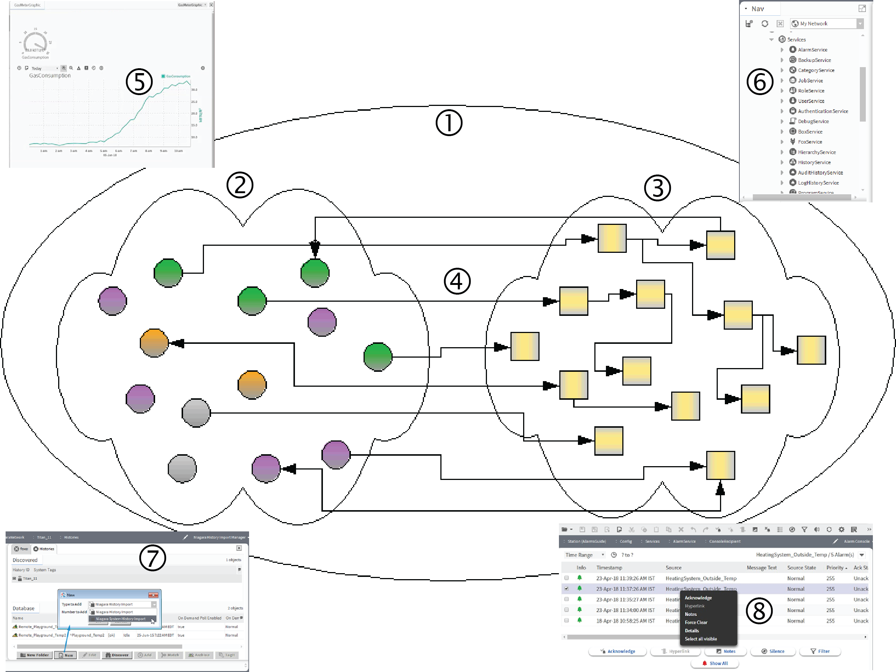
The usage of kitControl components is entirely optional. It is possible to build a monitoring-type application with only proxy points (and perhaps a few simple control points). This would allow real-time data monitoring, plus user-invoked action overrides through writable points’ right-click command menus. As needed, you could also add extensions to the proxy points for alarming and history collections.
- represents the common component model. Inside the model are three things:
  - (2) station points and proxy points
  - (3) kitControl components.
  - (4) Links between the points and kitControl components. Outside the common component model are:
  - (5) Px graphics

- (6) Services
- (7) Histories
- (8) Alarms

About the kitControl palette
The kitControl palette provides a toolkit with which to manage building automation systems. The palette is a standard feature of .
Figure 2 Folders in the palette kitControl
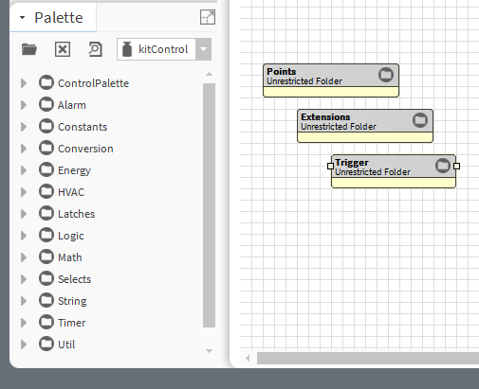
The kitControl palette contains over 90 unique components across 12 folder categories (not counting Control- Palette). The folders in the palette reflect the types of components:
- ControlPalette includes these subfolders: Points, Extensions, and Trigger. These standard control palette folders in the kitControl provide easy access to the simple control points, extensions, and timers, in addition to the kitControl components found under its other folders.
- Alarm contains three extensions for alarming. One is expressly for a LoopPoint (setpoint-deviation) alarm- ing. The others provide alarming options for a Boolean point with a DiscreteTotalizerExt. A fourth component provides alarm count monitoring of any Alarm Class, and includes a Boolean relay output.
- Constants contains four components, one for each data category. Each provides a linkable status-type out- put, and a Set action for changing value.
- Conversion contains 19 components that mainly convert status values to simple values, and vice versa. This folder also contains other special conversion types.
- Energy contains 10 components for typical energy functions, such as degree day calculation and electrical demand limiting.
- HVAC contains nine components for typical HVAC functions, such as interstart delay, lead-lag control, and sequence control. This folder includes Tstat (thermostat) and LoopPoint (PID loop) components.
- Latches contains four components, one for each data category.
- Logic contains 10 components, each with StatusBoolean output.
- Math contains 23 components for processing one or more numeric input values to produce a StatusNumeric output.
- Selects contains four components, one for each data category.

EC-Net4 KitControl Guide Chapter 1 About kitControl

  - String contains six components with one or more StatusString inputs.
  - Timer contains five components. Three are timers: BooleanDelay, NumericDelay, and OneShot. Two are ab- solute timers: Current Time, and TimeDifference.
  - Util contains 16 various utility components including Expr (BQL Expression).

Where to locate kitControl components
As with simple control points, you can copy kitControl components to any folder or component in the station. This includes placing kitControl components under any device Points extension (container), or under any Points extension subfolder.
There are two competing best practice philosophies about locating your control logic:
  - Philosophy A maintains that only proxy points belong under a device’s Points container. You can add exten- sions (control, history, and alarm), as needed, to proxy points. However, other components (kitControl com- ponents, simple control points, schedules) should be located under a central folder—not under the station’s Driver architecture—but instead in subfolders under a main Logic folder (by convention) created in the root of the station’s Config container.
This philosophy requires many internal links between proxy points and kitControl components. It often makes following control logic harder, because you do not see most links except as knobs. In addition, it makes applications much less portable in that you cannot copy an entire application by selecting a single device container.
  - Philosophy B maintains that kitControl components and schedules belong under each device’s Points con- tainer (either directly, or in subfolders). This allows you to create local links between device proxy points and other components. Copying an entire application requires copying a single device container.
The original intention of Philosophy A was to establish a logic convention to simplify universal support of differ- ent application types. However, Philosophy B offers easier portability of each application, allowing easy replica- tion and reuse at a device level. In general, use of Philosophy B is more common. In other words, it is preferable to locate kitControl components where they are needed.

Extensions and kitControl components
You can add point extensions, such as alarm extension, history extension, or perhaps a control extension, to many kitControl components. Other kitControl components cannot receive extensions.
These are some specific examples of kitControl components that support extensions:
  - Average object (Math folder): Inputs link to multiple proxy NumericPoints, each representing a room temper- ature. The Average object represents a Zone temperature (average). To this object you may add an alarm extension (OutOfRangeAlarmExt) and history extension (NumericInterval).
  - And object (Logic folder): Inputs link to multiple proxy BooleanPoints, each representing fan status (off or on). The And object links to downstream control logic. To track when all fans are running, you may add a his- tory extension (BooleanChangeOfValue) and perhaps a control extension to collect runtime (DiscreteTotalizerExt).
  - NumericSwitch object (Util folder): Inputs link to two proxy NumericWritables, each representing a power rate (kW). The object output links to downstream control logic (and represents the current switched rate). To totalize this effective rate into energy accumulation, you can add a control extension (NumericTotalizerExt) and proper scaling to collect kWh.
These components are not based on simple control points (ControlPoint) and do not support the addition of extensions:
  - Constants components (any)
  - Conversion components (any)
  - Energy components (any)

- HVAC components (except for LoopPoint, InterstartDelayControl and Tstat, which do support extensions)
- Latches components (any)
- Selects components (any)
- String components (any)
- Timer components (any)
- Util components (except BooleanSwitch, EnumSwitch, MultiVibrator, numericSwitch, Ramp, Random, and SineWave, which do support extensions)
You can quickly tell if a kitControl object can receive an extension, by seeing if it has the frozen ProxyExt (proxy extension). To see this, expand the object in the kitControl palette, Nav tree or view the object’s property sheet. If a Proxy Ext property is present, you can add other extensions (provided they are the correct type), for ex- ample a BooleanChangeOfValue history extension for a Logic-type object, and so forth. If you try to add an ex- tension to a kitControl component that does not support extensions, you receive an illegal parent error message.
NOTE: The frozen ProxyExt is the only use for the proxy extension in a kitControl object. Its value is always null. Only control points can be proxy points.

Chapter 2 Building management examples

Topics covered in this chapter
- How to project demand for electricity
- How to manage demand for electricity
- Lead-lag compensation example – kitControl
- PID loop configuration
- Night time heat configuration
- Reversible actuator control
- Heating and cooling management to reduce energy consumption
- Hot water control setpoint based on outside air temperature
- Data gathering

The kitControl components facilitate the flexible modeling of building automation systems. This chapter pro- vides practical examples to help you creatively construct an efficient model for your application.

How to project demand for electricity
The kitControl’s ElectricalDemandLimit component monitors instantaneous electrical power, calculates a pro- jected demand average over a specified demand interval, and directs the shedding of specific loads when the projected demand average exceeds a specified demand limit. As projected demand levels recede, the compo- nent prioritizes the restoration of loads. In addition, it records and saves peak demand times, dates and values for both the current and previous months.
Figure 3 Demand interval illustration
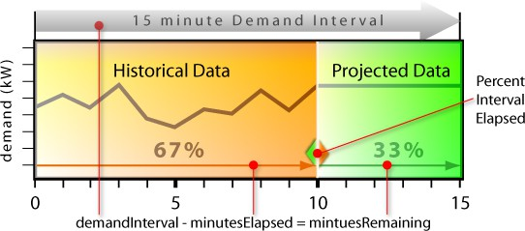
On the left are actual historical electricity demand data. On the right are projected data. The component uses the two data sets across a 15 minute demand interval to calculate the Projected Demand Average. In this example, the Percent Interval Elapsed property is set to 67. This causes the actual minutes elapsed over the 15 minute demand interval to equal 10 minutes and the minutes remaining to equal five minutes. The com- ponent averages the actual historical demand data over 10 minutes and uses the instantaneous demand taken at minute 11 to calculate an average projected data value for the remaining third of the period. Using these two numbers, it calculates the Projected Demand Average.
You configure Percent Interval Elapsed on the property sheet of the ElectricalDemandLimit component.

Using mostly projected values
This example uses mostly projected values to calculate the Projected Demand Average.
Assuming that the Demand Interval is set to 15 minutes and the Percent Interval Elapsed property is set to 7 (7%), the system calculates demand based on the current minutes demand reading which it projects for the remaining minutes in the Demand Interval window. The following example assumes that the Power In- put value is 400.
minutesElapsed = 15 * 6.67 / 100 = 1
minutesRemaining = 15 - 1 = 14
calculated total = (current Power Input * minutesRemaining) + Power Input from each mi- nutesElapsed interval
calculated total = (400 * 14) + 400 = 6000
projectedDemand = calculated total / (minutesElapsed + minutesRemaining) projectedDemand = 6000 / (1 + 14) = 400
By setting the Percent Interval Elapsed property to a value that corresponds to the first minute of the de- mand window, the system calculates demand based almost entirely on a projected data value.
In this case, the projected demand calculation uses the Power Input value at minute two (2) and averages de- mand across the remaining 14 minutes.

Using all recorded values
This example uses mostly recorded values to calculate the Projected Demand Average.
Assuming that the Demand Interval property is set to 15 minutes and the Percent Interval Elapsed property is set to 93%, the system calculates demand based completely on recorded demand readings for the current minute and the 14 previous minutes. Following, is an example of using all recorded values and no pro- jected values.
minutesElapsed = 15 * 93.33 / 100 = 14
minutesRemaining = 15 - 14 = 1
calculated total = (current Power Input * minutesRemaining)
+ Power Input from each minutesElapsed interval calculated total = (600 * 1) + 600 + 600 + 600 + 600 + 600
+ 600 + 600 + 600 + 600 + 400 + 400 +400 + 400 + 400 = 8000
projectedDemand = calculated total / (minutesElapsed
+ minutesRemaining)
projectedDemand = 8000 / (14 + 1) = 533
In this case, there would be no projected demand. Actual demand is used in this calculation.
This example assumes that the Power Input is currently 600 and has been at that level for the previous nine minutes, prior to that, the value was 400.
By setting the Percent Interval Elapsed to a value that corresponds to the last minute of the Demand In- terval, the projected output is a sliding window average of the minutely recorded Power Input values.

Using recorded and projected values
This example uses projected and recorded values to calculate the Projected Demand Average.
The EDL (Electrical Demand Limit) component defaults to a Percent Interval Elapsed property value of 75%. This setting configures the component to calculate demand based 75% on actual recorded Power Input property values and 25% on a projection, which assumes that demand will remain at the current level for the re- maining minutes in the Demand Interval.

How to manage demand for electricity
It is one thing to project future electricity demand, but how does the framework then manage the demand for power to reduce cost?
The framework divides a day into three periods. For each period, you configure a specific demand limit. The framework compares the Projected Demand Average to this Demand Limit at the current time of day and, based on this comparison, sheds or restores electrical load as appropriate. In other words, if the projected de- mand is higher than the demand limit for the current time of day, the system sheds power. If shedding is active, and the projected demand is lower than the demand limit for the current time of day, the system restores power.
Thirty-two power shed levels serve the shedding calculations. Each shed level value represents an amount by which to drop the power when that shed level is active. You configure these estimates manually in the Electri- calDemandLimit and ShedControl property sheets. They do not reflect live data. When the projected demand exceeds the Demand Limit for the current demand period, the component calculates how many loads to shed. You should set the Power Shed Level properties to demand values based on loads that are controlled by the specific shed group. The load shed logic calculates how much demand to reduce, and then uses the Power Shed Level values to determine how many of the loads to shed.
Shedding and restoring loads occurs in a fixed priority. The system sheds Power Shed Level1 first and restores it last.

Electrical demand reduction calculations
When Projected Demand Average exceeds the Demand Limit value for the current Demand Interval, the system calculates how many loads to shed.
You should set all available (or desired) Power Shed Level properties (1-32) to a demand value based on the loads that are controlled by the specific shed group.
An estimate of the demand associated with a group of equipment can be calculated if the operating voltage and current draw are known for the loads. This is an example of a calculation for single-phase loads:
W = V * A
W = 120 Volts * 30 Amps = 3600 Watts = 3.6 kW
The following is an example using the square root of 3 for three-phase loads:
W = V * A * 1.73
W = 480 Volts * 30 Amps * 1.73 = 24919 Watts = 24.9 kW
Assume that the current demand limit period is Demand Limit Period1, and the ElectricalDemandLimit compo- nent is configured as follows:

Figure 4 EDL example configuration
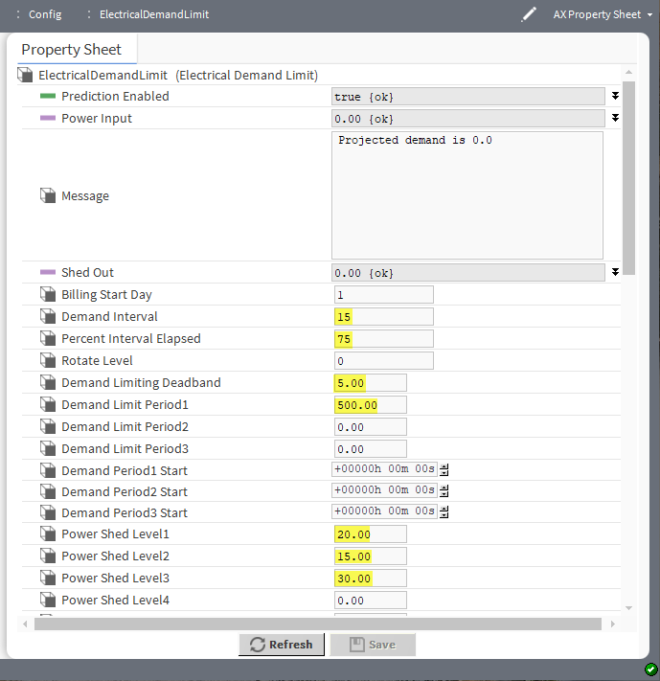
In addition, the calculated total is 7625 kW and the Projected Demand Average is 533 kW. These equations show the kW that needs to be shed:
targetIntervalTotal = demandLimit * (minutesElapsed + minutesRemaining) targetIntervalTotal = 500 * (11.25 + 3.75) = 7500
powerChange = (calculated total - targetIntervalTotal) / minutesRemaining powerChange = (7625 - 7500) / 3.75 = 33.33 KW that needs to be shed
Since Power Shed Level1 is only expected to reduce the demand by 20 kW, both Power Shed Level1 and
Power Shed Level2 must be shed to reduce the demand by an expected 35 kW combined.
The necessary loads are shed in sequential order during the same execution cycle, without evaluating the ac- tual impact on demand.
The load shed determination is based on the projected reduction in demand for each group.
Subsequent calculations may result in additional load shedding if the actual demand is not reduced below the demand limit.

Electrical demand reduction examples
This example shows a partial wiresheet view of an ElectricDemandLimit component configured for shedding energy loads. The current time period in this example is Demand Period2.

Figure 5 Wiresheet view of an EDL example application
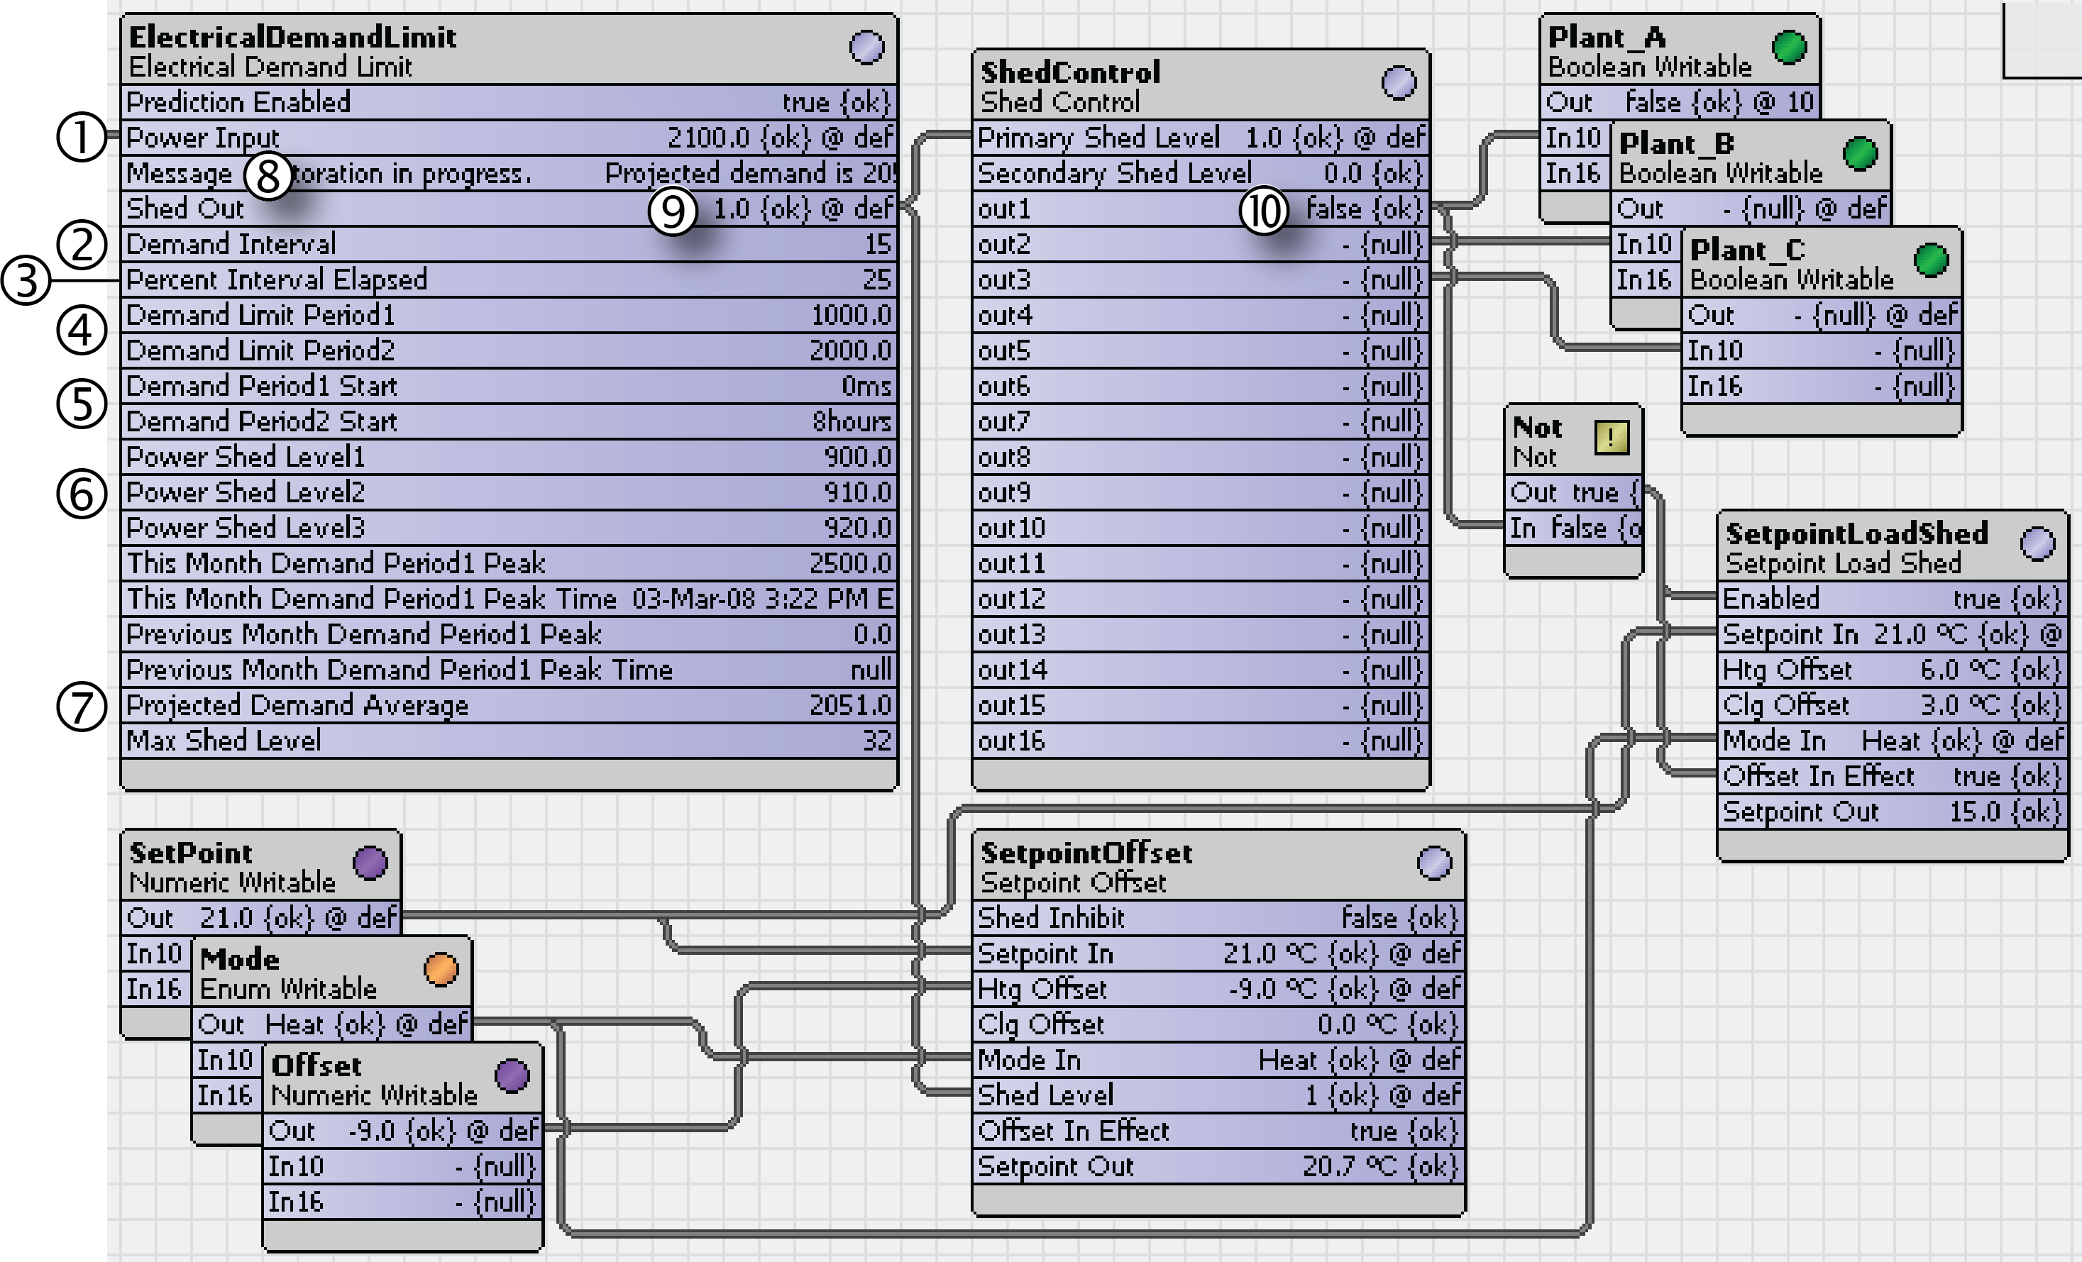
Power Input (1) reflects total demand, which is linked into the EDL component Power Input property. This is a single input value, therefore the power sources need to be totaled before linking because there is more than one meter supplying actual electrical demand data. This demand level value is expected to change in response to load shedding.
Demand Interval (2) is set to update every 15 minutes.
Percent Interval Elapsed (3) is set to 25 percent, which adds more weight to current demand and less weight to historical demand for each calculation of the Projected Demand Average.
Demand Limit Periods 1 and 2 (4) are set to 1000 and 2000, respectively. These values specify the demand levels that initiate power shedding.
Demand Period (5) start times for periods 1 and 2 are set to 0000 (midnight) and 0800 (8 am) respectively.
Demand Period3 Start time is not shown. These times specify the start time for each of the demand periods.
Power Shed Levels1–3 settings (6) are based on these estimates:
- By shedding loads associated with Power Shed Level 1, the amount of demand will decrease by 900 kW.
- Power Shed Levels 2 and 3 should be set at 910 and 920 respectively.
If these estimates are correct, shedding at level 3 reduces demand by the sum of all three shed levels: (900
+910+920)=270330 kW.
Projected Demand Average (7) has a current value of 2051.
Since this value is greater than the demand limits, the component initiates shedding and displays this message
(8): “SHEDDING REQUIRED ! Projected demand is 2051”.
The Shed Out (9) value of 1.0 indicates that one level is to be shed. This property links to a Shed Control com- ponent, which configures the specific Shed Level (1–16) links into Boolean controls. In the example, these con- trols shut off power to Plant_A, Plant_B, and Plant_C, with Shed Level(1, 2, and 3), respectively. In addition,

the ShedControl component’s out1 value (10) links to a SetpointLoadShed component that uses a setpoint off- set to reduce power usage.
You can also link from the Shed Out property to other energy components, such as a Setpoint Offset compo- nent (also shown here).
With a Shed Level1 in effect, Power Input is at 2100, and the Projected Average Demand value is 2051, still greater than the Demand Limit Period2 value of 2000. The Power Shed Level2 value (estimate) indicates that invoking a Power Shed Level2 yields a decrease of 910kW and brings the demand down below the limit. If this estimate is fairly accurate, actual power usage should drop and the Power Input value should lower to below the Demand Limit Period2 value.
The following wire sheet provides a close-up example of how to configure the ShedControl component.
Figure 6 ShedControl component example
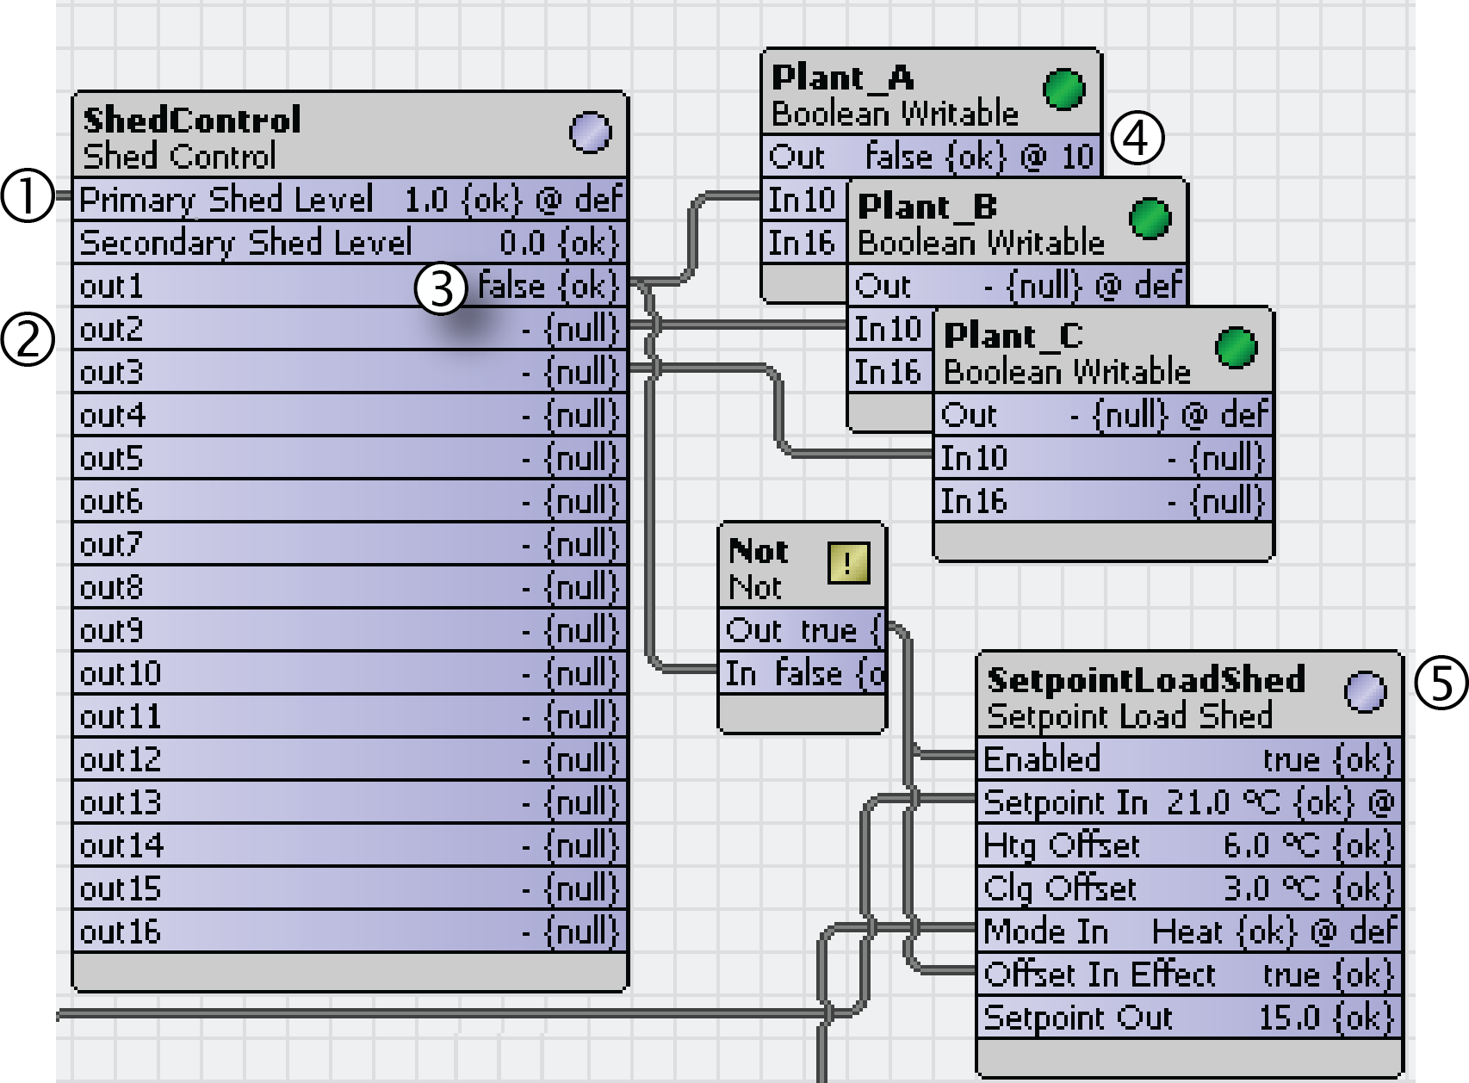
The Primary Shed Level (1) links from an EDL component. Its value is 1.0. No Secondary Shed Level is used.
Out1, 2, and 3 (2) link to Boolean controls that are set to turn off power to Plant_A, B, and C, respectively.
The current Primary Shed Level of 1.0 sets out1 (3) to false and the Plant_A Boolean control status (4) to
false. This should turn off power to any power consuming devices that are linked to this object.
The out1 value is also linked to the SetpointLoadShed component (5), which adjusts a setpoint to reduce the electrical demand.
If more shed levels are needed, the component sets out2 and out3 to false. If shed levels are no longer needed, the component invokes a restoration, which restores out3, out2, and out1, in that order, to null as al- lowed by the current shed level.

Reducing demand for electricity
Configuring shed and restoration control using the ElectricalDemandLimit component can reduce peak demand for electricity and save money.
Step 1 Drag the ElectricalDemandLimit component to the Nav tree or wire sheet and open its property sheet by double-clicking it.
Step 2 Enable the component by either linking to it in the wire sheet or by manually setting the Prediction Enabled property value to true.

Step 3 Configure the component properties.
Step 4 Set up any power input links including linking the Shed Out slot (output) to a ShedControl object.
This provides equipment shed and restoration control.
Based on how you configure the EDL component, the calculations direct that load shedding, load restoration, or no action be taken. With each calculation, the component updates and displays the projected average demand.

Lead-lag compensation example – kitControl
This topic provides an example of how to use the LeadLagCycle component to control when three pumps run. The purpose of controlling the three is to prevent them from drawing excess electricity by all three running at the same time.
The wire sheet for controlling the lag times for three pumps might look like this:
Figure 7 LeadLagCycle example with linked objects
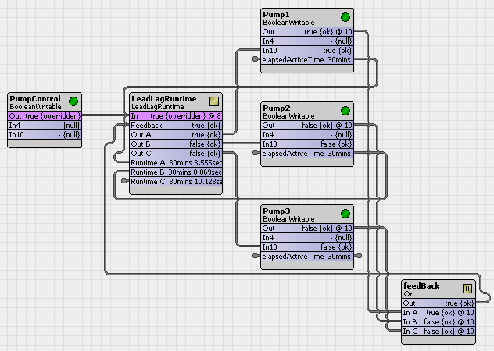
Each of the three BooleanWritable points has a DiscreteTotalizerExt with its changeOfStateCount slot linked back to a Cycle Count x input on the LeadLagCycles object (not visible in the illustration). The feedback Or ob- ject simulates feedback, fed through a BooleanDelay object. The following shows the configuration of the prop- erty sheet:

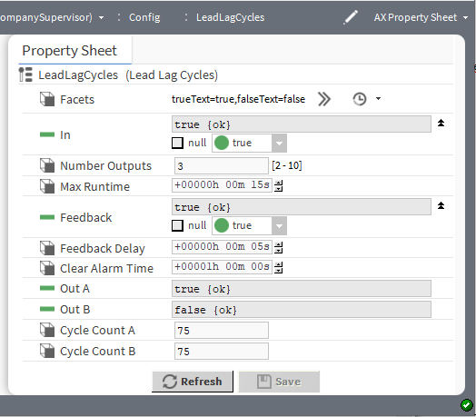
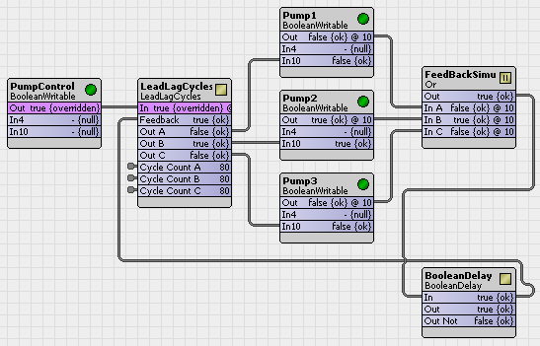
The wiresheet for controlling the runtime for three pumps might look like this:
Each of the three BooleanWritable points has a DiscreteTotalizerExt, with its elapsedActiveTime slot (1) ex- posed up in the composite of the parent point for link clarity. The feedback Or object (2) simulates feedback. The property sheet would look like this:

Figure 8 LeadLagRuntime properties
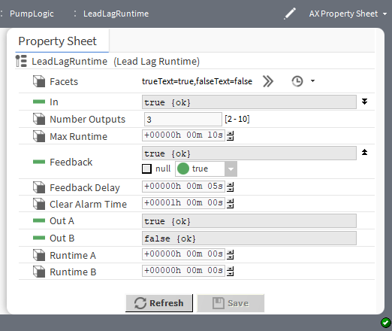

PID loop configuration
The LoopPoint component implements a simple PID (Proportional, Integral, Derivative) control loop. The following terms are used when describing the operation of the LoopPoint component.
- Process variable (PV): the controlled process, in other words, the value at the setpoint input, your starting point.
- Setpoint (setpt): the target for the process variable. In other words, the value at the setpoint output, your goal.
- Setpoint error(E_{S}): the difference between the process variable and the setpoint acted upon by the loop algorithm.
- Loop output: the correction signal produced by the loop algorithm. This value should be linked directly or in- directly to the NumericWritable component used to position a proportionally-modulated device, such as a valve or damper, that controls the process variable.
- Proportional gain (K_{P}): the value of the property Proportional Constant sets the overall gain of the loop as in this ratio:
K_{P} = Output range / affected process range (sometimes called throttling range)
- Throttling range: the amount of process variable change expected as a result of throttling the system be- tween the Minimum Output and Maximum Output.
- Bias: the algorithm typically adds this value to the output to correct any offset error in proportional calcula- tions and only as a control pivot output value for when PV = setpt.
- Action: defines the direction of the output relative to any setpoint error, where:
  - Direct means that the loop output increases when PV increases.
  - Reverse means that the loop output increases with PV decreases.
- Integral gain (K_{I}): is the value of the property Integral Constant used to set or reset the gain of the loop expressed in repeats per minute. This value reacts to the duration of the setpoint error.
- Derivative gain: is the value of the property Derivative Constant used to set the derivative or rate gain of the loop expressed in repeats per minute. This value reacts to the rate of change of the setpoint error providing a dampening effect.

Proportional-only control
P-only control is just reset action, where loop output is directly proportional to the magnitude of the setpoint er- ror (E_{S}) and the size of the proportional gain (K_{P}).
P-only loop output is linear, and is calculated as follows:
Output = (K_{P} x E_{S}) + bias (if action = direct) or Output = - ((K_{P} x E_{S}) + bias) (if action = reverse) where E_{S} = [PV - setpt]
If you are using proportional-only loop control, follow these guidelines:
- Output limits: Define the Maximum Output and Minimum Output properties for the loop output, noting that the maximum value must be greater than the minimum.
- Proportional Gain: Calculate and enter a proportionalConstant (K_{P}) property value starting with this formula:
[output range (maxOutput - minOutput)] / throttling range
where throttling range is the corresponding result in the process variable.
For example, for a temperature loop where a 0-to-100% loop output results in a 20 degree swing in the proc- ess variable, a starting point KP is:
[(100% - 0%)/ 20deg.] = [(100% / 20deg.] = 5
When tuning the loop, you can try increasing this value (effectively using only a portion of the throttling range) to eliminate the amount of setpoint error. However, if you increase the K_{P} too much, this typically re- sults in a constant oscillation of the process variable (above and below the setpoint).
- Bias: Assign the bias property an output-midpoint value (for example, 50.0). This allows for equal correc- tions for a process variable above or below setpoint.
- Integral and Derivitive Gain: Set the properties integralConstant and derivativeConstant to 0.0 (the defaults).

Proportional with Integral (PI) control
PI configuration is recommended for most control loops, because the integral term eliminates the setpoint offset inherent in P-only loops. PI control uses proportional gain to adjust the output, and then incrementally continues to add (or subtract, if appropriate) from the output value for as long as a setpoint error continues to exist.
PI loop output is calculated as follows:
Output = K_{P} x (E_{S} + K_{I} x ErrorSum) (if action = direct), or Output = - (K_{P} x (E_{S} ₊ K_{I} x ErrorSum)) (if action = reverse) where: E_{S} = [PV - setpt]
ErrorSum = Sum of E_{S} over time

Repeats per minute
The Integral Constant property specifies the integral gain (K_{I}) in repeats per minute. This is sometimes called a reset rate. To understand repeats per minute, consider the scenario where a loop is controlling at set- point. If a certain setpoint error occurs, say from a sudden setpoint change, the loop output immediately changes by a level corresponding to its proportional constant (acting on the P-term). During this hypothetical example, assume the controlled process does not react from any loop output change, but stays at the original value (setpoint error stays constant).
The loop’s integral term immediately begins increasing the output (or decreasing the output, depending on the direction of setpoint error) at specific rate determined by the integral term. Over the period of one minute, the amount of output change that would occur is defined by the Integral Constant (repeats per minute). A re- peat equals the amount of output change initially generated by the P-term. For example, if this loop was

configured with an Integral Constant value of 2.0, and the original output change was +7%, over a period of one minute the integral term would linearly ramp up the output value an additional +14%, or two repeats.
In a real-world PI loop, of course, the process variable does respond to an output change, and this continu- ously-linear ramping of the output would not occur. Instead, the process variable would start moving towards setpoint and the setpoint error would change (changing the proportional and integral terms, thus the loop output).

Integral overshot
The integral term of a PI loop can cause an “overshoot” of setpoint, meaning that the increased loop output may result in a new setpoint error in the opposite direction. In some cases, it is possible for this overshoot to continuously repeat (oscillation), which is typically undesired. However, a small amount of overshoot for an ini- tial correction is not uncommon.
To minimize overshoot, the PI loop’s integralConstant is typically kept small, and sized appropriately for the as- signed proportionalConstant.

Integral windup prevention
Integral windup is prevented by limiting the ErrorSum value based on the LoopPoint’s Maximum Output and
Minimum Output values.

Pi configuration guidelines
If using PI loop control, follow these guidelines:
- Output limits: Define the Maximum Output and Minimum Output properties for the loop output, noting that the maximum value must be greater than the minimum.
- Proportional gain: Calculate and enter a Proportional Constant (K_{P}) property value starting with this formula:
[output range (minOutput - maxOutput)] / throttling range
where throttling range is the corresponding result in the process variable.
For example, for a temperature loop where a 0-to-100% loop output results in a 20 degree swing in the proc- ess variable, a starting point K_{P} is:
[(100% - 0%)/ 20deg.] = [(100% / 20deg.] = 5
When tuning a PI loop, you typically reduce the Proportional lConstant value, because the integral ef- fect on the output will correct setpoint error over time.
- Bias: Assign a value of 0.0 (no output bias). A fixed bias is not desired, because the integral term of the loop effectively creates an adjustable bias, as needed.
- Integral Gain: Set the integral gain (property Integral Constant) to a nominal value, typically less than one (1.0). A value of 0.5 is a good starting point for many loops. Decreasing the integral constant makes the loop respond more slowly.
- Deravitive Gain: Disable derivative by setting the Derivative Constant property at 0.0 (the default).

Proportional with Integral and Derivative (PID) control
PID loop control can be difficult to tune and (often for this reason) is seldom used. However, in certain cases, PID control may be needed. An example is the control of a process with a long reaction time, such as tempera- ture control of a large mass. For such a lag-oriented system, the derivative component of the PID loop output can help prevent overshoot that might otherwise result from PI control.
The derivative gain (K_{D}) exerts an anticipating braking effect on the loop output, based on the rate-of-change of the process.
PID loop output is calculated as follows:
Output = K_{P} x (E_{S} + K_{I} x ErrorSum + K_{D} x ((E_{S} - LastE_{S}) / deltaT)) if action = direct) or

Output = -(K_{P} x [E_{S} + K_{I} x ErrorSum) + K_{D} x ((E_{S} - LastE_{S}) / deltaT))) (if action = reverse) where: E_{S} = [PV - setpt]
ErrorSum = Sum of E_{S} over time deltaT = time between samples
In the LoopPoint, the Derivative Constant property specifies the derivative gain (K_{D}) directly in seconds (note this differs from some systems using derivative in minutes).
If using PID control, follow the same PI configuration as for Proportional with Integral (PI) control, with the addi- tion of defining a positive value as the Derivative Constant. In general, a Derivative Constant less than 10 seconds should be tried first, and only then increased (if necessary), providing that the loop output re- mains stable at steady-state conditions.
Following is an example of a wire sheet for a loop point.
Figure 9 Example LoopPoint in a wire sheet, linked to other components
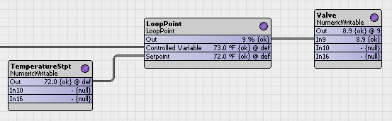
The following is the property sheet for the above example.
Figure 10 Example LoopPoint property sheet
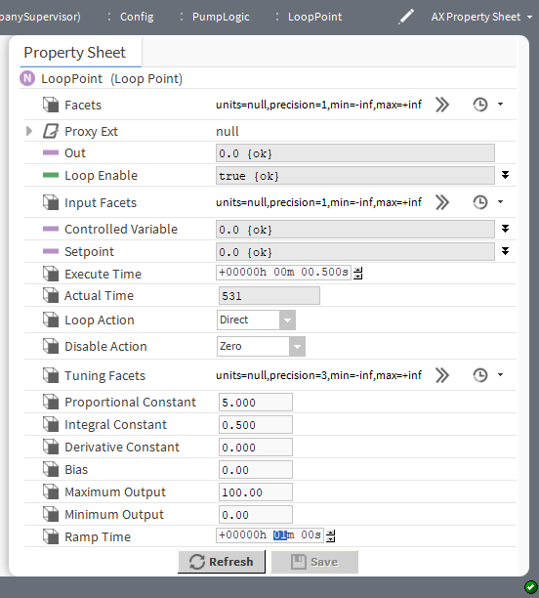

Night time heat configuration
At night the air supply to a building needs to provide the least amount of heat. The NightPurge kitControl com- ponent configures air supply to meet this requirement.
Two wire sheets demonstrate how the night time purge works.
Figure 11 NightPurge application: purge enabled and active
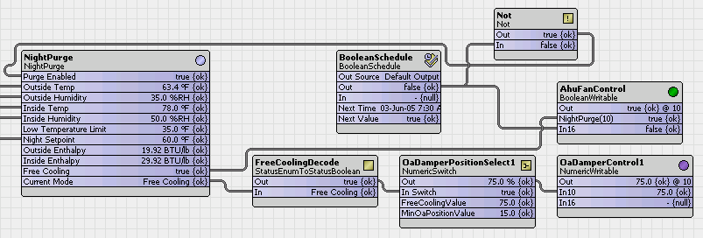

Figure 12 NightPurge application: purge disabled
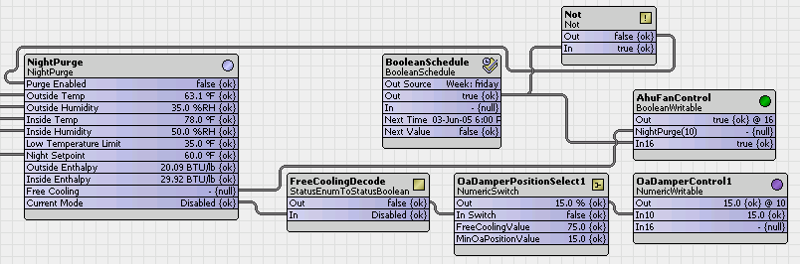
The following is an example of a NightPurge property sheet.

Figure 13 NightPurge property sheet
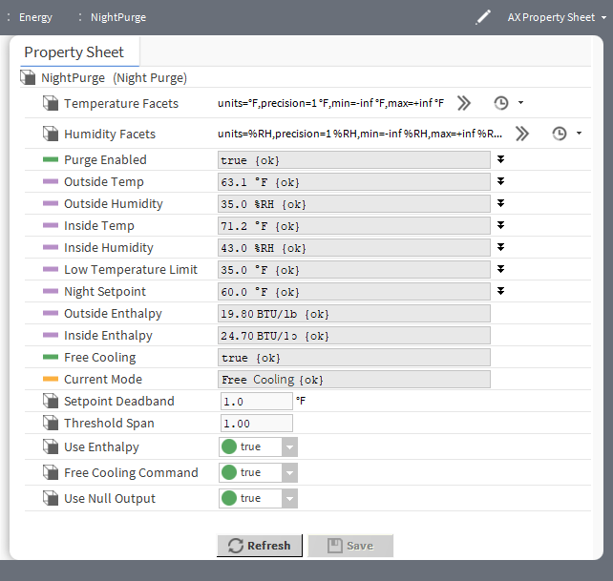

Reversible actuator control
A typical application for the RaiseLower component is to control a reversible actuator to drive a coupled valve or damper either open or closed.
The external hardware device consists of two on-board relays with volt free contacts that switch to provide power to either the open or the close command of the actuator. The component activates either relay for a pro- portion of the full scale drive time of the actuator (drive time is pre-defined by the manufacturer).
Figure 14 RaiseLower component
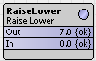
The acceptable input to this device is 0 to 10 volts, with staged control at 0v, 4v, 7v and 10v as detailed below:

Volts | Raise | Lower | Function
0 | Off | Off | Off
4 | Off | On | Lower
7 | Off | Off | Static
10 | On | Off | Raise

Figure 15 Example using the RaiseLower component
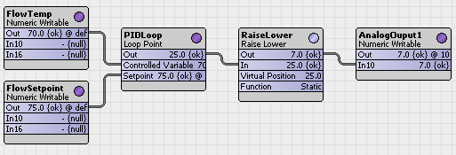
The wire sheet is an example of an actuator configured for a 100 second full-scale drive time. The initial actua- tor and virtual position values of are set at 0% (synchronized at fully lowered). Should the input signal increase to 40 percent, the raise output turns on for 40 percent of the full scale drive time (40 sec). A subsequent input decrease to 15 percent lowers the output to 25 percent of full scale drive time (25 sec) moving the actuator to 15 percent open.

Heating and cooling management to reduce energy consumption
In a simple model, a schedule can control when the heat or air conditioning turn on and off. Using the Optimi- zedStartStop kitControl component you can configure a more sophisticated automatic system that optimizes heating and cooling start and stop times based on actual outside and inside temperatures.
To conserve energy in a building, the OptimizedStartStop kitControl component serves two goals:
- Turn the heating or cooling equipment on at the latest possible time while still providing a comfortable tem- perature during building occupancy.
- Turn the same equipment off at the earliest possible time, allowing the building to “drift” while staying within a comfortable temperature range until it is no longer occupied.
Starting and stopping heating or cooling equipment are valid schedule events, which you link to the Optimized- StartStop component. Setting the component’s Start Enable or Stop Enable property to true initiates the heating or cooling event on behalf of the schedule. Once started or stopped, the component runs a calculation 15 seconds after the beginning of every minute until the next event, which is not already set in the schedule.
The result of the calculation is called the Calculated Command Time. The value of this property determines the next scheduled event: an early start command to achieve a specified temperature range by the time the building is occupied or an early stop command without sacrificing the temperature range by the time the space is unoccupied. After a schedule invokes the Calculated Command Time, the component analyzes the actual area response (temperature change rate) and makes weighted adjustments to the calculation parameters based on the detected values so that subsequent calculations might be more accurate.
If one of the enable values (Start Enable or Stop Enable) is scheduled to be set to true in one hour, but is already true, the component performs no calculation even if Start Enable or Stop Enable is set to true.

Calculated start and stop times
The OptimizedStartStop component optimizes only one start sequence per day. You can perform multiple stop operations but no optimized stop can occur before the time specified by the Earliest Stop Time property.
These factors define the calculated start time:

Temperature differential
If the inside (space) temperature is outside the range defined by the lower and upper comfort limits, the dif- ference between the space temperature and the closer limit represents the number of degrees the mechani- cal equipment must make up during the prestart (optimized) period.

Run-time minutes

Whether to heat or cool depends on the direction that the space temperature must move. The component multiplies this run-time value by the temperature differential to determine the number of run-time minutes re- quired to achieve the comfort limit at occupancy time, as defined by the schedule's start time.

Optimum start time
This is the best time to start heating or cooling before the scheduled start for the day. If the system’s time is later than the schedule’s time offset by the calculated lead time, the component enables optimum start outputs.
NOTE: If the calculated lead time is so large that an optimum start time prior to midnight is the result, the op- timum start occurs at midnight. The component performs an optimum start only before the first scheduled start for the day.
Similar factors define stop time:

Temperature differential
If the inside (space) temperature is inside the range defined by the lower and upper comfort limits and if the schedule’s status is active, the difference between the space temperature and one of the limits (depending on the mode) represents the number of degrees the temperature can drift between the time the mechanical equipment is stopped and the schedule’s inactive event time.

Drift time
The drift (lead time) calculation is similar to the one for start time but using the drift-time heating and cooling factors.

Optimum stop time
The component invokes the optimum stop time for each of the schedule’s inactive events based on the drift time and Next Event Time value.

Optimized start example
To optimize performance, the framework turns an air handling unit on and off based on a weekly schedule.
Figure 16 A simple OptimizedStartStop component wire sheet
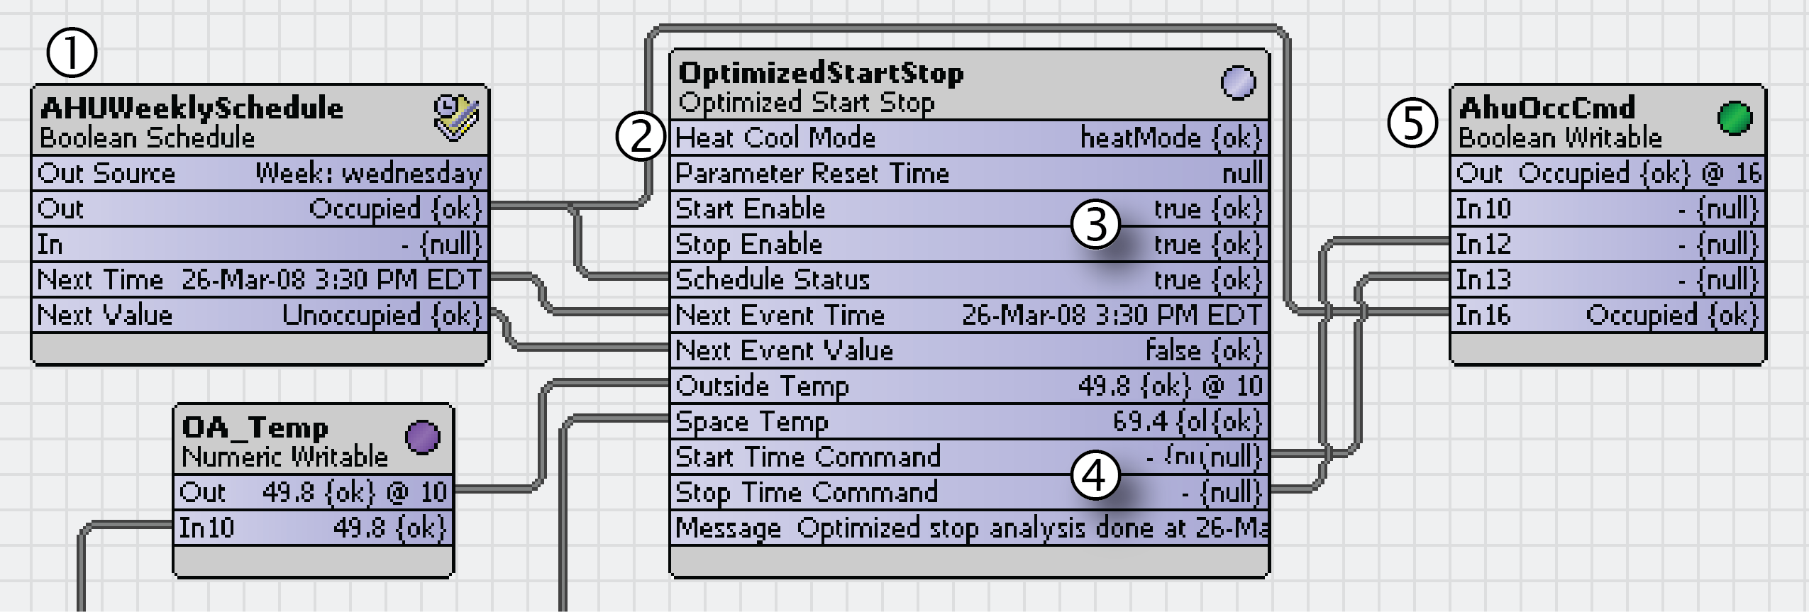
In this example:
- A weekly schedule specifies occupancy times and is linked to the component for calculations (1). The schedule is also linked directly (bypassing the component) to the In16 property (lowest priority in this case) of the occupancy control point (AhuOccCmd) (2).
- The components Start Enable and Stop Enable properties (3) are both true. This means that both op- timized starts and optimized stops are enabled.
- The Start Time and Stop Time Commands (4) are linked to priority inputs In12 and In13 respectively of the occupancy control point (AhuOccCmd) (5). These commands are true when an optimal start or stop con- dition is required, otherwise the outputs are set to null, which relinquishes control to the next higher priority level.

Figure 17 Another OptimizedStartStop component wire sheet
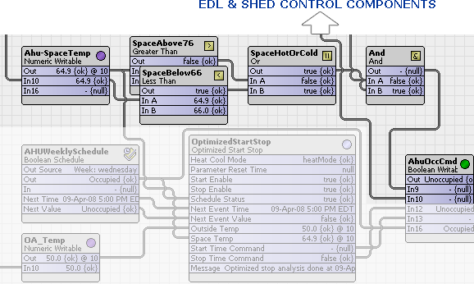
Additional logic is linked into the occupancy command component (AhuOccCmd) to control which logic has pri- ority on specifying the AhuOccCmd Boolean point status, as follows:
  - In9 temperature control overrides a demand limiting link from an EDL component to In10. This prevents a load shed if the comfort range that can be configured is exceeded.
  - In10 (demand limiting link from the EDL component) overrides an OptimizedStartStop component’s Stop link into In12.
  - In12 (OptimizedStartStop component’s Stop link) overrides a Start link into In13 (as described above).
  - In13 (optimal start) overrides the schedule link to In16 (lowest priority) (as described above).

Hot water control setpoint based on outside air temperature
A Reset math object establishes a hot water control setpoint based on the outside air temperature at InA. The Reset component is located in the Math folder of the kitControl palette.
Figure 18 Reset properties
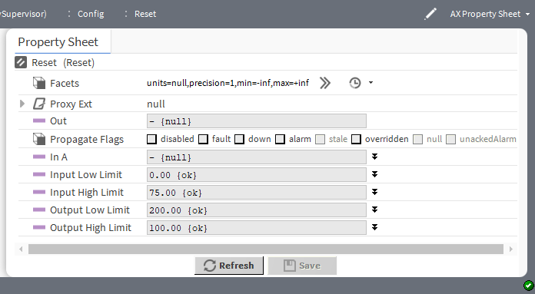
When the outside air temperature is 0° F, the hot water setpoint is 200° F. When the outside air temperature is 75° F, the hot water setpoint is 100° F. The Reset object is configured as:
  - Input Low Limit = 0.0

- Input High Limit = 75.0
- Output Low Limit = 200.0
- Output High Limit = 100.0
If the InA value is beyond the input limits, the output is limited by the corresponding output limit (in this case, 200 at 0° F or below, 100 at 75° F or above). When the input is at an intermediate value, the output scales line- arly. For example, when the outside air temperature is at 38.2° F, the Reset output is 149.1° F.

Data gathering
These examples illustrate how to configure Latch components to collect Boolean and numeric data. Each latch component contains a Clock property and a Latch action. Either can trigger the collection of data (capturing the In value from a control point and making it available as an Out value).
The examples are similar, in that they all use a Schedule component to invoke a latch. Other components may be used to invoke a latch, however, any latch you invoke using the Clock property must include a method for setting the Clock property status back to false before the clock is available for latching again. The third ex- ample illustrates the use of a latch component's latch action instead of using the Clock property.

Chapter 3 Alarm components

Topics covered in this chapter
- kitControl-AlarmCountToRelay
- kitControl-ChangeOfStateCountAlarmExt
- kitControl-ElapsedActiveTimeAlarmExt
- kitControl-LoopAlarmExt

Components include services, folders and other model building blocks associated with a module. You may drag them to a property or wire sheet from a palette. The Alarm folder in the kitControl palette contains four spe- cial-purpose alarm extensions.
Two extensions are for Boolean type points that also have one or more DiscreteTotalizerExt extensions:
  - ChangeOfStateCountAlarmExt
  - ElapsedActiveTimeAlarmExt
These extensions provide alarm capability based upon COS count and runtime (elapsed active time). To use ei- ther (or both) of these extensions in the parent Boolean point (BooleanPoint, BooleanWritable) place them under the corresponding DiscreteTotalizerExt.
The LoopAlarmExt provides a sliding-limit type alarm for a LoopPoint. Its calculations are based on control devi- ation from a setpoint.
You can configure the AlarmCountToRelay extension to monitor the number of alarms (alarm count) of a linked Alarm Class component. AlarmCountToRelay features a timed Boolean relay output.
An additional alarm extension, StringChangeOfValueExt is in the alarm palette. This extension generates an alarm upon inclusion or exclusion of a particular string value, or more accurately, regular expression (regexp) of a point's Out slot (string type).
The descriptions included in the following topics appear as headings in documentation. They also appear as context-sensitive help topics when accessed by:
  - Right-clicking on the object and selecting Views→Guide Help
  - Clicking Help→Guide On Target

kitControl-AlarmCountToRelay
This component links from an Alarm Class component to monitor alarm count and send an associated Boolean output to a relay when the alarm count increases.
AlarmCountToRelay is in the Alarm folder of the kitControl palette.
The alarm count type to monitor is optional and includes the alarm states or statuses. Use this component in se- curity applications or situations to connect the occurrence of a new alarm with an event, such as a light, horn, or other signal, which requires a relay connection.

Figure 19 AlarmCountToRelay property sheet
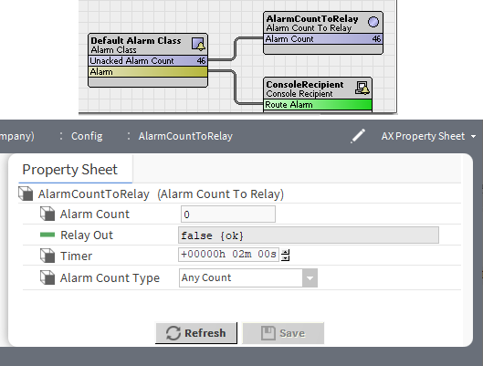
The screen capture shows an AlarmCountToRelay component that is linked to the Unacked Alarm Count property. In this example, the unacknowledged Alarm Count is 46. Any increase in this number causes the Re- lay Out property to change status from false to true for a time equal to the value of the Timer property.

Property | Value | Description
Alarm Count | number | Displays the current alarm count for an alarm class component that is linked to this component. The numeric value of this prop- erty dynamically displays the number of alarms of the type specified in the Alarm Type Count property.
Relay Out | read-only true or false {ok} (default) | Provides a Boolean output value for linking into a relay control component.  false indicates no change in the alarm count.  true indicates a change in the Alarm Count (alarm count is ac- tive). When an Alarm Count increases, the framework changes this property from false to true and maintains this status for the amount of time specified by the Timer property value.
Timer | hours minutes sec- onds (defaults to two minutes) | Defines how long to hold the Relay Out in the active (true) state.
Alarm Count Type | drop-down list | Selects the type of alarm for which to monitor the count.  Any Count links from any type of alarm to the Alarm Count property.  Unacked Alarm Count links from the Unacked Alarm Count property on an Alarm Class component to the Alarm Count property of this component.  Open Alarm Count links from the Open Alarm Count property on an Alarm Class component to the Alarm Count property of this component.  In Alarm Count links from the In Alarm Count property on an Alarm Class component to the Alarm Count property of this component.

EC-Net4 KitControl Guide Chapter 3 Alarm components

kitControl-ChangeOfStateCountAlarmExt
This special-purpose alarm extension is especially for use as a child of a BooleanPoint or BooleanWritable that has one or more DiscreteTotalizerExt extensions. It provides alarming on COS (change of state) counts, using the offNormal property errorLimit.
ChangeOfStateCountAlarmExt is available in the Alarm folder of the kitControl palette, along with a Elap- sedActiveTimeAlarmExt (for runtime-based alarms). Both extensions can reference the same DiscreteTotalizerExt.
In the parent Boolean point, order the ChangeOfStateCountAlarmExt slot below the DiscreteTotalizerExt slot that it references. In the ChangeOfStateCountAlarmExt’s Offnormal container, use the Discrete Totalizer Select property to reference the DiscreteTotalizerExt.
The properties for this extension are the same as those for a standard framework alarm extension. Refer to the
.

kitControl-ElapsedActiveTimeAlarmExt
This component is a special-purpose alarm extension, which is especially for use as a child of a BooleanPoint or BooleanWritable that has one or more DiscreteTotalizerExt extensions. It provides alarming on runtime (elapsed active time), using the offNormal property errorLimit.
ElapsedActiveTimeAlarmExt is available in theAlarm folder of the kitControl palette along with a ChangeOf- stateCountAlarmExt extension for COS-based alarms. You can use both extensions to reference the same DiscreteTotalizerExt.
In the parent Boolean point, order the ElapsedActiveTimeAlarmExt slot below the DiscreteTotalizerExt slot that it references. In the ElapsedActiveTimeAlarmExt’s Offnormal container, use the Discrete Totalizer Se- lect property to reference the DiscreteTotalizerExt.
The properties for this extension are the same as those for a standard framework alarm extension. Refer to the
Alarms Guide.

kitControl-LoopAlarmExt
This component is a special-purpose alarm extension, especially for the use as a child of a LoopPoint compo- nent. It provides alarming as a deviation from the current setpoint (plus or minus), using offnormal properties er- rorLimit and deadband. As of EC-Net 4.14, when the Low Diff Limit Enabled property is set to true, a Low Diff Limit is defined that may differ from the existing error limit. Once Low Diff Limit Enabled is set to true, the Low Diff Limit property will be used by the algorithm.
LoopAlarmExt is available in the Alarm folder of the kitControl palette.
The properties for this extension are the same as those for a standard framework alarm extension. Refer to the
Alarms Guide.

Chapter 4 Constant components

Topics covered in this chapter
- kitControl-BooleanConst
- kitControl-EnumConst
- kitControl-NumericConst
- kitControl-StringConst

Components include services, folders and other model building blocks associated with a module. You may drag them to a property or wire sheet from a palette. Each of these components provides a linkable status-type out- put value, and offers a default action for changing its value.
A constant may be handy when the same target property of multiple components needs to be adjusted simulta- neously. Constants may also help to clarify logic on a wire sheet.
The descriptions included in the following topics appear as headings in documentation. They also appear as context-sensitive help topics when accessed by:
- Right-clicking on the object and selecting Views→Guide Help
- Clicking Help→Guide On Target

kitControl-BooleanConst
This component provides a constant status Boolean value with two actions to set. BooleanConst is available in the Constants folder of the kitControl palette.
It provides a linkable status-type output value, and two actions for changing its value: Active (true) and Inactive (false).
Figure 20 BooleanConst properties
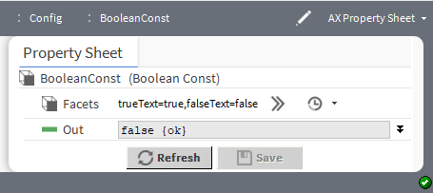

Property | Value | Description
Facets | Config Facets win- dow (defaults to true and false) | Defines a range of enumerated states ( Boolean values).
Out | StatusBoolean true and false (default) and null definition | Shows the current binary state of the point (on or off).

kitControl-EnumConst
This component provides a constant EnumStatus value, with available action to Set.

EnumConst is available in the Constants folder of the kitControl palette.
It provides a linkable status-type output value, and two actions for changing its value: Active (true) and Inactive (false). A constant may be handy when the same target property of multiple components needs to be adjusted simultaneously. Constants may also help to clarify logic on a wire sheet.
Figure 21 EnumConst properties
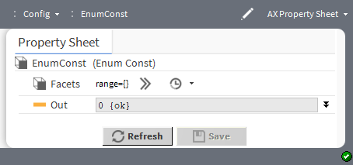

Property | Value | Description
Facets | Config Facets win- dow (defaults to zero (0)) | Defines a range of enumerated states (Enum values).
Out | enumerated list (defaults to zero (0), that is, no list) | Shows the current enum value associated with the point.

kitControl-NumericConst
This component provides constant StatusNumeric value, with available action to Set. NumericConst is available in the Constants folder of the kitControl palette
Constant components are far simpler than writable control points (no priorities, status processing, and so forth). Constant components provide a linkable status-type output value and a default Set action for changing that val- ue. This type of object may be handy when the same target property of multiple components needs to be ad- justed simultaneously. Constants may also help clarify logic on a wire sheet.
Figure 22 NumericConst properties
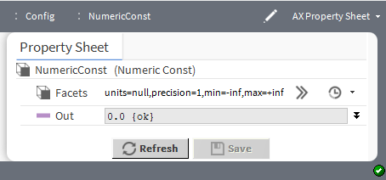

EC-Net4 KitControl Guide Chapter 4 Constant components

Property | Value | Description
Facets | Config Facets win- dow (defaults to null for units, one decimal place for precision, negative infinity for mini- mum, and positive infinity for maximum) | Selects units and configures how the value displays:  units defines the unit of measure from acceleration to  volumetric flow.  precision defines the number of decimal places.  min defines the lowest value allowed.  max defines the highest value allowed.
Out | number (defaults to zero (0)) | Shows the current binary state of the point (on or off).

kitControl-StringConst
This component Provides constant StatusString value, with available action to Set. StringConst is available in the Constants folder of the kitControl palette.
Figure 23 StringConst properties
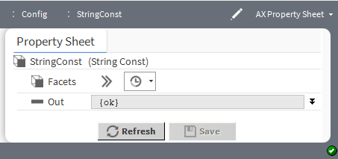

Property | Value | Description
Facets | Config Facets win- dow (defaults to blank) | Associates a key with one or more phrases.
Out | text (defaults to blank) and null definition | Displays the phrase associated with the point.

Chapter 5 Conversion components

Topics covered in this chapter
- kitControl-BooleanToStatusBoolean
- kitControl-DoubleToStatusNumeric
- kitControl-EnumToStatusEnum
- kitControl-FloatToStatusNumeric
- kitcontrol-IntToStatusNumeric
- kitControl-LongToStatusNumeric
- kitControl-StringToStatusString
- kitControl-StatusBooleanToBoolean
- kitControl-StatusEnumToEnum
- kitControl-StatusEnumToInt
- kitControl-StatusEnumToStatusBoolean
- kitControl-StatusEnumToStatusNumeric
- kitControl-StatusNumericToStatusEnum
- kitControl-StatusNumericToDouble
- kitControl-StatusNumericToFloat
- kitControl-StatusNumericToInt
- kitControl-StatusStringToStatusNumeric
- kitControl-StatusNumericToStatusString
- kitControl-NumericUnitConverter

Components include services, folders and other model building blocks associated with a module. You may drag them to a property or wire sheet from a palette. In most cases, a conversion object takes an input value and makes it available in the object’s output as a different type of data. Prior to AX-3.6, they typically served to link different data types. This functionality is now standard, which means that for most applications you do not need a conversion component. Instead, the framework automatically converts data type between linked components.
The descriptions included in the following topics appear as headings in documentation. They also appear as context-sensitive help topics when accessed by:
- Right-clicking on the object and selecting Views→Guide Help
- Clicking Help→Guide On Target

kitControl-BooleanToStatusBoolean
This component links (converts) the simple Boolean value (a non-status value) in an extension or other compo- nent (In property) to the Out property of a point or kitControl object (a StatusBoolean value). This component is the reverse of the StatusBooleanToBoolean component.
BooleanToStatusBoolean is available in the Conversion folder of the kitControl palette.

Figure 24 BooleanToStatusBoolean properties
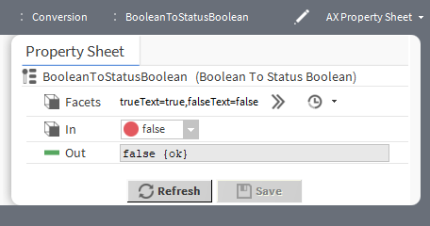

Property | Value | Description
Facets | Config Facets win- dow (defaults to true and false) | Defines the text to display for each boolean value.  trueText configures the text to describe the state when the component returns true.  falseText configures the text to describe the state when the component returns false.  This definition applies to the In property value. What text to de- fine depends on how you are using the component.
In | true and false  (default) | Displays the source simple non-status value.
Out | read-only Status- Boolean true and false | Displays the converted target status value.

kitControl-DoubleToStatusNumeric
This component converts a double value to StatusNumeric.
DoubleToStatusNumeric is available in the Conversion folder of the kitControl palette.
The conversion object is often used in a AX-3.5 or earlier host. This component links from the source non-sta- tus value of a property in an extension or other component to the target In property of a point or kitControl ob- ject (status value).
Figure 25 DoubleToStatusNumeric properties
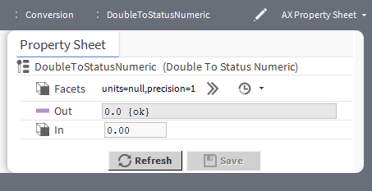

Property | Value | Description
Facets | Config Facets win- dow (defaults to null for units and one decimal place of precision) | Selects units and configures how the value displays:  units defines the unit of measure from acceleration to  volumetric flow.  precision defines the number of decimal places.  This definition applies to the In value for this component.
Out | read-only number | Displays the converted status numeric value.
In | number (defaults to zero (0)) | Displays the source double value.

kitControl-EnumToStatusEnum
This component converts an Enum value to StatusEnum, one of multiple enumerated states in the operating range of a component.
EnumToStatusEnum is available in the Conversion folder of the kitControl palette.
The conversion object is often used in a AX-3.5 or earlier host. This component links from the source non-sta- tus value of a property in an extension or other component to the target In property of a point or kitControl ob- ject (range of StatusEnum values).
Figure 26 EnumToStatusEnum properties
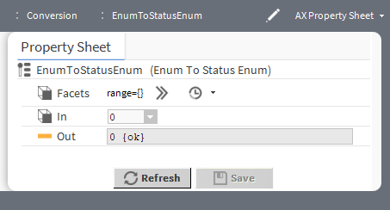

Property | Value | Description
Facets | Config Facets win- dow (defaults to blank) | Defines a range of enumerated states (enum values) This value applies to the In property of this component.
In | number (defaults o zero (0)) | Displays the source non-status enum value.
Out | read-only enumer- ated value | Displays the converted target status enum value.

kitControl-FloatToStatusNumeric
This component converts a Float value to a StatusNumeric.
FloatToStatusNumeric is available in the Conversion folder of the kitControl palette.
The conversion object is often used in a AX-3.5 or earlier host. This component links from the source non-sta- tus Out value of a property in an extension or other component to the target In property of a point or kitControl object (StatusNumeric value).

Figure 27 FloatToStatusNumeric properties
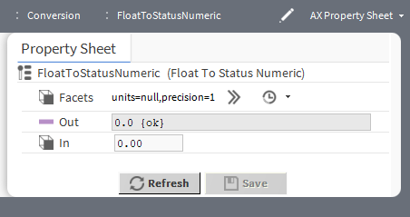

Property | Value | Description
Facets | Config Facets win- dow (defaults to null and a single decimal position) | Selects units and configures how the values displays:  units define the unit of measure from acceleration to  volumetric flow.  precision defines the number of decimal places. This configuration applies to the In property value.
Out | read-only number | Displays the converted target status numeric value.
In | number | Displays the source float value.

kitcontrol-IntToStatusNumeric
This component converts an Int (integer) value to StatusNumeric. IntToStatusNumeric is in the Conversion folder of the kitControl palette.
The conversion object is often used in a AX-3.5 or earlier host. This component links from the source integer value of a property in an extension or other component to the target In property of a point or kitControl object (StatusNumeric value).
For example, to link the changeOfStateCount property of a BooleanPoint’s DiscreteTotalizer extension to a math object input, you would link an IntToStatusNumeric between the two.
Figure 28 IntToStatusNumeric properties
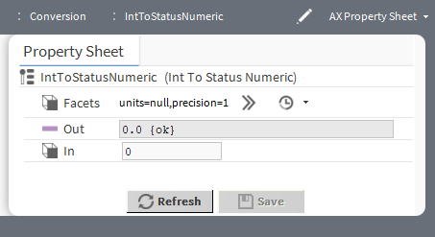

Property | Value | Description
Facets | Config Facets win- dow (defaults to null for units and one decimal place for precision) | Selects units and configures how the values display:  units defines the unit of measure from acceleration to  volumetric flow.  precision defines the number of decimal places. This configuration applies to the In property value.
Out | read-only number | Displays the converted target status numeric value.
In | number | Displays the source integer value.

kitControl-LongToStatusNumeric
This component converts a Long value to StatusNumeric.
LongToStatusNumeric is available in the Conversion folder of the kitControl palette.
The conversion object is often used in a AX-3.5 or earlier host. This component links from the source non-sta- tus Out value of a property in an extension or other component to the target In property of a point or kitControl object (StatusNumeric value).
Figure 29 LongToStatusNumeric properties
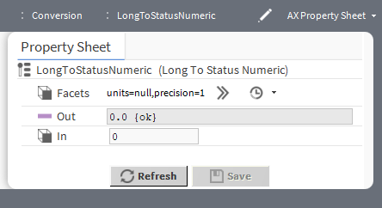

Property | Value | Description
Facets | Config Facets win- dow (defaults to null for units and a single decimal place) | Selects unit and configures how the value displays:  units defines the unit of measure from acceleration to  volumetric flow.  precision defines the number of decimal places. This configuration applies to the In property value.
Out | read-only number | Displays the converted target status numeric value.
In | number | Displays the source long value.

kitControl-StringToStatusString
This component converts the string In value to a StatusString Out value. StringToStatusString is available in the Conversion folder of the kitControl palette.

Figure 30 StringToStatusString properties
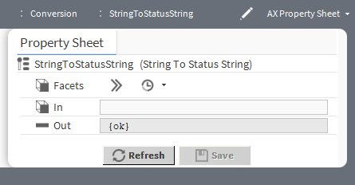

Property | Value | Description
Facets | Config Facets win- dow (defaults to blank) | Associates a key with one or more phrases.
In | text | Displays the source simple phrase (text string).
Out | read-only text | Displays the converted target phrase (status string).

kitControl-StatusBooleanToBoolean
This component converts a StatusBoolean In value to a simple Boolean Out value. This component is the re- verse of the BooleanToStatusBoolean component.
StatusBooleanToBoolean is available in the Conversion folder of the kitControl palette.
This component converts an units output from a source component to the units of the target component. Such conversion is automatic. But, if needed, you can use this component to convert between:
- Source Out of a point, kitControl, or Schedule object (status value), to a
- Target non-status In value of a property in an extension or other component.
For example, to link the Out of a Schedule object to the Enabled property of a history extension of a point or object, you link a StatusBooleanToBoolean object between the two.
Figure 31 StatusBooleanToBoolean properties
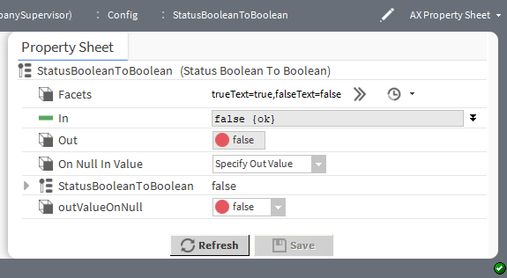

Property | Value | Description
Facets | Config Facets win- dow (defaults to true and false) | Defines the text to display for each Boolean value.  trueText configures the text to describe the state when the component returns true.  falseText configures the text to describe the state when the component returns false.  This definition applies to the In property value. What text to de- fine depends on how you are using the component.
In | true and false  (default) | Displays the source status Boolean value.
Out | read-only Status- Boolean true and false | Displays the converted target simple Boolean value.
On Null In Value | drop-down list (de- faults to Use In Value) | Configures how to handle null values.  Use In Value outputs the In default value when the result of the conversion is null. Normally, the Fallback property for a given point defines the meaning of null as 0.0. If, during configu- ration, the null status check box is unchecked and another value entered and saved, the changed value becomes the new null value for the point.  For example, a NumericWritable point (proxy point) positions a damper from 0 to 100% open. In the point’s configuration, its Fallback property defaults to a null value of 0.0. If this null sta- tus is unchecked and another value, such as 20, is entered and saved, the new value becomes the default when the value for the point is null.  If this modified component links to another StatusNumeric prop- erty, the framework ignores the null value. But, if connected to a StatusBooleanToBoolean, the result of a null input value de- faults to the changed value, which may not be what you intended.  Specify Out Value adds the Out Value On Null property to this component. Configure it to return a reasonable value when the In value is null.
Out Value On Null | number | Defines an Out value for the conversion object when its In val- ue has a null status.

kitControl-StatusEnumToEnum
This component converts a StatusEnum In value to a simple Enum Out value. StatusEnumToEnum is available in the Conversion folder of the kitControl palette.

Figure 32 StatusEnumToEnum properties
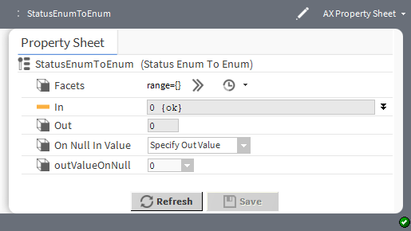

Property | Value | Description
Facets | Config Facets win- dow (defaults to blank) | Defines a range of enumerated states(enum values). This configuration applies to the Out property value.
In | number (defaults to 0) and null definition | Displays the source status enum value.  When null is checked, the value displayed defaults to the incom- ing value from the device. If you remove the check mark you can configure theIn value.
Out | read-only enumer- ated value | Displays the converted target simple enum value.
On Null In Value | drop-down list (de- faults to Use In Value) | Configures how to handle null values.  Use In Value outputs the In default value when the result of the conversion is null. Normally, the Fallback property for a given point defines the meaning of an Enum null as zero (0). If, during configuration, the null status check box is unchecked and another value entered and saved, the changed value becomes the new null default value for the point.  If this modified component links to another StatusEnum prop- erty, the framework ignores the null value. But, if connected to a StatusEnumToEnum component, the result of a null input value defaults to the changed value, which may not be what you intended.  Specify Out Value adds the outValueOnNull property to this component. Configure it to return a reasonable value when the In value is null.
Out Value On Null | number | Defines an Out value for the conversion object when its In val- ue has a null status.

kitControl-StatusEnumToInt
This component converts a StatusEnum Out value to an Integer In value. StatusEnumToInt is available in the Conversion folder of the kitControl palette.

Figure 33 StatusEnumToInt properties
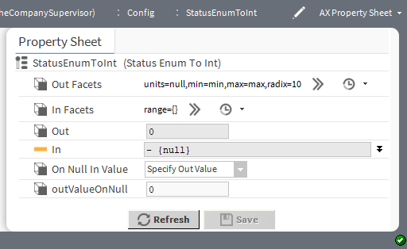

Property | Value | Description
Out Facets | Config Facets win- dow (defaults to null for units, min for minimum, max for maximum and 10 for radix) | Selects units and configures how the value displays:  units defines the unit of measure from acceleration to  volumetric flow.  min defines the minimum value.  max defines the maximum value.  radix defines the base of the numeration system. This configuration applies to the Out property value.
In Facets | Config Facets window | Defines the range of enumerated states (enum values) for the  In value.
Out | read-only integer | Displays the target integer.
In | number (defaults to 0) with null definition | Displays the source status enum value.  When null is checked, the value displayed defaults to the incom- ing value from the device. If you remove the check mark you can configure the Invalue.
On Null In Value | drop-down list (de- faults to Use In Value) | Configures how to handle null values.  Use In Value outputs the Out default value when the result of the conversion is null. Normally, the Fallback property for a given point defines the meaning of an Enum null as zero (0). If, during configuration, the null status check box is unchecked and another value entered and saved, the changed value becomes the new null default value for the point.  If this modified component links to another StatusEnum prop- erty, the framework ignores the null value. But, if connected to a StatusEnumToInt component, the result of a null input value de- faults to the changed value, which may not be what you intended.  Specify Out Value adds the outValueOnNull property to this component. Configure it to return a reasonable value when the In value is null.
Out Value On Null | number | Defines an In value for the conversion object when the input  Out value has a null status.

kitControl-StatusEnumToStatusBoolean
This component converts a StatusEnum Out value to a StatusBoolean In value. StatusEnumToStatusBoolean is available in the Conversion folder of the kitControl palette
Figure 34 StatusEnumToStatusBoolean properties
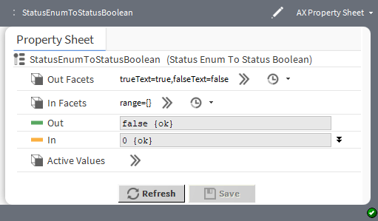

Property | Value | Description
Out Facets | Config Facets win- dow (defaults to true and false) | Defines the text to display for each Boolean value.  trueText configures the text to describe the state when com- ponent returns true.  falseText configures the text to describe the state when com- ponents returns false.  This configuration applies to the Out property value.
In Facets | Config Facets window | Defines a range of enumerated states (enum values). This configuration applies to the In property value.
Out | read-only Status- Boolean true and false | Displays the target converted status Boolean value.
In | enumerated value (defaults to 0, that is, no value) | Displays the source status enum value.  When null is checked, the value displayed defaults to the incom- ing value from the device. If you remove the check mark you can configure the In value.

Property | Value | Description
On Null In Value | drop-down list (de- faults to Use In Value) | Configures how to handle null values.  Use In Value outputs the Out default value when the result of the conversion is null. Normally, the Fallback property for a given point defines the meaning of an Enum null as zero (0). If, during configuration, the null status check box is unchecked and another value entered and saved, the changed value becomes the new default null value for the point.  If this modified component links to another StatusEnum prop- erty, the framework ignores the null value. But, if connected to a StatusEnumToStatusBoolean component, the result of a null in- put value defaults to the changed value, which may not be what you intended.  Specify Out Value adds the outValueOnNull property to this component. Configure it to return a reasonable In value when the Out value is null.
Out Value On Null | number | Defines an In value for the conversion object when the input  Out value has a null status.

kitControl-StatusEnumToStatusNumeric
This component converts a StatusEnum Out value to a StatusNumeric In value. StatusEnumToStatusNumeric is available in the Conversion folder of the kitControl palette.
Figure 35 StatusEnumToStatusNumeric properties
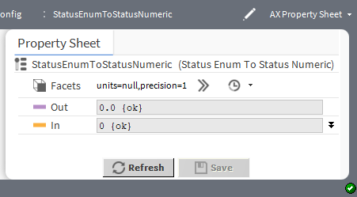

Property | Value | Description
Facets | Config Facets win- dow (defaults to null for units and one decimal place of precision) | Selects units and configures how the value displays:  units defines the measure from acceleration to the volu- metric flow.  precision defines the number of decimal places. This configuration applies to the In property value.
Out | read-only number | Displays the converted target status numeric value.
In | number and null definition (defaults to 0) | Displays the source status enum value.  When null is checked, the value displayed defaults to the incom- ing value from the device. If you remove the check mark you can configure theIn value.

kitControl-StatusNumericToStatusEnum
This component converts a StatusNumeric value to a StatusEnum value. StatusNumericToStatusEnum is available in the Coversion folder of the kitControl palette.
Figure 36 StatusNumericToStatusEnum
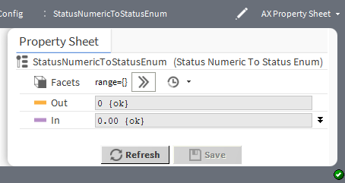

Property | Value | Description
Facets | Config Facets win- dow (defaults to blank) | Defines a range of enumerated states (enum values). This configuration applies to the In property value.
Out | read-only enumer- ated value | Displays the converted target status enum value.
In | number and null definition (defaults to 0) | Displays the source status numeric value.  When null is checked, the value displayed defaults to the incom- ing value from the device. If you remove the check mark you can configure the In value.

kitControl-StatusNumericToDouble
This component onverts a StatusNumeric value to a Double value. StatusNumericToDouble is available in the Conversion folder of the kitControl palette.
Figure 37 StatusNumericToDouble properties
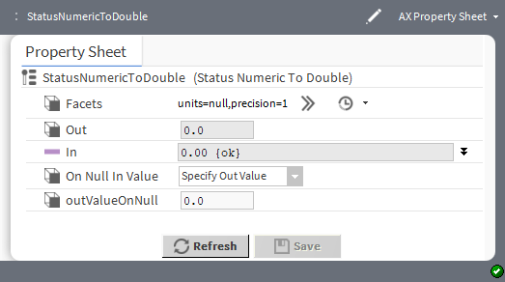

Property | Value | Description
Facets | Config Facets win- dow (defaults to units=null, preci- sion=1) | Selects units and configures how the value displays:  units defines the unit of measure of acceleration to volu- metric flow.  precision defines the number of decimal places.  This configuration applies to the In property value.
Out | read-only number | Displays the target double value.
In | number and null definition (defaults to 0) | Displays the source status numeric value.  When null is checked, the value displayed defaults to the incom- ing value from the device. If you remove the check mark you can configure the In value.

kitControl-StatusNumericToFloat
This component converts a StatusNumeric value to a Float value. StatusNumerictoFloat is available in the Conversion folder of the kitControl palette.
Figure 38 StatusNumericToFloat properties
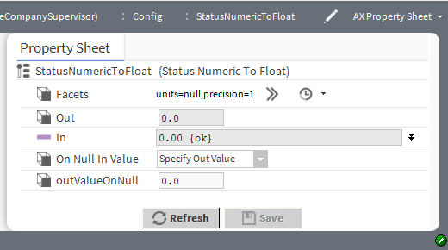

Property | Value | Description
Facets | Config Facets win- dow (defaults to null for units and one decimal place of precision) | Selects unit and configures how the value displays:  units define the unit of measure from acceleration to  volumetric flow.  precision defines the number of decimal places. This configuration applies to the In property value.
Out | read-only number | Displays the converted target float value.
In | number and null definition (defaults to 0) | Displays the source status numeric value.  When null is checked, the value displayed defaults to the incom- ing value from the device. If you remove the check mark you can configure the In value.

Property | Value | Description
On Null In Value | drop-down list (de- faults to Use In Value) | Configures how to handle null values.  Use In Value outputs the Out default value when the result of the conversion is null. Normally, the Fallback property for a given point defines the meaning of null as 0.0. If, during configu- ration, the null status check box is unchecked and another value entered and saved, the changed value becomes the new null value for the point.  If this modified component links to another StatusNumeric prop- erty, the framework ignores the null value. But, if connected to a StatusNumericToFloat component, the result of a null input val- ue defaults to the changed value, which may not be what you intended.  Specify Out Value adds the Out Value On Null property to this component. Configure it to return a reasonable value when the Out value is null.
Out Value On Null | number | Defines an In value for the conversion object when its Out val- ue has a null status.

kitControl-StatusNumericToInt
This component converts a StatusNumeric value to an Int (integer). StatusNumericTolnt is available in the Conversion folder of the kitControl palette.
Figure 39 StatusNumericToInt properties
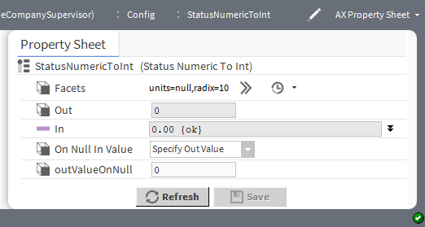

Property | Value | Description
Facets | Config Facets window | Selects units and configures how the value displays:  units defines the unit of measure from acceleration to  volumetric flow.  radix defines the base of the numeration system. This configuration applies to the In property value.
Out | read-only integer | Displays the converted target integer.
In | number and null definition (defaults to 0) | Displays the source status numeric value.  When null is checked, the value displayed defaults to the incom- ing value from the device. If you remove the check mark you can configure the In value.

Property | Value | Description
On Null In Value | drop-down list (de- faults to Use In Value) | Configures how to handle null values.  Use In Value outputs the Out default value when the result of the conversion is null. Normally, the Fallback property for a given point defines the meaning of an Enum null as zero (0). If, during configuration, the null status check box is unchecked and another value entered and saved, the changed value becomes the new null default value for the point.  If this modified component links to another StatusEnum prop- erty, the framework ignores the null value. But, if connected to a StatusEnumToInt component, the result of a null input value de- faults to the changed value, which may not be what you intended.  Specify Out Value adds the outValueOnNull property to this component. Configure it to return a reasonable value when the In value is null.
Out Value On Null | number | Defines an In value for the conversion object when the input  Out value has a null status.

kitControl-StatusStringToStatusNumeric
This component converts a StatusString value to an StatusNumeric value. StatusStringToStatusNumeric is available in the Conversion folder of the kitControl palette.
The input string must contain only numeral characters, and optionally one period (.) for decimal notation. Valid input strings examples are 145678 or 34.81. Leading and/or trailing space characters are allowed and ignored. Any other input string characters (for example, alpha, punctuation) result in a fault status.
Figure 40 StatusStringToStatusNumeric properties
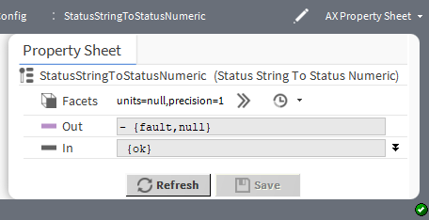

Property | Value | Description
Facets | Config Facets win- dow (defaults to null for units and one decimal place of precision) | Selects unit and configures how the value displays:  units define the unit of measure from acceleration to  volumetric flow.  precision defines the number of decimal places. This configuration applies to the In property value.
Out | read-only number | Displays the converted target status numeric value.
In | number and null definition (defaults to 0) | Displays the source status text.

Property | Value | Description
 |  | When null is checked, the value displayed defaults to the incom- ing value from the device. If you remove the check mark you can configure the In value.
On Null In Value | drop-down list (de- faults to Use In Value) | Configures how to handle null values.  Use In Value outputs the Out default value when the result of the conversion is null. Normally, the Fallback property for a given point defines the meaning of null as 0.0. If, during configu- ration, the null status check box is unchecked and another value entered and saved, the changed value becomes the new null value for the point.  If this modified component links to another StatusString prop- erty, the framework ignores the null value. But, if connected to a StatusStringToStatusNumeric component, the result of a null in- put value defaults to the changed value, which may not be what you intended.  Specify Out Value adds the Out Value On Null property to this component. Configure it to return a reasonable value when the Out value is null.
Out Value On Null | number | Defines an In value for the conversion object when its Out val- ue has a null status.

kitControl-StatusNumericToStatusString
This component converts a StatusNumeric value to a StatusString value. StatusNumericToStatusString is available in the Conversion folder of the kitControl palette.
Object properties specify the number of integer (whole number) digits and decimal digits to use in the output string, with a default value of six (6) each. Unused digits are padded with a zero. For example, with an input nu- meric value of 72.8, the default output string would be: 000072.800000.
Figure 41 StatusNumericToStatusString properties
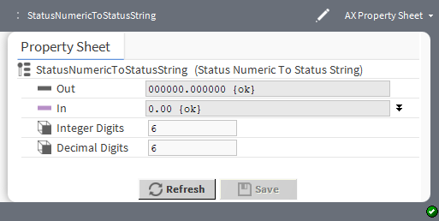

Property | Value | Description
Out | read-only number | Displays the converted target status text.
In | number and null definition (defaults to 0) | Displays the source status numeric value.  When null is checked, the value displayed defaults to the incom- ing value from the device. If you remove the check mark you can configure the In value.

Property | Value | Description
Integer Digits | number (defaults to 6) | Configures the whole number to the left of the In value’s deci- mal point.
Decimal Digits | number (defaults to 6) | Configures the fraction to the right of the In value’s decimal point.

kitControl-NumericUnitConverter
This component converts a StatusNumeric value from a definable In Facets to a different definable Out Facets.
NumericUnitConverter is available in the Conversion folder of the kitControl palette.
This component is unique in that it does not change the data type (both input and output are StatusNumeric). It changes the actual numeric value. To produce a valid numeric output, both configured facets must conform to the same category (such as temperature, power, and so forth). Otherwise, the NumericUnitConverter reports a fault status.
Figure 42 NumberUnitConverter properties
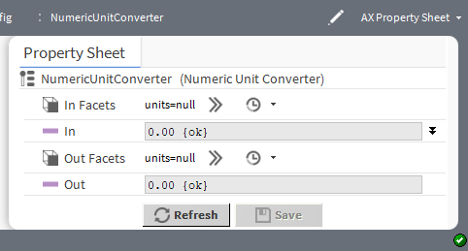

Property | Value | Description
In Facets | Config Facets window | Configures the unit of measure for the In value.
In | number and null definition (defaults to 0) | Displays the source value based on the source unit of measure.  When null is checked, the value displayed defaults to the incom- ing value from the device. If you remove the check mark you can configure the In value.
Out Facets | Config Facets window | Configures the unit of measure for the Out value.
Out | read-only number | Displays the converted out value based on its unit of measure.

Chapter 6 Energy components

Topics covered in this chapter
- kitControl-DegreeDays
- kitControl-ElectricalDemandLimit
- kitControl-NightPurge
- kitControl-OptimizedStartStop
- kitControl-OutsideAirOptimization
- kitControl-Psychrometric
- kitControl-SetpointLoadShed
- kitControl-SetpointOffset
- kitControl-ShedControl
- kitControl-SlidingWindowDemandCalc

Components include services, folders and other model building blocks associated with a module. You may drag them to a property or wire sheet from a palette. These components include a degree-days calculation object as well as various objects used for electrical demand limiting. Additional energy-saving functions are also repre- sented as components.
The descriptions included in the following topics appear as headings in documentation. They also appear as context-sensitive help topics when accessed by:
- Right-clicking on the object and selecting Views→Guide Help
- Clicking Help→Guide On Target

kitControl-DegreeDays
This component provides degree day calculations, based upon temperature received at the Temp In slot and values of various other properties.
DegreeDays is available in the Energy folder of the kitControl palette.
Degree Days is a unit of measure that may be expressed as either Heating Degree Days (HDD) or Cooling De- gree Days (CDD). You calculate Degree Days by taking the difference between the average temperature during a given time period (month, season, year) and a reference point, usually 65 degrees Fahrenheit. Both cooling and heating degree day values are available, including totalized values. A Reset Totals action is available to clear (zero) totalized values.

Figure 43 DegreeDays property sheet
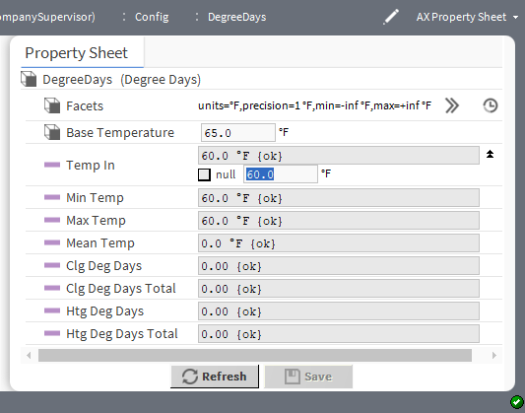
The screen capture is an example of the DegreeDays property sheet.

Property | Value | Description
Facets | Config Facets win- dow (defaults to Fahrenheit, a single decimal place, neg- ative and positive infinity respectively) | Selects units and configures how the value displays:  units defaults to temperature.  precision defines number of decimal places in temperature.  min defines the lowest temperature allowed.  max defines the highest temperature allowed.  This configuration applies to the Temp In, Min Temp, Max Temp, and Mean Temp properties.
Base Temperature | degrees | Specifies the base temperature used in the degree-day calculation.
Temp In | number of degrees and null definition (defaults to 0) | Defines the input for the outside air temperature used in the de- gree-day calculation. If this input is not valid temperature, the framework performs no calculations.  When null is checked, the value displayed defaults to the incom- ing value from the device. If you remove the check mark you can configure the In value.
Min Temp | read-only degrees | Displays the minimum temperature recorded for the current day. The framework tests and sets this value on each calculation.
Max Temp | read-only degrees | Displays the maximum temperature recorded for the current day. The framework tests and sets this value on each calculation.
Mean Temp | read-only degrees | Displays the mean temperature recorded for the previous day. The framework calculates this value when the day changes. The calculation is:  Temp = (Max Temp + Min Temp) / 2.0

Property | Value | Description
Clg Deg Days | read-only degrees | Displays the cooling degree-day calculated for the previous day. The framework calculates this value when the day changes us- ing this formula:  If (Mean Temp - Base Temperature) > 0  Clg Deg Days = Mean Temp - Base Temperature else  Clg Deg Days = 0.0
Clg Deg Days Total | read-only degrees | Displays the totalized cooling degree-days since the user in- voked the last Reset Totals action. The framework calculates this value when Clg Deg Days changes.
Htg Deg Days | read-only degrees | Displays the heating degree-day calculated for the previous day. The framework calculates this value when the day changes us- ing this formula:  If (Mean Temp - Base Temperature) < 0  Htg Deg Days = Base Temperature - Mean Temp else  Htg Deg Days = 0.0
Htg Deg Days Total | read-only degrees | Displays the totalized heating degree-days sincethe user in- voked the last Reset Totals action. The framework calculates this value when Htg Deg Days changes.

kitControl-ElectricalDemandLimit
This component provides load shedding calculations based upon projected electrical demand averaging. It uses a sliding window interval, which can be configured.
ElectricalDemandLimit is available in the Energy folder of the kitControl palette along with related objects SetpointOffset and ShedControl.
Electrical Demand Limiting (EDL) is an energy management tool for leveling out fluctuations that may occur in daily energy demand levels. Energy providers often set billing rates based on periodic maximum demand lev- els. It is possible that a single day (an anomaly) could dramatically increase a monthly billing rate. Reducing peak demand levels can significantly lower energy costs even if the total energy consumption does not change. To avoid costly spikes in demand level, this component monitors and controls building and enterprise energy usage.
To use the ElectricalDemandLimit component, as a minimum, you need to do the following:

Figure 44 ElectricalDemandLimit configuration properties
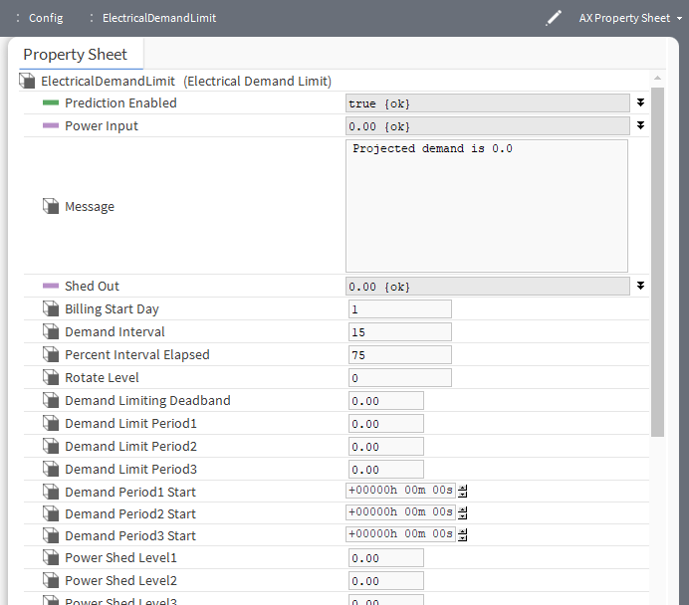

Property | Value | Description
Prediction Enabled | true (default) or false and null definition | Turns this component on and off.  true enables this component. This value must be set to true  for the component to work.  false disables this component.  When null is checked, the value displayed defaults to the incom- ing value from the device. If you remove the check mark you can configure theIn value.
Power Input | kW rate and null definition (defaults to 0) | Defines the power demand (kW) rate. The component uses this value to average the demand rate over every minute for compar- ison with the Projected Demand Average. This property should represent the total actual demand rate — the total of all meters monitored by this component on the energy network.  When the component invokes a shed or restoration, this value is expected to change in relation to the estimated values config- ured for the Power Shed Level properties.  When null is checked, the value displayed defaults to the incom- ing value from the device. If you remove the check mark you can configure theIn value.
Message | read-only text | Displays information that relates to the status of the shed, resto- ration, or projected demand values, and may indicate the status of the EDL component, itself.

Property | Value | Description
Shed Out | number and null definition (defaults to 0) | Displays a value that indicates the number of levels to be shed. For example, a Shed Out value of 3 indicates that a Power Shed Level of 3 is being shed.  When null is checked, the value displayed defaults to the incom- ing value from the device. If you remove the check mark you can configure theIn value.
Billing Start Day | date | Specifies the first utility billing day of the month. This aligns sys- tem data with the actual energy company billing periods. Each month, on the day specified by this property, the current month’s data move to the previous month, and the current month’s data become this month.
Demand Interval | 15 or 30 minutes  (defaults to 15 minutes) | Configures the demand window used to calculate the average. You may change this value to 30 minutes. Any other value re- verts to 15 minutes. The larger demand interval has more data points (one per minute) than the smaller interval.  Depending on the value of the Percent Interval Elapsed property, the data points may be comprised of mostly sampled historical demand values, mostly values that are projected (based on current demand), or half and half.
Percent Interval Elapsed | percentage (de- faults to 75) | Determines how much of the calculated demand is based on ac- tual demand as opposed to how much is based on projected de- mand. A value of 50 calculates the Projected Demand Average using half of the actual sampled (or historical) values and half of the projected values.  To calculate projected demand, the component uses current en- ergy data at the current minute. In a 15 minute demand window, a value of 67 means that the current minute is 10. Larger num- bers in this property increase the amount of historical data used and decrease the amount of data that are based on the current minute demand.
Rotate Level | a number from 1 to 32 (defaults to 0) | Specifies the maximum Shed Level to use. For example, a val- ue of 3 limits load shedding to Power Shed Level3.
Demand Limiting Deadband | kW | Sets a deadband value the component uses to determine whether or not to invoke a restoration when activating restora- tion levels. The component does not use this value to invoke shed actions.
Demand Limit Peri- od(n) | kW | These three values set demand limits that correspond to each of the three daily periods. When energy usage exceeds the De- mand Limit value for a period, load shedding begins.

Property | Value | Description
Demand Period(n) Start | hours minutes sec- onds (default to 0) | These three values split up a 24-hour day into three time-periods used to assign a separate demand limit for each distinct time.
Power Shed Level (n) | a number to two decimal places | These levels set up to 32 demand limit values based on the loads that are controlled by the specific shed group. Each value represents the amount of demand to shed when the component invokes the associated shed level. The component may invoke one or more shed levels to lower the demand below the current Demand Period limit. In other words, the load-shed logic calcu- lates how much demand is required to be reduced, and then uses these values to determine how many loads to shed.  Once the component invokes a shed level is invoked, it evalu- ates the actual power drop at the next minute to determine the effect of the shed action. If the initial load shed does not actually reduce the demand below the limit, the component invokes the next shed level (if any).  To limit the number of shed levels the component may invoke, configure the Rotate Level property.

ElectricalDemandLimit data – kitControl
You access these data by scrolling down the ElectricalDemandLimit property sheet.
Figure 45 ElectricalDemandLimit data
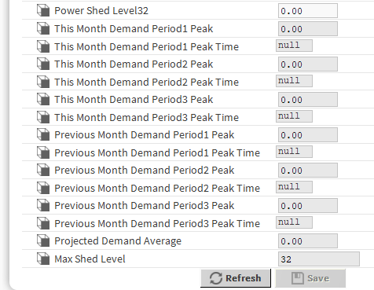

Data item | Description
This Month Demand Period(n) Peaks | Displays the value of the highest demand (minute) so far in the current month.
This Month Demand Period(n) Peak Times | Displays the time and date that the current month’s peak demand occurred.
Previous Month Demand Period(n) Peaks | Displays the value of the highest demand (minute) that occurred in the previous month.
Previous Month Demand Period(n) Peak Times | Displays the time and date that the previous month’s peak demand occurred.

Data item | Description
Projected Demand Average | Totals the value of the Power Input every time this value changes, and once a minute calculates Projected Demand Average and Shed Level. The compo- nent averages a combination of projected and historical samplings over the speci- fied interval. To influence the value of the Projected Demand Average, configure the Demand Interval and the Percent Interval Elapsed properties.
Max Shed Level | Displays the maximum shed level used in the current month.

kitControl-NightPurge
This component uses the two sets of temperature and humidity inputs to find the air supply with the least amount of heat when the Purge Enabled input is true.
NightPurge is available in Energy folder of the kitControl palette.
For inside and outside comparisons, you can select either temperature or enthalpy comparisons. There is also a low temperature check to protect against freezing.
Figure 46 NightPurge properties

Property | Value | Description
Temperature Facets | Config Facets window | Selects units and configures how the value displays:  units defaults to temperature.  precision defines the number of decimal places of temperature.  min defines the lowest temperature allowed.  max defines the highest temperature allowed.  This configuration applies to the Outside Temp, Inside Temp, and Low Temperature Limit property values.
Humidity Facets | Config Facets window | Selects units and configures how the value displays:  units defaults to percentage of relative humidity (%RH) .  precision defines the number of decimal places of humidity percentage.  min defines the lowest humidity allowed.  max defines the highest humidity allowed.  This configuration applies to the Outside Humidity and In- side Humidity property values.
Purge Enabled | StatusBoolean true or false (default) and null definition | true enables the night purge operation.  false sets the Free Cooling output to the opposite of the Free Cooling Command (or null, if Use Null Output is set to true), and the Current Mode slot value is Disabled.  Often this slot is linked to a Not object sourced from a Boolean- Schedule output.  When null is checked, the value displayed defaults to the incom- ing value from the device. If you remove the check mark you can configure the In value.
Outside Temp | number of degrees of temperature (de- faults to 0.0F) and null definition | Defines the current outside air temperature. This input must be valid for this object to function.  When null is checked, the value displayed defaults to the incom- ing value from the device. If you remove the check mark you can configure the In value.
Outside Humidity | percentage of rela- tive humidity (de- faults to 0.0 %RH) and null definition | Defines the current outside air humidity. This input must be valid for this object to function.  When null is checked, the corresponding value defines the de- fault when a calculation returns null.
Inside Temp | number of degrees of temperature (de- faults to 0.0F) and null definition | Defines the current inside air temperature. This input must be valid for this object to function.  When null is checked, the value displayed defaults to the incom- ing value from the device. If you remove the check mark you can configure the In value.
Inside Humidity | percentage of rela- tive humidity (de- faults to 0.0 %RH) and null definition | Defines the current inside air humidity. This input must be valid for this object to function.

Property | Value | Description
 |  | When null is checked, the value displayed defaults to the incom- ing value from the device. If you remove the check mark you can configure the In value.
Low Temperature Limit | number of degrees of temperature (de- faults to 0.0F) and null definition | Provides freeze protection.  When null is checked, the value displayed defaults to the incom- ing value from the device. If you remove the check mark you can configure the In value.
Night Setpoint | number of degrees of temperatur (de- faults to 0.0F) and null definition | Defines the night temperature setpoint, at or below which free cooling is not applied. Instead, the Current Mode is set to Satisfied.  When null is checked, the value displayed defaults to the incom- ing value from the device. If you remove the check mark you can configure the In value.
Outside Enthalpy | read-only energy measured in BTUs per pound to two decimal places (de- faults to 0.00 BTU/ lb) | Displays the calculated outside air enthalpy.
Inside Enthalpy | read-only energy measured in BTUs per pound to two decimal places (de- faults to 0.00 BTU/ lb) | Displays the calculated inside air enthalpy.
Free Cooling [output] | read-only Status- Boolean true or false (default) | Displays the value of the Free Cooling Command when free cooling should be used. Otherwise, it displays the opposite state, or null (if Use Null Output is set to true).  The component sets the Free Cooling output to false if  outside >= inside or true if outside = Night Setpoint.
Current Mode | read-only value (defaults to Disabled | Indicates which of the following modes this object is currently in:  Disabled indicates that Purge Enabled is false. Free Cooling  No Free Cooling indicates that free cooling is not available.  Low temperature indicates that Outside Temp is below the Low Temperature Limit and free cooling is disabled.  Input error indicates that a temperature or humidity is invalid (down, fault, etc.) and free cooling is disabled.  Satisfied indicates that inside temperature is below the  Night Setpoint and free cooling is disabled.
Setpoint Deadband | degrees of temper- ature to a single decimal place (de- faults to 1.0F) | Applies temperature Setpoint Deadband when inside temper- ature falls below Night Setpoint before free cooling can be enabled.

Property | Value | Description
Threshold Span | number to two deci- mal places (de- faults to 1.0) | Defines a value. The difference between the Inside Enthalpy and the Outside Enthalpy must be greater than this value be- fore the component enables free cooling.
Use Enthalpy | StatusBoolean true (default) or false | true enables the use of enthalpy to determine if free cooling is available.  false uses outside and inside temperature to decide.
Free Cooling Command | StatusBoolean true (default) or false | Configures Free Cooling output.  true indicates that free cooling is available, therefore Free Cooling output should be set to true.  false indicates that free cooling is not available, therefore  Free Cooling output should be set to false.
Use Null Output | StatusBoolean true (default) or false | Configures Free Cooling output.  true sets the null flag for Free Cooling output when free cool- ing is not available.  false ignores the null flag for Free Cooling output.

kitControl-OptimizedStartStop
This component uses Start Time Optimization and Stop Time Optimization to save energy. It uses a space temperature input and area characteristics to calculate an optimal amount of lead-time before a sched- uled event. It can analyze area temperature changes and adjust the optimization parameters based on the ac- tual temperature change rates after an optimized start or stop.
OptimizedStartStop component is available in the Energy folder of the kitControl palette.

Figure 47 OptimizedStartStop properties
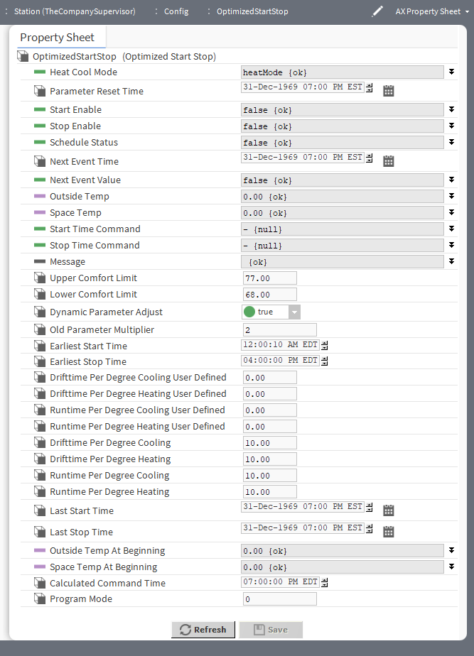

Property | Value | Description
Heat Cool Mode | drop-down list and null definition | Selects heating or cooling. The selected option applies only to optimized stop calculations. This means that optimized stop cal- culations are performed only for the selected mode. Optimized start calculations are performed for both heat and cool modes regardless of this property value.  When null is checked, the value displayed defaults to the incom- ing value from the device. If you remove the check mark you can configure the In value.
Parameter Reset Time | date hour:minute (defaults to 7 PM EST (Eastern | Displays the time when any of the four runtime or driftime prop- erties change to the user-defined values. This component cop- ies the user defined drifttime and runtime property values to the corresponding actual drifttime and runtime property values.

Property | Value | Description
 | Standard Time); in- cludes date picker
Start Enable | true and false (default) and null definition | Manually or automatically turns the optimized start function on (true) and off (false).  When null is checked, the value displayed defaults to the incom- ing value from the device. If you remove the check mark you can configure the In value.
Stop Enable | true and false (default) and null definition | Manually or automatically turns the optimized stop function on (true) and off (false).  When null is checked, the value displayed defaults to the incom- ing value from the device. If you remove the check mark you can configure the In value.
Schedule Status | true and false (default) and null definition | Monitors and displays the status of the schedule that is linked to this component.  When null is checked, the value displayed defaults to the incom- ing value from the device. If you remove the check mark you can configure the In value.
Next Event Time | date and time (de- faults to EST (East- ern Standard Time)) | Links to a schedule for the time of the next scheduled event.
Next Event Value | true and false (default) and null definition | Links to a schedule and reflects the value of the action for the next scheduled event.  When null is checked, the value displayed defaults to the incom- ing value from the device. If you remove the check mark you can configure the In value.
Outside Temp | number of degrees (defaults to 0.00) and null definition | Links to outside temperature and displays the value for informa- tion only.  When null is checked, the value displayed defaults to the incom- ing value from the device. If you remove the check mark you can configure the In value.
Space Temp | number of degrees (defaults to 0.00) and null definition | Links to a space temperature output and displays the tempera- ture of the area affected by equipment associated with this component.  When null is checked, the value displayed defaults to the incom- ing value from the device. If you remove the check mark you can configure the In value.
Start Time Command | true and false (default) and null definition | Links to a control for invoking an equipment start command. For example, you can link it to a prioritized input of a Boolean writ- able, or directly to the equipment Start control.  When null is checked, the value displayed defaults to the incom- ing value from the device. If you remove the check mark you can configure the In value.
Stop time Command | true and false (default) and null definition | Links to a control for invoking an equipment stop command. For example, you can link it to a prioritized input of a Boolean writ- able, or directly to the equipment Stop control.

Property | Value | Description
 |  | When null is checked, the value displayed defaults to the incom- ing value from the device. If you remove the check mark you can configure the In value.
Message | text and null definition | Provides information that indicates the results of the latest start or stop command, the status of an optimized start analysis, or other possible messages. For example, the following message indicates that an optimized stop has occurred: Optimized stop for 14-Jun-07 5:18 PM EDT schedule time. Space temp is 75.0.  When null is checked, the value displayed defaults to the incom- ing value from the device. If you remove the check mark you can configure the In value.
Upper Comfort Limit | degrees to two dec- imal places (de- faults to 0.00) (defaults to 77.00 F, 25.00 C) | Defines the cooling mode target temperature.
Lower Comfort Limit | degrees to two dec- imal places (de- faults to 0.00) (defaults to 68.00 F, 20.00 C) | Defines the heating mode target temperature.
Dynamic Parame- ter Adjust | true (default)or  false | Controls if calculation the component programmatically adjusts parameters after an execution. After the component completes a start or stop control, if this property is set to true, the compo- nent evaluates the actual recovery rate (degrees/hour) and au- tomatically adjusts the values of the runtime and drifttime properties so that they are influenced by actual drift time and run time.
Old Parameter Multiplier | single-digit number (defaults to 2) | Applies a weighting factor to the dynamic parameter adjustment calculation. This value affects how much weight to assign to the previous runtime property value when the component uses it in a dynamic parameter adjustment calculation. A larger value in- creases the weighting factor given to the previous runtime value, and a smaller value decreases this weighting factor.
Earliest Start Time | hours minutes sec- onds (defaults to 12 and 10 seconds AM EDT (Eastern Day- light Time)) | Specifies a time, before which, the component may issue no op- timized start command. If this value is set earlier than the Cal- culated Command Time, the component adjusts the Calculated Command Time to equal this time.
Earliest Stop Time | hours minutes sec- onds (defaults to 4 PM EDT (Eastern Daylight Time)) | Specifies a time, before which, the component may issue no stop command. If this value is set earlier than the Calculated Command Time, the component adjusts the Calculated Com- mand Time to equal this time.
Drifttime Per De- gree cooling User Defined | single-digit number to two decimal pla- ces (defaults to 0.00) | Sets a default value for calculating the rate of drift in cooling mode. The component copies this value to the Drifttime Per Degree Cooling property.

Property | Value | Description
DriftTime Per De- gree Heating User Defined | single-digit number to two decimal pla- ces (defaults to 0.00) | Sets a default value for calculating the rate of drift in heating mode. The component copies this value to the Drifttime Per Degree Heating property.
Runtime Per De- gree cooling User Defined | single-digit number to two decimal pla- ces (defaults to 0.00) | Sets a default value for calculating the runtime value in cooling mode. The component copies this value to the Runtime Per Degree Cooling property.
Runtime Per De- gree Heating User Defined | single-digit number to two decimal pla- ces (defaults to 0.00) | Sets a default value for calculating the runtime value in heating mode. The component copies this value to the Runtime Per Degree Heating property.
Drifttime Per De- gree Cooling | two-digit number to two decimal places (defaults to 10.00) | Displays the actual value used to calculate an optimized stop time when the equipment is in cooling mode. The component automatically adjusts this value Dynamic Parameter Adjust value is set to true.
Drifttime Per De- gree Heating | two-digit number to two decimal places (defaults to 10.00) | Displays the actual value used to calculate an optimized stop time when the equipment is in heating mode. The component automatically adjusts this value if Dynamic Parameter Ad- just value is set to true.
Runtime Per De- gree Cooling | two-digit number to two decimal places (defaults to 10.00) | Displays the actual value used to calculate an optimized start time when the equipment is in cooling mode. The component automatically adjusts this value if Dynamic Parameter Ad- just value is set to true.
Runtime Per De- gree heating | two-digit number to two decimal places (defaults to 10.00) | Displays the actual value used to calculate an optimized start time when the equipment is in heating mode. The component automatically adjusts this value if Dynamic Parameter Ad- just value is set to true.
Last Start Time | date, hours:minutes (defaults to 7 PM EST (Eastern Standard Time) | Displays the last start time used to calculate an optimized start time. Since the component allows only one optimized start per day, this value does not display start times (restarts) that occur subsequent to the initial start time for the day.
Last Stop Time | date, hours:minutes (defaults to 7 PM EST (Eastern Standard Time)) | Displays the last stop time used to calculate an optimized stop time. Since the component allows multiple optimized stops per day, this value changes to reflect the latest optimized stop time.
Outside Temp At Beginning | number of degrees (defaults to 0.00) and null definition | Displays the outside air temperature at the time of the last start or stop command. This is the temperature used in the dynamic parameter adjustment calculations.  When null is checked, the value displayed defaults to the incom- ing value from the device. If you remove the check mark you can configure the In value.
Space Temp At Beginning | number of degrees (defaults to 0.00) and null definition | Displays the space temperature at the time of the last start or stop command. This is the temperature used in the dynamic pa- rameter adjustment calculations.  When null is checked, the corresponding value defines the de- fault when a calculation returns null.

Property | Value | Description
Calculated Com- mand Time | hours:minutes (de- faults to 7 PM EST (Eastern Standard Time)) | Shows the calculated time for the next command. This could be a start or a stop command.
Program Mode | read-only single- digit number (de- faults to zero (0)) | Displays one of five current heating or cooling states for an opti- mized start or stop. These states serve primarily in logic control and may also inform the system engineer.  - (no calculation) indicates that no calculation is in progress.  - (start calculation) indicates that the optimized start calculation is ongoing, but no optimized start or stop is yet in progress.  - (start in process) indicates that the component initiated an op- timized start.  - (stop calculation) indicates that an optimized stop calculation is ongoing, but no optimized start or stop is yet in progress.  - (stop in process) indicates that the component initiated an op- timized stop.

kitControl-OutsideAirOptimization
This component supports applications that need to allow for enthalpy based free cooling. This object is typically used during occupancy periods.
OutsideAirOptimization is available in the Energy folder kitControl palette.
The freeCooling output is set to false if outside >= inside and set to true if outside <= inside - (abs) thresholdSpan.
There is also a low temperature check to protect against freezing.

Figure 48 OutsideAirOptimization properties
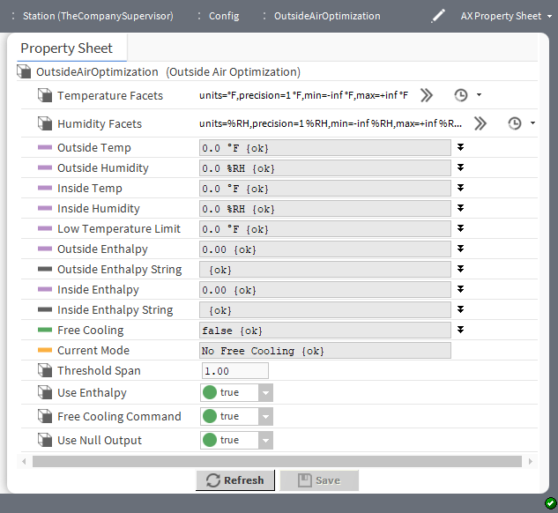

Property | Value | Description
Temperature Facets | Config Facets window | Selects units and configures how the value displays:  units defaults to temperature.  precision defines the number of decimal places of temperature.  min defines the lowest temperature allowed.  max defines the highest temperature allowed.  This configuration applies to Outside Temp, Inside Temp, and Low Temperature Limit properties.
Humidity Facets | Config Facets window | Selects units and configures how the value displays:  units defaults to percentage of relative humidity (%RH).  precision defines the number of decimal places of humidity percentage.  min defines the lowest humidity allowed.  max defines the highest humidity allowed.  This configuration applies to the Outside Humidity and In- side Humidity property values.
Outside Temp | number of degrees of temperature (de- faults to 0.0 de- grees F) and null definition | Defines the current outside air temperature. This input must be valid for this object to function.

Property | Value | Description
 |  | When null value is checked, the value displayed defaults to the incoming value from the device. If you remove the check mark you can configure the In value.
Outside Humidity | percentage of hu- midity (defaults to 0.0 RH percent) and null definition | Defines the current outside air humidity. This input must be valid for this object to function.  When null value is checked, the value displayed defaults to the incoming value from the device. If you remove the check mark you can configure the In value.
Inside Temp | number of degrees of temperature (de- faults to 0.0 de- grees F) and null definition | Defines the current inside air temperature. This input must be valid for this object to functio
Inside Humidity | percentage of hu- midity (defaults to 0.0 RH percent) and null definition | Defines the current inside air humidity. This input must be valid for this object to function.
Low Temperature Limit | number of degrees of temperature (de- faults to 0.0 de- grees F) and null definition | Provides freeze protection.  When null value is checked, the value displayed defaults to the incoming value from the device. If you remove the check mark you can configure the In value.
Outside Enthalpy | number (defaults to 0.00) and null definition | Displays the calculated outside air enthalpy.  When null value is checked, the value displayed defaults to the incoming value from the device. If you remove the check mark you can configure the In value.
Outside Enthalpy String | text (defaults to blank) and null definition | Provides the outside enthalpy value as a string or possible sta- tus/error message.  When null value is checked, the value displayed defaults to the incoming value from the device. If you remove the check mark you can configure the In value.
Inside Enthalpy | number (defaults to 0.00) and null definition | Displays the calculated inside air enthalpy.  When null value is checked, the value displayed defaults to the incoming value from the device. If you remove the check mark you can configure the In value.
Inside Enthalpy String | text (defaults to blank) and null definnition | Provides the inside enthalpy value as a string or possible status/ error message.  When null value is checked, the value displayed defaults to the incoming value from the device. If you remove the check mark you can configure the In value.
Free Cooling | true or false (default) and null definition | Sets the value of the Free Cooling Command when the com- ponent determines that free cooling should be used. Otherwise, the value is null.  When null value is checked, the value displayed defaults to the incoming value from the device. If you remove the check mark you can configure the In value.

Property | Value | Description
Current Mode | text (defaults to No Free Cooling) | Indicates what mode this object is currently in: Input out of range  Free Cooling No Free Cooling  Low temperature  Input error
Threshold Span | number to two deci- mal places (de- faults to 1.00) | Configures the difference between the inside enthalpy and the outside enthalpy. The actual difference must be greater than this value before the system enables free cooling.
Use Enthalpy | true (default) or  false | Enables (true) and disables (false) the use of enthalpy for determining if free cooling is available. Otherwise, the compo- nent uses outside and inside temperature to decide.
Free Cooling Command | true (default) or  false | Defines the Boolean value to be set in the Free Cooling prop- erty if free cooling is available.
Use Null Output | true (default) or  false | true sets the null flag on Free Cooling output when free cool- ing is not available.

kitControl-Psychrometric
This component You can use it to support applications that need to calculate the properties of moist air using given temperature and humidity inputs.
Psychrometric is available in the Energy folder of the kitControl palette.
Figure 49 Psychrometric properties
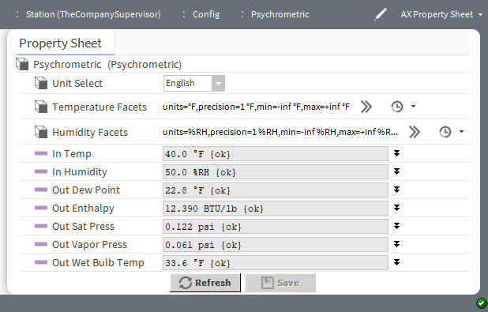

Property | Value | Description
Unit Select | drop-down list (de- faults to English) | Selects units of measure.
Temperature Facets | Config Facets window | Selects units and configures how the value displays:

Property | Value | Description
units defaults to temperature.
precision defines the number of decimal places of temperature.
min defines the lowest temperature allowed.
max defines the highest temperature allowed.
This configuration applies to Outside Temp, This configuration applies to the In Temp property value.
Humidity Facets | Config Facets window | Selects units and configures how the value displays:  units defaults to percentage of relative humidity (%RH).  precision defines the number of decimal places of humidity percentage.  min defines the lowest humidity allowed.  max defines the highest humidity allowed.  This configuration applies to In Humidity property value.
In Temp | number of degrees of temperature (de- faults to 0.0 de- grees F) and null definition | Defines the input temperature.  When null value is checked, the value displayed defaults to the incoming value from the device. If you remove the check mark you can configure the In value.
In Humidity | percentage of hu- midity (defaults to 0.0 percent RH) and null definition | Defines the input humidity.  When null value is checked, the value displayed defaults to the incoming value from the device. If you remove the check mark you can configure the In value.
Out Dew Point | nan (not a number) or degrees (de- faults to nan) and null definition | Reports the calculated dew point temperature. This value re- quires valid In Temp and In Humidity values.  When null value is checked, the value displayed defaults to the incoming value from the device. If you remove the check mark you can configure the In value.
Out Enthalpy | nan (not a number) or BTU/lb (defaults to nan) and null definition | Reports calculated enthalpy. This value requires valid In Temp  and In Humidity values.  When null is checked, the value displayed defaults to the incom- ing value from the device. If you remove the check mark you can configure theIn value.
Out Sat Press | number of psi (pounds per square inch) (defaults to 0.019) and null definition | Reports calculated saturated pressure. This value requires a valid In Temp.  When null value is checked, the value displayed defaults to the incoming value from the device. If you remove the check mark you can configure the In value.

Property | Value | Description
Out Vapor Press | nan psi and null definition | Reports calculated vapor pressure. This value requires valid In Temp and In Humidity values.  When null value is checked, the value displayed defaults to the incoming value from the device. If you remove the check mark you can configure the In value.
Out Wet Bulb Temp | nan or degrees (de- faults to nan) and null definition | Reports calculated wet bulb temperature. This value requires valid In Temp and In Humidity values.  When null value is checked, the value displayed defaults to the incoming value from the device. If you remove the check mark you can configure the In value.

kitControl-SetpointLoadShed
This component provides a convenient way to implement load shedding strategies. It causes a specified set- point to be raised or lowered by a specific amount in response to an input link, that enables the Setpoin- tLoadShed component. Generally, this component solves the problem often found in temperature control sequences where shutting down an output directly may be complicated by other control dependencies. By changing the setpoint based on a shed request, the control sequence directs the output when to shut down and maintains the interdependencies.
SetpointLoadShed is available in the Energy folder of the kitControl palette.
Figure 50 SetpointLoadShed property sheet
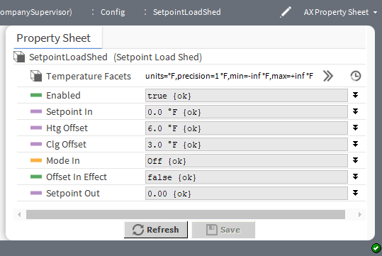

Property | Value | Description
Enabled | true (default) or false and null definition | Turns changing the setpoint on and off. true adjusts the setpoint by the offset value. false ignores the setpoint.  When null is checked, the value displayed defaults to the incom- ing value from the device. If you remove the check mark you can configure theIn value.
Setpoint In | number of degrees of temperature (de- faults to 0.0 F) and null definition | Displays the normal setpoint value to be adjusted by this object.

Property | Value | Description
 |  | When null is checked, the value displayed defaults to the incom- ing value from the device. If you remove the check mark you can configure theIn value.
Htg Offset | signed (+ or -) num- ber of degrees of temperature (de- faults to 6.0 F) and null definition | Defines the amount by which to adjust the setpoint when in heat- ing mode.  When null is checked, the value displayed defaults to the incom- ing value from the device. If you remove the check mark you can configure theIn value.
Clg Offset | signed (+ or -) num- ber of degrees of temperature (de- faults to 3.0 F) and null definition | Defines the amount by which to adjust the setpoint when in cool- ing mode.  When null is checked, the value displayed defaults to the incom- ing value from the device. If you remove the check mark you can configure theIn value.
Mode In | StatusEnum (drop- down list) with three options and null definition | Selects the current need: Off, Heat, Cool.  When null is checked, the value displayed defaults to the incom- ing value from the device. If you remove the check mark you can configure theIn value.
Offset in Effect | true or false (default) and null definition | Indicates if the Setpoint Out property value has been adjusted.  When null is checked, the value displayed defaults to the incom- ing value from the device. If you remove the check mark you can configure theIn value.
Setpoint Out | number of degrees of temperature and null definition | Displays the adjusted setpoint value, if active, otherwise it passes through to the original setpoint.  When null is checked, the value displayed defaults to the incom- ing value from the device. If you remove the check mark you can configure theIn value.

kitControl-SetpointOffset
This component provides setpoint control for electrical demand limiting applications. You use it with the Electri- calDemandLimit and ShedControl components.
SetpointOffset is available in the Energy folder of the kitControl palette

Figure 51 SetpointOffset properties
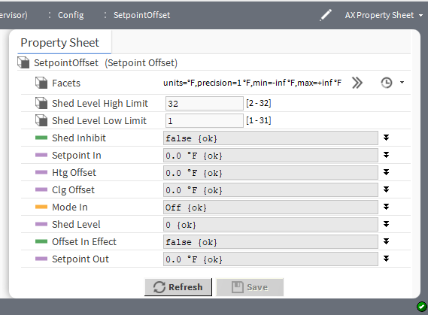

Property | Value | Description
Facets | Config Facets win- dow (defaults to Fahrenheit temper- ature for units, a single decimal place, negative in- finity for minimum and positive infinity for maximum) | Selects units and configures how the value displays:  units defines the unit of measure from acceleration to  volumetric flow.  precision defines the number of decimal places.  min and max refer to minimum and maximum temperatures.
Shed Level High Limit | number between 2 and 32 (defaults to 32) based on the facets | Defines the maximum offset.
Shed Level Low Limit | number between 1 and 31 (defaults to 1) based on the facets | Defines the level at which the offset begins.
Shed Inhibit | true or false  (defaults to false) | Turns adjustment of the setpoint on and off:  true disables the shedding ability.  false causes the setpoint to be adjusted by the offset.
Setpoint In | number of degrees (defaults to zero (0.0)) | Displays the source setpoint value linked in to this component.
Htg Offset | number of degrees (defaults to zero (0.0)) | Defines the maximum setpoint (plus or minus) offset if heating is active and in heating mode.
Clg Offset | number of degrees (defaults to zero (0.0)) | Defines minimum setpoint (plus or minus) offset if cooling is ac- tive and in cooling mode.

Property | Value | Description
Mode In | Off (default) and  On | Selects the current need: Off, Heat, Cool.
Shed Level | number of degrees (defaults to zero (0)) | Displays the shed level that is in effect.
Offset In Effect | true or false (default) and null definition | Indicates if the Setpoint Out property value has been adjusted.  When null is checked, the value displayed defaults to the incom- ing value from the device.If you remove the check mark you can configure the In value.
Setpoint Out | number of degrees (defaults to zero (0)) | Displays the adjusted setpoint if it is active. Otherwise, it pass through the original setpoint.

kitControl-ShedControl
This component receives inputs from a primary (network) EDL source and a local (secondary) EDL source (separate ElectricalDemandLimit objects) that specify the number of load levels that should be shed. The Sec- ondary Shed Level backs up when the Primary Shed Level is not available
ShedControl is available in the Energy folder of the kitControl palette, along with related objects. ShedControl has StatusBoolean outputs for up to 16 contiguous levels, as specified in the Number Levels
property. A Status slot provides an output message to indicate this component’s state in reference to the over- all demand limiting control scheme.

Figure 52 ShedControlProperties
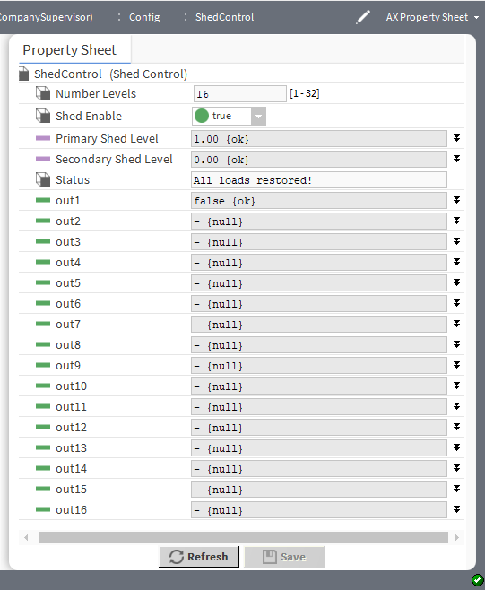

Property | Value | Description
Number Levels | number from 1–32  (defaults to 16) | Defines
Shed Enable | true (default) or  false | Turns execution of this component on and off.
Primary Shed Level | number (defaults to 0.0) and null definition | Defines the input to link to from an EDL component. Typically, this would be a component on the network.  When null is checked, the value displayed defaults to the incom- ing value from the device. If you remove the check mark you can configure theIn value.

Property | Value | Description
Secondary Shed Level | number (defaults to 0.0) and null definition | Defines an input to from a secondary (or backup) EDL compo- nent. Typically, this would be an EDL component with a locally available connection. The Secondary Shed level is used only if the Primary Shed Level property is not available.  When null is checked, the value displayed defaults to the incom- ing value from the device. If you remove the check mark you can configure theIn value.
Status (out1 through out16) | binary status values and null definitions | Reflect the current active Shed Level. For example, a Shed Lev- el of 3 (as indicated by the Primary Shed Level, or Secondary Shed Level when Primary is not available) sets the first three out properties (out1, out2, out3) to false. This false value may be used to turn off power by linking to an appropriate control. When a restore changes the Shed Level to 2, the out3 property returns to null, relinquishing control to the next (out2) priority level.  When null is checked, the value displayed defaults to the incom- ing value from the device. If you remove the check mark you can configure theIn value.

kitControl-SlidingWindowDemandCalc
This component simulates a demand meter and calculates the sliding window demand for 5, 15, and 30-minute demand intervals based on an accumulative pulse counter input. It also calculates the total kWh since last reset and the hourly and daily kWh values.
SlidingWindowDemandCalc is available in the Energy folder of the kitControl palette.
Once calculated, a standard history extension setup to execute on-trigger only can log the hourly and daily kWh values. The SlidingWindowDemandCalc object fires the hourly and daily triggers to align the kWh data correctly to actual clock values. The pulse input into the object is assumed to be accumulative (not delta pulses) that roll over after reaching the 16 bit limit (65535).
You can configure this component to reset all the calculated accumulative values on a preset interval such as at “noon on the first Sunday, every month.”

Figure 53 SlidingWindowDemandCalc properties
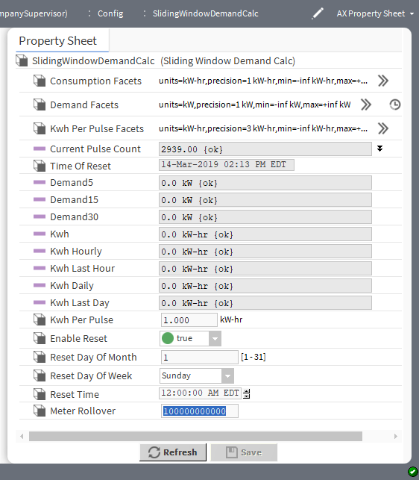

Property | Value | Description
Consumption Facets | Config Facets win- dow (defaults to kW-hr for units, one decimal point for precision, negative infinity for minimum value, and positive infinity for the maxi- mum value) | Configures the consumption output property:  units configures units of measure (default to energy and kilo- watt hour (kW-hr)).  precision defines the number of decimal places for the out values (defaults to 1).  min defines the smallest allowable value of the output property (defaults to -infinity)  max defines the largest allowable value of the output property (defaults to +infinity)
Demand Facets | Config Facets win- dow (defaults to kW for units, one deci- mal point for preci- sion, negative infinity for mini- mum, positive infin- ity for maximum) | Configures the demand output property:  units configures units of measure (default to power and kilo- watt hour (kW-hr).  precision defines the number of decimal places for the out values (defaults to 1).  min defines the smallest allowable value of the output property (defaults to -infinity)  max defines the largest allowable value of the output property (defaults to +infinity)
Kwh Per Pulse Facets | Config Facets win- dow (defaults to | Configures the kwh per pulse output property.

Property | Value | Description
 | kW-hr for units, three decimal pla- ces for precision, negative infinity for minimum, and posi- tive infinity for maximum) | units configures units of measure (default to energy and kilo- watt hour (kW-hr)).  precision defines the number of decimal places for the out values (defaults to 3).  min defines the smallest allowable value of the output property (defaults to -infinity)  max defines the largest allowable value of the output property (defaults to +infinity)
Current Pulse Count | number (defaults to 0.00) and null definition | Displays data from a link to a pulse counter input object indicat- ing the running total of pulses.  When null is checked, the value displayed defaults to the incom- ing value from the device. If you remove the check mark you can configure theIn value.
Time of Reset | read-only | Displays the date and time of the last reset
Demand5 | read-only | Displays the demand (kW) for a five minute window.
Demand15 | read-only | Displays the demand (kW) for a fifteen minute window.
Demand30 | read-only | Displays the demand for a 30 minute period.
Kwh | read-only | Displays the running kWh (consumption) value since the last reset.
Kwh Hourly | read-only | Displays the running value since the last hourly reset.
Kwh Last Hour | read-only | Displays the kWh (consumption) value for the last hour.
Kwh Daily | read-only | Displays the kWh (consumption) value since the last daily reset.
Kwh Last Day | read-only | Displays the kWh (consumption) value for the last day.
Kwh Per Pulse | number of kilowatts per hour (defaults to 1 kW-hr) | Sets the value per pulse, that is, how much energy each pulse represents. This value is usually noted on the meter or provided by the power company.
Enable Reset | true (default) or  false | true configures recurring automatic resets to happen at a fre- quency based on the following properties.  false disables automatic resets.
Reset Day of Month | number from 1 to 31 | Sets the day of month when a recurring automatic reset (if en- abled) occurs.
Reset Day of Week | drop-down list (de- faults to Sunday) | Selects the day of the week when a recurring automatic reset (if enabled) occurs.
Reset Time | hours:minutes (de- faults to 12 AM) | Sets the time of day for a recurring automatic reset (if enabled) to occur.
Meter Rollover | number | Specifies the maximum value the meter provides before it rolls over to zero (0). The default value is 65535, the data type is a long (up to a very large number, 9223372036854775807).

Chapter 7 HVAC components

Topics covered in this chapter
- kitControl-InterstartDelayControl
- kitcontrol-InterstartDelayMaster
- kitControl-LeadLagCycles
- kitControl-LeadLagRuntime
- kitControl-LoopPoint
- kitControl-RaiseLower
- kitControl-SequenceBinary
- kitControl-SequenceLinear
- kitControl-Tstat

Components include services, folders and other model building blocks associated with a module. You may drag them to a property or wire sheet from a palette. These components provide various control functions used in commercial HVAC applications.
The descriptions included in the following topics appear as headings in documentation. They also appear as context-sensitive help topics when accessed by:
- Right-clicking on the object and selecting Views→Guide Help
- Clicking Help→Guide On Target

kitControl-InterstartDelayControl
This component delays the start of an HVAC component function. InterstartDelayControl is available in the HVAC folder of the kitControl palette.
These objects are like BooleanWritables, each with three additional slots for use in interstart delay sequences, as follows:
- Delay — Specifies an amount of time to wait before the framework starts next object in the delay.
- Master — Specifies the InterstartDelayMaster component in the station that controls the delay sequence.
- Start Pending — a read-only Boolean status that indicates if a start is pending (true) or not (false).
Use this component with an InterstartDelayMaster, then link outputs of InterstartDelayControl objects, as needed, to control corresponding Boolean writable points (typically proxy points) for the final interstart control.
No other InterstateDelayControl object using the same delay master can start for delay time after this object starts. If delay is not defined, the framework uses the default delay on the master.

Figure 54 InterstartDelayControl properties
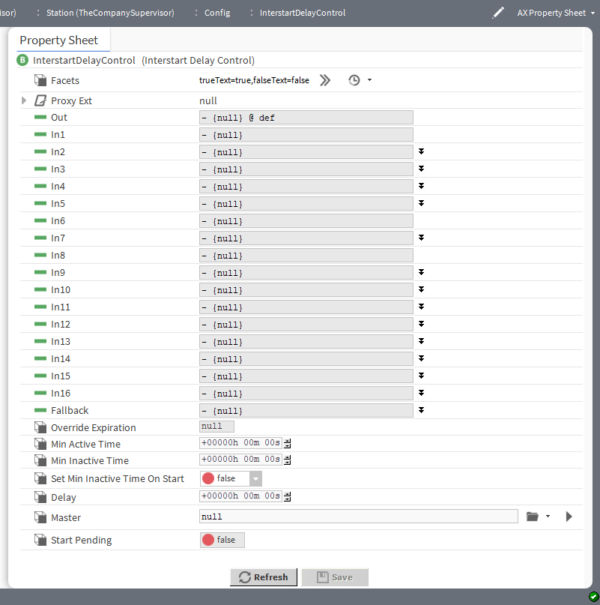

Property | Value | Description
Facets | Config Facets win- dow (defaults to true and false) | Defines text to display for each Boolean value.  trueText configures the text to describe the state when the component returns true.  falseText configures the text to describe the state when the component returns false.
Out | read-only | Displays the result of the configuration.
In1 through In16 | StatusBoolean true or false (default) and null definition | Link to up to 16 points, which provide StatusBoolean input.  When null is checked, the value displayed defaults to the incom- ing value from the device.If you remove the check mark you can configure the In value.
Fallback | StatusBoolean true or false (default) and null definition | Sets the Out property’s value to the value of this property when a point returns a null or invalid value at inputs In1-In16.

Property | Value | Description
Override Expiration | defaults to null | It defaults the value to null.
Min Active Time | hours minutes seconds | Provides for a minimum up time.
Min Inactive Time | hours minutes seconds | Provides for a minimum down time.
Set Min Inactive Time On Start | true or false  (default) | Ensures the minimum inactive time when the station starts.
Delay | hours minutes seconds | Defines the amount of time to elapse before the component starts the next object in the sequence.
Master | file chooser (de- faults to null) | Locates the InterstartDelayMaster component in the station.
Start Pending | read only Status- Boolean true or false (default) | Indicates if a start is pending.  true indicates the start is pending.  false indicates no start is pending.

kitcontrol-InterstartDelayMaster
This component defines the master in an inter-start delay sequence. Use it in conjunction with one or more In- terstartDelayControl objects.
InterstartDelayMaster is available in the HVAC folder of the kitControl palette. An available action for this component is DelayTimerExpired.
Figure 55 InterstartDelayMaster properties
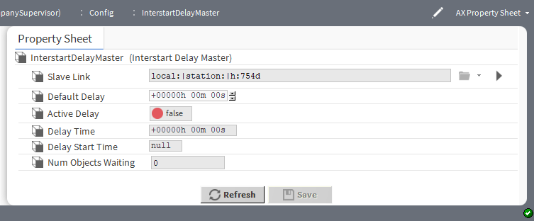

Property | Value | Description
Slave Link | ORD | Links to the slave InterstartDelayControl components.
Default Delay | hours minutes sec- onds (defaults to zero) | Defines the how long to wait before starting a request. The com- ponent uses this value only if Delay Time is not defined.
Active Delay | read-only true or  false (default) | Displays if the delay is active.  true indicates that the interstart delay is active  false indicates that the interstart delay is not active.

Property | Value | Description
Delay Time | read-only hours mi- nutes seconds (de- faults to zero) | Displays the length of the current delay.
Delay Start Time | read-only clock time | Displays the time that the current delay started.
Num Objects Waiting | read-only number (defaults to zero (0)) | Displays the number of objects currently waiting to start.

kitControl-LeadLagCycles
This component provides lead-lag control of from 2 to 10 BooleanWritables based upon their accumulated COS (change of state) counts. This object balances the number of change of states cycles of each of the devi- ces. Only one of the controlled devices is active at a time based on cycle count
LeadLagCycles is available in the HVAC folder of the kitControl palette, along with a similar LeadLagRun- time object.
Figure 56 LeadLagCycles property sheet

Property | Value | Description
Facets | Config Facets win- dow (defaults to true and false) | Defines text to display for each Boolean value.  trueText configures the text to describe the state when the component returns true.  falseText configures the text to describe the state when the component returns false.
In | status Boolean in- put: true or false (default) and null definition | Configures a control device to be on or off.  true indicates that one of the outputs is active based on the cycle count of each controlled device.

Property | Value | Description
 |  | When null is checked, the value displayed defaults to the incom- ing value from the device.If you remove the check mark you can configure the In value.
Number Outputs | number from 1–10  (defaults to 2) | Specifies the number of devices (outputs) to control.
Max Runtime | hours, minutes, seconds (defaults to six minutes) | Specifies the maximum amount of time a given output is active (its In property is set to true) before switching to another output.
Feedback | status Boolean in- put: true or false (default) and null definition | Provides positive feedback that a controlled device actually started. If the feedback value does not show true within the Feedback Delay time, the current controlled output generates an alarm, and the component switches to the next controlled output.  Setting this value to true without linking disables this alarm feature.  When null is checked, the value displayed defaults to the incom- ing value from the device.If you remove the check mark you can configure the In value.
Feedback Delay | hours, minutes, seconds (defaults to 5 seconds) | Specifies the delay time used to evaluate the feedback link (if any).
Clear alarm time | hours minutes seconds | It clears alarm time.
Out A-J | read only Status- Boolean outputs: true or false (default) | Each typically links to a BooleanWritable control point with a Dis- creteTotalizerExt. Outputs usually control loads of some type, such as two or more pumps.
Cycle Count A-J | integer inputs | These inputs cycle count feedback for the corresponding Out A  - J properties. They typically link to the ChangeOfStateCount property of the DiscreteTotalizerExt that is measuring the cycles of the corresponding Out A - J properties.

kitControl-LeadLagRuntime
This component provides lead-lag control of from two to 10 BooleanWritables based upon their accumulated runtimes (elapsed active time). This object balances the active runtime of each of the devices. Only one of the controlled devices is active at a time based on runtime
LeadLagRuntime is available in the HVAC folder of the kitControl palette, along with a similar LeadLag- Cycles object.

Figure 57 LeadLagRuntime properties

Property | Value | Description
Facets | Config Facets window | Defines text to display for each Boolean value.  trueText configures the text to describe the state when the component returns true.  falseText configures the text to describe the state when the component returns false.
In | status Boolean in- put: true or false (default) and null definition | Configures a control device to be on or off.  true indicates that one of the outputs is active based on the cycle count of each controlled device.  When null is checked, the value displayed defaults to the incom- ing value from the device.If you remove the check mark you can configure the In value.
Number Outputs | number from 1–10  (defaults to 2) | Specifies the number of devices (outputs) to control.
Max Runtime | hours, minutes, seconds (defaults to six minutes) | Specifies the maximum amount of time a given output is active (its In property is set to true) before switching to another output.
Feedback | status Boolean in- put: true or false (default) and null definition | Provides positive feedback that a controlled device actually started. If the feedback value does not show true within the Feedback Delay time, the current controlled output generates an alarm, and the component switches to the next controlled output.  Setting this value to true without linking disables this alarm feature.
Feedback Delay | hours, minutes, seconds (defaults to 5 seconds) | Specifies the delay time used to evaluate the feedback link (if any).

Property | Value | Description
Clear alarm time | hours, minutes, seconds | It clears alarm time.
Out A-J | read-only Status- Boolean outputs: true or false (default) | Each typically links to a BooleanWritable control point with a Dis- creteTotalizerExt. Outputs usually control loads of some type, such as two or more pumps.
Cycle Count A-J | RelTime inputs | These inputs provide runtime feedback for the corresponding Out A - J properties. They typically link to the ElapsedActi- veTime property of the DiscreteTotalizerExt that is measuring the runtime of the corresponding Out A - J properties.

kitControl-LoopPoint
This component implements a simple PID control loop. Loop objects provide closed-loop PID control (propor- tional, integral, derivative) at the station level. Independent gain constants configure the loop as P-only, PI, or PID.
LoopPoint is available in the HVAC folder of the kitControl palette.
Figure 58 LoopPoint properties

Property | Value | Description
Facets | Config Facets window | Selects units and configures how the value displays:  unit defines the unit of measure from acceleration to  volumetric flow.  precision defines the number of decimal places.  min defines the lowest value allowed. max defines the highest value allowed. These facets apply to the Out value.
Out | read-only number | Displays the output value for the loop.
Loop Enable | true (default) or false and null definition | Turns the loop on and off.  true enables the PID loop algorithm to execute at the rate se- lected by the Execute Time property.  false forces the PID loop output to a value that is dependent on the selection in the Disable Action property.  When null is checked, the value displayed defaults to the incom- ing value from the device.If you remove the check mark you can configure the In value.
Input Facets | Config Facets window | Selects units and configures how the value displays:  unit defines the unit of measure from acceleration to  volumetric flow.  precision defines the number of decimal places.  min defines the lowest value allowed. max defines the highest value allowed. These facets apply to the input.
Controller Variable | number (defaults to 0.0) and null definition | Defines the input value for the controlled property (for example, space temperature). This input must be valid for this object to function.  When null is checked, the value displayed defaults to the incom- ing value from the device.If you remove the check mark you can configure the In value.
Setpoint | number of degrees of temperature and null definition | Defines the input value for the setpoint (for example, the space temperature setpoint). This value must be valid for this object to function. The object does not provide an integral command func- tion for the setpoint value when entered on the property sheet.  If a commandable setpoint is required, link from a NumericWrit- able control point to the setpoint slot.
Execute Time | hours minutes sec- onds (defaults to .5 second) | Controls the execution frequency for the PID algorithm.
Actual Time | read-only integer (defaults to zero (0)) | Reports the milliseconds since the previous execution. Chang- ing the Execute Time changes this time.

Property | Value | Description
Loop Action | drop-down list (de- faults to Direct) | Determines if the control algorithm is direct or reverse acting.  Direct increases the loop output as the value of the controlled variable increases to greater than the setpoint value. In a tem- perature loop, this is considered to be a cooling application.  Reverse increases the loop output as the value of the con- trolled variable decreases to less than the setpoint value. In a temperature loop, this is considered to be a heating application.
Disable Action | drop-down list (de- faults to Zero) | Selects the value for the loop output (Out) when Loop Enable  is false.  Max Value sets the loop output value to the value configured for Max Output.  Min Value sets the loop output value to the value configured for Min Output.  Hold maintains the loop output value at the last calculated value.  Zero sets the loop output value to zero (0.00).
Tuning Facets | Config Facets window | Selects units and configures how the value displays:  unit defines the unit of measure from acceleration to  volumetric flow.  precision defines the number of decimal places.  min defines the lowest value allowed.  max defines the highest value allowed.  These facets apply to the tuning properties, such as the con- stants, Bias, and output properties.
Proportional Constant | number of seconds to three decimal places | Defines a value used by the loop algorithm to set the overall gain for the loop. A starting point for this value equals: output range/ throttling range.
Integral Constant | number to three decimal places | Defines the integral gain in repeats per minute. The loop algo- rithm uses this value (also called the reset rate) to act on the magnitude of the setpoint error. A typical starting point is 0.5.
Derivative Constant | number to three decimal places | Defines the derivative gain used by the loop algorithm to act on the rate of change of the setpoint error.
Bias | number to two deci- mal places | Defines an amount of output the algorithm adds to correct any offset error. The algorithm uses this value normally only with pro- portional control.
Maximum Output | number to two deci- mal places | Defines the maximum output value that the loop algorithm can produce.

Property | Value | Description
Minimum Output | number to two deci- mal places | Defines the minimum output value that the loop algorithm can produce.
Ramp Time | hours minutes sec- onds (defaults to 0) | Defines the minimum time that the output can ramp completely from Minimum Output to Maximum Output, effectively estab- lishing a rate-of-change slope. This component enforces this value at station startup or whenever the LoopPoint transitions from disabled to enabled.  Once Ramp Time expires, it no longer affects the output. This property is intended to prevent the loop from opening a valve or other controlled device to its maximum limit (“slamming”) during startup.  NOTE: The default Ramp Time is 0:00:00, or disabled. To con- strain the loop output rate of change when the loop starts or is enabled, enter a reasonable Ramp Time value.

Action
ResetIntegral clears the current integral component of the loop’s output calculation. If needed, you can link this slot to another object to provide a quick purge of the integral effect. Typically, the latter would provide more of a debug utility, and should not be necessary if the LoopPoint’s configuration properties are correctly defined.

kitControl-RaiseLower
This component provides a staged analog output designed to be used with a third party two-relay hardware de- vice. It also provides for the operation of two digital outputs from normal IO hardware such as NDIO as an alter- native control method. The actuator should be able to sustain an overdrive at each boundary (for example, a clutch mechanism) as the Raise lower object does not have proportional feedback or limit switch features.
RaiseLower component is available in the HVAC folder of the kitControl palette.
Figure 59 RaiseLower properties
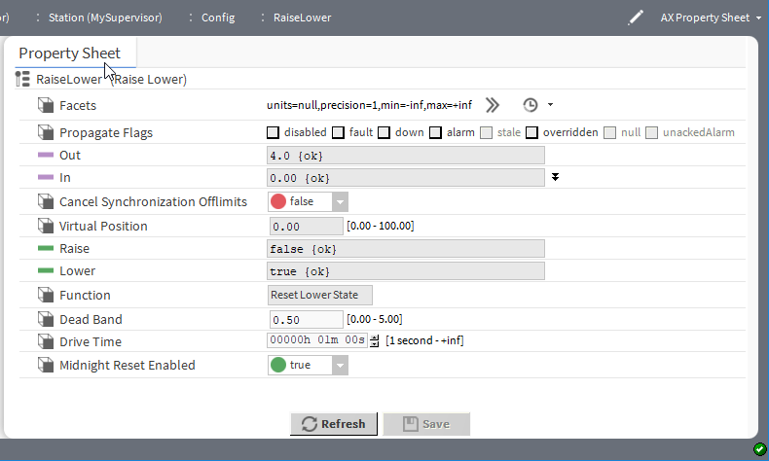

Property | Value | Description
Facets | Config Facets window | Selects units and configures how the value displays:  unit defines the unit of measure from acceleration to  volumetric flow.  precision defines the number of decimal places.  min defines the lowest value allowed.  max defines the highest value allowed.  This configuration applies to the Out property value.
Out | read only StatusNu- meric number of volts | Displays the analog output value from the object. Valid voltage outputs of 0v, 4v, 7v and 10v depend on the function determined by the object.  When null is checked, the value displayed defaults to the incom- ing value from the device.If you remove the check mark you can configure the In value.
In | status numeric val- ue for percentage from 0 to 100 (de- faults to 0.00) and null definition | Defines an input percentage. This slot typically connects to a modulated output of a Control object such as a PID Loop.
Cancel Synchroni- zation Offlimits | true or false  (default) | true prevents the doubling of the Drive Time when moving to the limit positions: 0.0 or 100.0.  false permits the doubling of Drive Time.
Virtual Position | status numeric per- centage value for percentage from 0 to 100 (defaults to 0.00) | Represents the virtual position of the actuator as calculated by the RaiseLower component.
Raise | status Boolean val- ue: true or false (default) | true configures the output to raise the position of the actuator. The component maintains the raise output for a period of time determined by the positive differential of Virtual Position subtracted from the In value, and is a relative proportion of the full-scale drive time.  If Virtual Position is 100 percent (fully raised), the component compensates for real time drift by asserting twice the drive time. This synchronizes the physical actuator with the calculated vir- tual position.  false leaves the position of the actuator unchanged.
Lower | status Boolean val- ue: true or false (default) | true configures the output to lower the position of the actuator. The component maintains the lower output for a period of time determined by the negative differential of Virtual Position subtracted from the In value, and is a relative proportion of the full-scale drive time.  If Virtual Position is 0 percent (fully lowered), the compo- nent compensates for real time drift by asserting twice the drive time. This synchronizes the physical actuator with the calculated virtual position.  false leaves the position of the actuator unchanged.

Property | Value | Description
Function | read-only | Displays operational information corresponding to the current activity of the object. Valid status values include: Off, Lower, Static, Raise.
Dead Band | single digit between 0 and 6 with two decimal places (de- faults to 0.50) | Configures an interval where no action occurs and should be set to a value that corresponds to a percentage of full scale drive time. The In value must exceed the Dead Band value before the Out command raises or lowers the actuator.
Drive Time | hours minutes sec- onds (defaults to one minute) | This should be set to a value that corresponds to the full scale drive time provided by the manufacturer.
Midnight Reset Enabled | true (default) or  false | true invokes a synchronization cycle at midnight to compen- sate for real time drift that may accumulate during normal opera- tion of the actuator. The reset cycle overrides an input signal for a period of twice the full length Drive Time.  false inhibits a reset. This is the desired setting.

kitControl-SequenceBinary
This component provides sequenced weighted staging control of from two to 10 BooleanWritables based upon the status numeric In value (0-100). An adjustable delay time is also provided. It can be used to support appli- cations that need to sequence two to 10 loads or stages in a binary sequence. Binary sequencing provides an analog to binary converter function that selects the outputs whose total load rating relates directly to the control need. For each successive output, the output rating is twice the previous output.
SequenceBinary is available in the HVAC folder of the kitControl palette. A similar object is the Sequence- Linear, which uses a rotating method (vs. a weighted method) for sequencing.
For example, this table illustrates how, by controlling three loads, eight unique levels of control can be achieved.

Control Signal (In)% | OutC (4 kw load size) | OutB (2 kw load size) | OutA (1 kw load size) | Stage Hysteresis
100 | On | On | On | 14.3
87.5 | On | On | Off | 14.3
71.4 | On | Off | On | 14.3
57.1 | On | Off | Off | 14.3
42.9 | Off | On | On | 14.3
28.6 | Off | On | Off | 14.3
14.3 | Off | Off | On | 14.3
0 | Off | Off | Off | 14.3

Figure 60 SequenceBinary properties
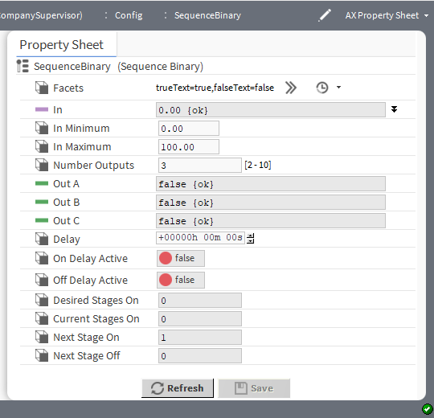

Property | Value | Description
Facets | Config Facets window | This configuration applies to the Out property values.
In | number (defaults to 0.00) and null definition | Determines the number of stages that should currently be On.  When null is checked, the corresponding value defines the de- fault when a calculation returns null.
In Minimum | single digit to two decimal places (de- faults to 0.00) | Defines the In value that turns all outputs off.
In Maximum | three-digit number to two decimal pla- ces (defaults to 100) | Defines the In value that turns all outputs on.
Number Outputs | number between 2  and 10 inclusive  (defaults to 3) | Defines the number of outputs or stages.
Out A-J | read-only Status- Boolean values: true or false | Controls each of from two to 10 loads. The Number Outputs  property defines how many are available.
Delay | hours minutes sec- onds (defaults to no delay) | Defines the amount of time that must pass between changes in outputs. The default time is 0 seconds.
On Delay Active | read-only Status- Boolean values: true or false (default) | Indicates true when the on delay timer is active.

Property | Value | Description
Off Delay Active | read-only Status- Boolean values: true or false (default) | Indicates true when the off delay timer is active.
Desired Stages On | read-only number | Indicates the calculated number of stages that should be on based on the In property.
Current Stages On | read-only number | Indicates the number of stages that are currently on. Normally Current Stages On and Desired Stages On are the same. They differ when going through a transition with the delay timer active.
Next Stage On | read-only number | Indicates the next stage to be turned on if needed.
Next Stage Off | read-only number | Indicates the next stage to be turned off if needed.

kitControl-SequenceLinear
This component provides sequenced rotating staging control of from two to 10 BooleanWritables based upon the status numeric In value (0-100). An adjustable delay time is also provided.
SequenceLinear is available in the HVAC folder of the kitControl palette. A similar object is the Sequence- Binary, which uses a weighted method (vs. a rotating method) for sequencing.
This component supports applications that need to sequence two to 10 loads or stages in a linear or rotating se- quence. With linear sequencing, the first stage on will be the last stage off. With rotating sequencing, the first stage on will be the first stage off. The In property, which is a StatusNumeric, controls the number of stages that should be on. The input range is defined by the In Minimum and In Maximum properties.
For example, On and Off setpoints are calculated for each stage by the following formulas (this assumes that five outputs are defined).

 | Linear | Rotating
range = InMaximum - InMinimum | 100 = 100 - 0 | 100 = 100 - 0
delta = range / NumberOutputs | 20 = 100 / 5 | 20 = 100 / 5
OnSetpointA = 1 * delta | 20 | 20
OnSetpointB = 2 * delta | 40 | 40
OnSetpointC = 3 * delta | 60 | 60
OnSetpointD = 4 * delta | 80 | 80
OnSetpointE = 5 * delta | 100 | 100
OffSetpointA = 0 * delta, 4 * delta | 0 | 80
OffSetpointB = 1 * delta, 3 * delta | 20 | 60
OffSetpointC = 2 * delta, 2 * delta | 40 | 40
OffSetpointD = 3 * delta, 1 * delta | 60 | 20
OffSetpointE = 4 * delta, 0 * delta | 80 | 0

Figure 61 SequenceBinary properties
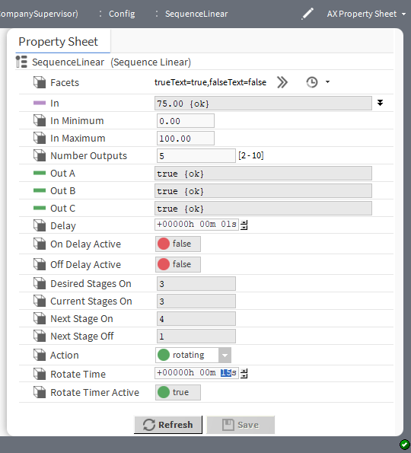

Property | Value | Description
Facets | Config Facets window | Defines text to display for each Boolean value.  trueText configures to describe the state when the component returnstrue.  falseText configures to describe the state when the compo- nent returnsfalse.  This configuration applies to the Out property values.
In | number (defaults to 0.00) and null definition | Determines the number of stages that should currently be On.
In Minimum | single digit to two decimal places (de- faults to 0.00) | Defines the In value that turns all outputs off.
In Maximum | three-digit number to two decimal pla- ces (defaults to 100) | Defines the In value that turns all outputs on.
Number Outputs | number between 2  and 10 inclusive  (defaults to 3) | Defines the number of outputs or stages.
Out A-J | read-only Status- Boolean values: true or false | Controls each of from two to 10 loads. The Number Outputs  property defines how many are available.

Property | Value | Description
Delay | hours minutes sec- onds (defaults to no delay) | Defines the amount of time that must pass between changes in outputs. The default time is 0 seconds.
On Delay Active | read-only Status- Boolean values: true or false (default) | Indicates true when the on delay timer is active.
Off Delay Active | read-only Status- Boolean values: true or false (default) | Indicates true when the off delay timer is active.
Desired Stages On | read-only | Indicates the calculated number of stages that should be on based on the In property.
Current Stages On | read-only | Indicates the number of stages that are currently on. Normally Current Stages On and Desired Stages On are the same. They differ when going through a transition with the delay timer active.
Next Stage On | read-only | Indicates the next stage to be turned on if needed.
Next Stage Off | read-only | Indicates the next stage to be turned off if needed.
Action | drop-down list | Selects between Linear and Rotating action.  Linear configures Out A (Stage 1) to always be the first stage to turn on and the last stage to turn off.  Rotating configures the first stage to turn on and increment to the next stage each time Current Stages On goes to 0.
Rotate Time | hours minutes sec- onds (defaults to one second) | Specifies the amount of time that the outputs remain in a fixed configuration before the component shifts them to the next configuration.
Rotate Timer Active | read-only status Boolean values: true or false (default) | Indicates that the rotate timer is active.

kitControl-Tstat
This component provides basic thermostatic (On/Off) control with a StatusBoolean Out property and StatusNu- meric inputs for controlled variable (Cv), setpoint (Sp), and differential (Diff). An Action property configures the operation directly or in reverse. A Null On Inactive property is also available. Default action is Direct (cooling).
Tstat is available in the HVAC folder of the kitControl palette.

Figure 62 Tstat properties
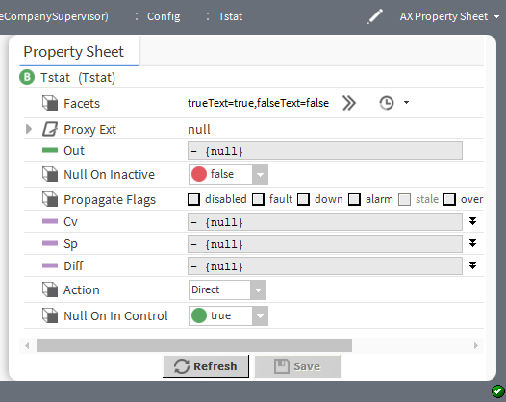

Property | Value | Description
Facets | Config Facets win- dow (defaults to true and false) | This configuration applies to the Out property value.
Out | read-only Status- Boolean true and false | Displays the result of the calculation.
Null On Inactive | true or false  (default) | true sets the Out value to null when the component is inactive.  false retains the last known setting.
Cv | number (defaults to null) and null definition | Defines an input Control Variable (Cv).  When null is checked, the value displayed defaults to the incom- ing value from the device.If you remove the check mark you can configure the In value.
Sp | number (defaults to null) and null definition | Defines the input thermostat Setpoint (Sp).  When null is checked, the corresponding value defines the de- fault when a calculation returns null.
Dif | number (defaults to null) and null definition | Defines an input differential (Dif).  When null is checked, the value displayed defaults to the incom- ing value from the device.If you remove the check mark you can configure the In value.
Action | drop-down list | Direct performs the calculation directly on the input variables.  Reverse reverses the calculation.
Null On In Control | true (default) or  false | true sets an In value to null.  false retains the last known value.

Chapter 8 Latch components

Topics covered in this chapter
- kitControl-BooleanLatch
- kitControl-EnumLatch
- kitControl-NumericLatch
- kitControl-StringLatch

Components include services, folders and other model building blocks associated with a module. You may drag them to a property or wire sheet from a palette. These components capture an input value by using either the component's Clock property or by using the component's Latch action. In either case, latching means setting the value of the latch component’s Out property to whatever the value of the latch component’s In property is at the time that the latch occurs. The framework ignores the value of the latch component In property unless a latch occurs.
Each latch component type has the same properties and function; they vary only to accommodate different point data types
The descriptions included in the following topics appear as headings in documentation. They also appear as context-sensitive help topics when accessed by:
- Right-clicking on the object and selecting Views→Guide Help
- Clicking Help→Guide On Target

kitControl-BooleanLatch
This component provides a latch for a status Boolean input. It has the same properties and actions as all the latch components.
BooleanLatch is in the Latches folder of the kitControl palette.
Figure 63 BooleanLatch properties
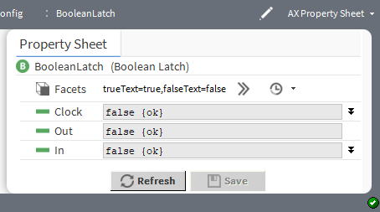

Property | Value | Description
Facets | Config Facets win- dow (defaults to true and false) | Defines text to display for each Boolean value.  trueText configures the text to describe the state when com- ponent returns true.  falseText configures the text to describe the state when com- ponent returns false.  This configuration applies to the Out property value.
Clock | true or false (default) and null definition | Triggers the component to capture and send the In value to the Out value at the moment this property changes from false to true. Nothing happens when it changes from true to false. This is called “latching the input property to the output property on the rising edge.”  When null is checked, the value displayed defaults to the incom- ing value from the device.If you remove the check mark you can configure the In value.
Out | read-only Status- Boolean true or false (default) | Contains the value that is captured from the In property at latch time. You link to this property to display the value on a graphic or to process the value with another component.
In | true or false (default) and null definition | Contains the value to pass to Out. You link to this property from a data source, such as from a control point or a Schedule output.  When null is checked, the value displayed defaults to the incom- ing value from the device.If you remove the check mark you can configure the In value.

Latch action
Latching triggers the component to capture the In value and send it to the Out value. In addition to the Clock property’s role in triggering a latch, you invoke this action:
- Manually, by right-clicking the latch component and clicking Actions→Latch.
- Automatically, by linking a Boolean value to the latch action slot on a Latch component. Any change of the Boolean status value invokes a latch action (false to true or true to false). This is in contrast to using the Clock property, which causes the component to latch only when its status changes from false to true.
Figure 64 Latch invoked by linking to the latch action
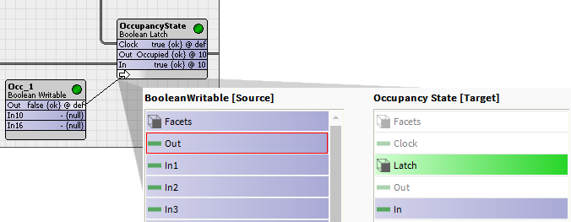
The Latch action captures the input value any time that the Latch command is invoked.

kitControl-EnumLatch
This component provides a latch for a status Enum input. It has the same properties and actions as all the latch components.
kitControl-EnumLatch is available in the Latches folder of the kitControl palette.
Figure 65 EnumLatch properties
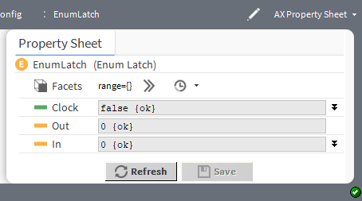

Property | Value | Description
Facets | Config Facets win- dow (defaults to blank) | Defines a range of enumerated states (enum values).This con- figuration applies to the Out property value.
Clock | true and false (default) and null definition | Triggers the component to capture and send the In value to the Out value at the moment this property changes from false to true. Nothing happens when it changes from true to false. This is called “latching the input property to the output property on the rising edge.”  When null is checked, the value displayed defaults to the incom- ing value from the device.If you remove the check mark you can configure the In value.
Out | read-only enumer- ated value (defaults to 0) | Contains the value that is captured from the In property at latch time. You link to this property to display the value on a graphic or to process the value with another component.
In | number (defaults to 0) and null definition | Contains the value to pass to Out. You link to this property from a data source, such as from a control point or a Schedule output.  When null is checked, the value displayed defaults to the incom- ing value from the device.If you remove the check mark you can configure the In value.

Latch action
Latching triggers the component to capture the In value and send it to the Out value. In addition to the Clock property’s role in triggering a latch, you invoke this action:
- Manually, by right-clicking the latch component and clicking Actions→Latch.
- Automatically, by linking a Boolean value to the latch action slot on a Latch component. Any change of the Boolean status value invokes a latch action (false to true or true to false). This is in contrast to using the Clock property, which causes the component to latch only when its status changes from false to true.
The Latch action captures the input value any time that the Latch command is invoked.

kitControl-NumericLatch
This component provides a latch for a status numeric input.
NumericLatch is available in the Latches folder of the kitControl palette.
Figure 66 NumericLatch properties
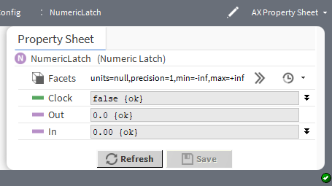

Property | Value | Description
Facets (Numeric) | Config Facets window | Selects units and configures how the value displays:  unit defines the unit of measure from acceleration to  volumetric flow.  precision defines the number of decimal places. This configuration applies to the Out property value.
Clock | true and false (default) and null definition | Triggers the component to capture and send the In value to the Out value at the moment this property changes from false to true. Nothing happens when it changes from true to false. This is called “latching the input property to the output property on the rising edge.”  When null is checked, the value displayed defaults to the incom- ing value from the device.If you remove the check mark you can configure the In value.
Out | read-only number (defaults to 0) | Contains the value that is captured from the In property at latch time. You link to this property to display the value on a graphic or to process the value with another component.
In | number (defaults to 0) and null definition | Contains the value to pass to Out. You link to this property from a data source, such as from a control point or a Schedule output.  When null is checked, the value displayed defaults to the incom- ing value from the device.If you remove the check mark you can configure the In value.

Latch action
Latching triggers the component to capture the In value and send it to the Out value. In addition to the Clock property’s role in triggering a latch, you invoke this action:
- Manually, by right-clicking the latch component and clicking Actions→Latch.
- Automatically, by linking a Boolean value to the latch action slot on a Latch component. Any change of the Boolean status value invokes a latch action (false to true or true to false). This is in contrast to using the Clock property, which causes the component to latch only when its status changes from false to true.

The Latch action captures the input value any time that the Latch command is invoked.

kitControl-StringLatch
This component provides a latch for a StatusString input.
StringLatch is available in the Latches folder of the kitControl palette.
Figure 67 StringLatch properties
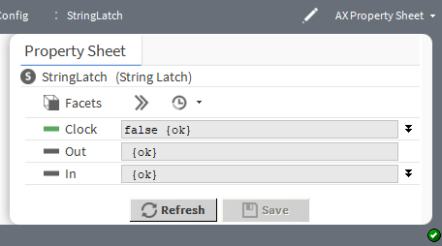

Property | Value | Description
Facets | Config Facets win- dow (defaults to true and false) | Defines the text to display for each Boolean value.  trueText configures to the text to describe the state when the component returnstrue  falseText configures to the text to describe the state when the component returnsfalse  This configuration applies to the Out property value.
Clock | true and false (default) and null definition | Triggers the component to capture and send the In value to the Out value at the moment this property changes from false to true. Nothing happens when it changes from true to false. This is called “latching the input property to the output property on the rising edge.”  When null is checked, the value displayed defaults to the incom- ing value from the device.If you remove the check mark you can configure the In value.
Out | read-only text (de- faults to blank) | Contains the value that is captured from the In property at latch time. You link to this property to display the value on a graphic or to process the value with another component.
In | text (defaults to blank) and null definition | Contains the value to pass to Out. You link to this property from a data source, such as from a control point or a Schedule output.  When null is checked, the value displayed defaults to the incom- ing value from the device.If you remove the check mark you can configure the In value.

Latch action
Latching triggers the component to capture the In value and send it to the Out value. In addition to the Clock property’s role in triggering a latch, you invoke this action:
- Manually, by right-clicking the latch component and clicking Actions→Latch.

- Automatically, by linking a Boolean value to the latch action slot on a Latch component. Any change of the Boolean status value invokes a latch action (false to true or true to false). This is in contrast to using the Clock property, which causes the component to latch only when its status changes from false to true.
The Latch action captures the input value any time that the Latch command is invoked.

Chapter 9 Logic components

Topics covered in this chapter
  - kitControl-And
  - kitControl-Equal
  - kitControl-GreaterThan
  - kitControl-GreaterThanEqual
  - kitControl-LessThan
  - kitControl-LessThanEqual
  - kitControl-Not
  - kitControl-NotEqual
  - kitControl-Or
  - kitControl-Xor
  - kitControl-BqlExprComponent

All 10 of the logic components process input values and provide a StatusBoolean output. Logic object types vary based on input type.
Four logic components receive StatusBoolean inputs:
- And
- Or
- Xor
- Not
Six logic components receive StatusNumeric inputs:
- Equal
- GreaterThan
- GreaterThanEqual
- LessThan
- LessThanEqual
- NotEqual
An ExprLogic component is unlike all others—and technically not a logic component. Instead, it demonstrates how to use an Expr component (BqlExprComponent) with a 4-input logic AND function.
You can add alarm and history extensions to any logic component, in addition to the control extension Discrete- TotalizerExt. If configured with a DiscreteTotalizerExt, you can also add special-purpose alarm extensions ChangeOfStateCountAlarmExt and/or ElapsedActiveTimeAlarmExt.
As with math components, you can individually configure logic components to propagate status flags received on linked inputs (by default, status propagation does not occur). For more details, refer to the Getting Started with EC-Net 4.

kitControl-And
This component performs a logical AND on all inputs and writes the result to the out property. kitControl-And is available in the Logic folder of the kitControl palette.

Figure 68 Logical And with two inputs
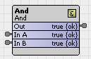
The minimum number of valid inputs for the AND logic object is one. A valid value is one that is “non-null”. In the unique case of only one valid input, the value of the input is passed directly to the output during calculation. The following shows the AND object truth table when using two inputs.

In A | In B | Out
false | false | false
false | true | false
true | false | false
true | true | true
This table shows the object truth using four inputs:
Figure 69 Logical And with four inputs
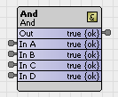

In A | In B | In C | In D | Out
false | false | false | false | false
false | false | false | true | false
false | false | true | false | false
false | false | true | true | false
false | true | false | false | false
false | true | false | true | false
false | true | true | false | false
false | true | true | true | false
true | false | false | false | false
true | false | false | true | false
true | false | true | false | false
true | false | true | true | false
true | true | false | false | false
true | true | false | true | false
true | true | true | false | false
true | true | true | true | true

Figure 70 And properties
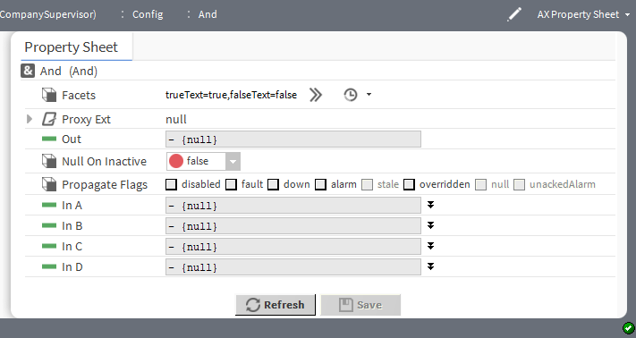

Property | Value | Description
Facets | Config Facets win- dow (defaults to true and false) | Defines the text to display for each Boolean value.  trueText configures to the text to describe the state when the component returnstrue  falseText configures to the text to describe the state when the component returnsfalse
Out | read-only true or  false | Displays the result of the And operation.
In A through In D | StatusBoolean true or false and null definition | Provides the input values for the And operation.

kitControl-Equal
This component performs the operation: A = B. Numeric.NaN values are never equal. Equal is available in the Logic folder of the kitControl palette
Figure 71 Equal properties
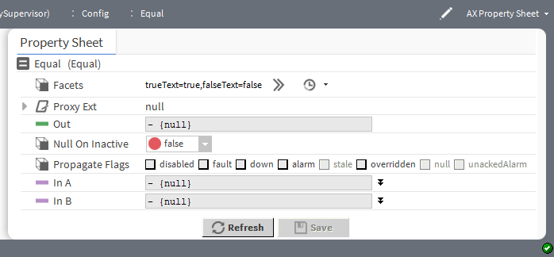

Property | Value | Description
Facets | Config Facets win- dow (defaults to true and false) | Defines the text to display for each Boolean value.  trueText configures the text to describe the state when com- ponent returns true.  falseText configures the text to describe the state when com- ponent returns false.
Out | read-only true or  false | Displays the result of the comparison.
In A and In B | StatusBoolean true or false and null definition | Provides the input values for the comparison.

kitControl-GreaterThan
This component performs the operation: A > B with a Boolean result. GreaterThan is available in the Logic folder of the kitControl palette.
Figure 72 GreaterThan properties
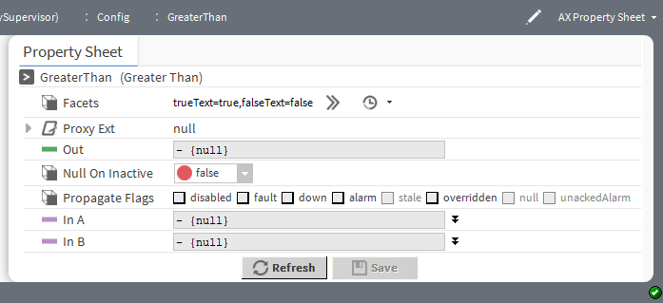

Property | Value | Description
Facets | Config Facets win- dow (defaults to true and false) | Defines the text to display for each Boolean value.  trueText configures the text to describe the state when com- ponent returns true.  falseText configures the text to describe the state when com- ponent returns false.
Out | read-only true or  false | Displays the result of the comparison.
In A and In B | StatusBoolean true or false and null definition | Provides the input values for the comparison.

kitControl-GreaterThanEqual
This component performs the operation: A >= B with a Boolean result.

GreaterThanEqual is available in the Logic folder of the kitControl palette
Figure 73 GreaterThanEqual properties
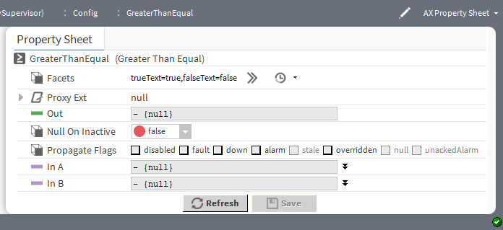

Property | Value | Description
Facets | Config Facets win- dow (defaults to true and false) | Defines the text to display for each Boolean value.  trueText configures the text to describe the state when com- ponent returns true.  falseText configures the text to describe the state when com- ponent returns false.
Out | read-only true or  false | Displays the result of the comparison.
In A and In B | StatusBoolean true or false and null definition | Provides the input values for the comparison.

kitControl-LessThan
This component performs the operation: A < B with a Boolean result. LessThan is available in the Logic folder of the kitControl palette.
Figure 74 LesstThan properties
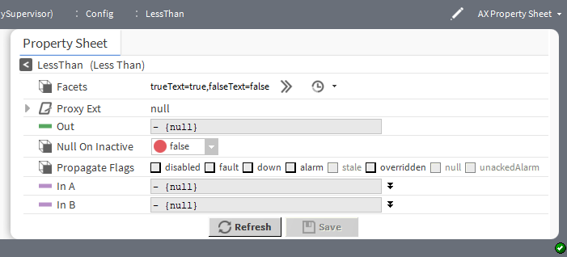

Property | Value | Description
Facets | Config Facets win- dow (defaults to true and false) | Defines the text to display for each Boolean value.  trueText configures the text to describe the state when com- ponent returns true.  falseText configures the text to describe the state when com- ponent returns false.
Out | read-only true or  false | Displays the result of the comparison.
In A and In B | StatusBoolean true or false and null definition | Provides the input values for the comparison.

kitControl-LessThanEqual
This component performs the operation: A <= B with a boolean result. LessThanEqual is available in the Logic folder of the kitControl palette.
Figure 75 LessThanEqual properties
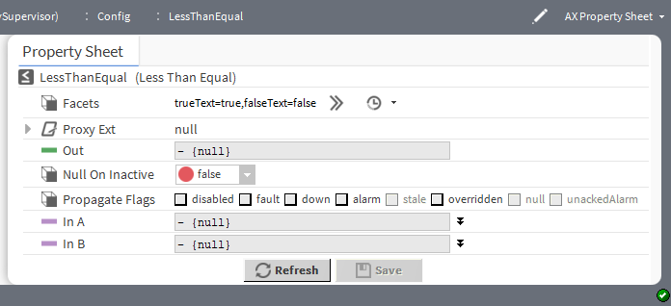

Property | Value | Description
Facets | Config Facets win- dow (defaults to true and false) | Defines the text to display for each Boolean value.  trueText configures the text to describe the state when com- ponent returns true.  falseText configures the text to describe the state when com- ponent returns false.
Out | read-only true or  false | Displays the result of the comparison.
In A and In B | StatusBoolean true or false and null definition | Provides the input values for the comparison.

kitControl-Not
This component inverts the Boolean logic value currently at the (single) object input.

Not is available in the Logic folder of the kitControl palette.
You often link Not objects with other logic objects to make different logic gates. The following tables are exam- ples using Not to create NAND (not and) logic, NOR (not or) logic, and EQUIV (equivalent) gate logic.
Figure 76 NAND logic using And and Not
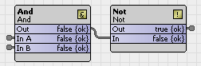

In A | In B | Out
false | false | true
false | true | true
true | false | true
true | true | false

Figure 77 NOR logic using Or and Not
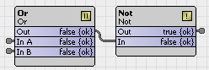

In A | In B | Out
false | false | true
false | true | false
true | false | false
true | true | false

Figure 78 NOR logic using Or and Not
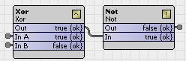

In A | In B | Out
false | false | true
false | true | false
true | false | false
true | true | true

Figure 79 Not properties
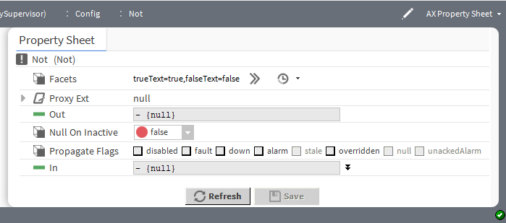

Property | Value | Description
Facets | Config Facets win- dow (defaults to true and false) | Defines the text to display for each Boolean value.  trueText configures the text to describe the state when com- ponent returns true.  falseText configures the text to describe the state when com- ponent returns false.
Out | read-only true or  false | Displays the result of the comparison.
In | StatusBoolean true or false and null definition | Provides the input values for the comparison.

kitControl-NotEqual
This component performs the operation: A != B with a Boolean result. NotEqual is available in the Logic folder of the kitControl palette.
Figure 80 NotEqual properties
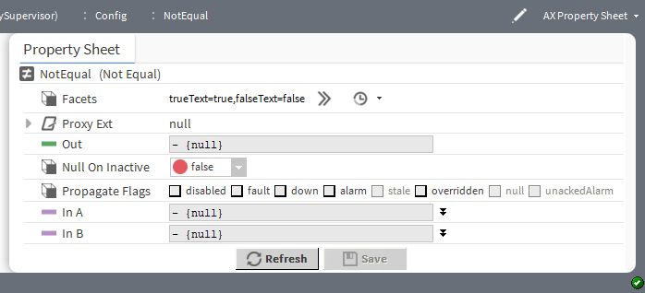

Property | Value | Description
Facets | Config Facets win- dow (defaults to true and false) | Defines the text to display for each Boolean value.  trueText configures the text to describe the state when com- ponent returns true.  falseText configures the text to describe the state when com- ponent returns false.
Out | read-only true or  false | Displays the result of the comparison.
In A and In B | StatusBoolean true or false and null definition | Provides the input values for the comparison.

kitControl-Or
This component performs a logical OR on all valid inputs and writes the boolean result to the Out property. Or is available in the Logic folder of the kitControl palette.
Figure 81 Or object truth table (two inputs)
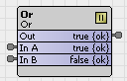

In A | In B | Out
false | false | false
false | true | true
true | false | true
true | true | true

Figure 82 Or object truth table (four inputs)
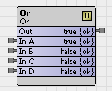

In A | In B | In C | In D | Out
false | false | false | false | false
false | false | false | true | true
false | false | true | false | true
false | false | true | true | true
false | true | false | false | true
false | true | false | true | true
false | true | true | false | true
false | true | true | true | true
true | false | false | false | true

In A | In B | In C | In D | Out
true | false | false | true | true
true | false | true | false | true
true | false | true | true | true
true | true | false | false | true
true | true | false | true | true
true | true | true | false | true
true | true | true | true | true

Figure 83 Or properties
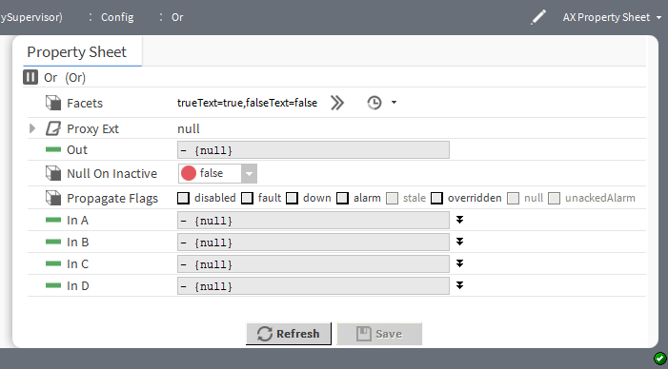

Property | Value | Description
Facets (Boolean) | Config Facets win- dow (defaults to true and false) | Defines the text to display for each Boolean value.  trueText configures the text to describe the state when com- ponent returns true.  falseText configures the text to describe the state when com- ponent returns false.
Out | read-only true or  false | Displays the result of the comparison.
In A through In D | StatusBoolean true or false and null definition | Provides the input values for the comparison.

kitControl-Xor
This component performs a logical XOR on all valid inputs and writes the result to the Out property. Xor is available in the Logic folder of the kitControl palette.
This table shows the Xor object truth table when using two inputs (typical).
This table shows the Xor object truth table if using all four inputs. EQUIV gate logic is accomplished by linking to a Not object.

Figure 84 Xor object truth table (two inputs)
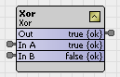

In A | In B | Out
false | false | false
false | true | true
true | false | true
true | true | false

Figure 85 Xor object truth table (four inputs)
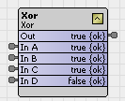

In A | In B | In C | In D | Out
false | false | false | false | false
false | false | false | true | true
false | false | true | false | true
false | false | true | true | false
false | true | false | false | true
false | true | false | true | false
false | true | true | false | false
false | true | true | true | true
true | false | false | false | true
true | false | false | true | false
true | false | true | false | false
true | false | true | true | true
true | true | false | false | false
true | true | false | true | true
true | true | true | false | true
true | true | true | true | false

Figure 86 Xor properties
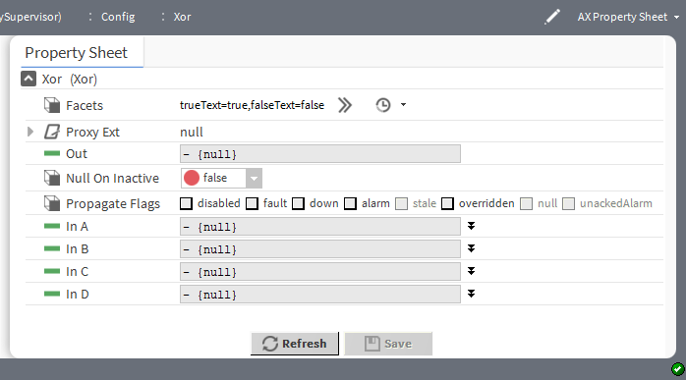

Property | Value | Description
Facets | Config Facets win- dow (defaults to true and false) | Defines the text to display for each Boolean value.  trueText configures the text to describe the state when com- ponent returns true.  falseText configures the text to describe the state when com- ponent returns false.
Out | read-only true or  false | Displays the result of the comparison.
In A through In D | StatusBoolean true or false and null definition | Provides the input values for the comparison.

kitControl-BqlExprComponent
This component creates custom math and logic operations based upon manually-added slots and one or more BQL expression statements. Slots can be various baja types, such as primitives Double, Float, Integer, Boo- lean, or String, or status types: StatusBoolean, StatusNumeric, and so on. Slots are either inputs or one or more outputs. You enter BQL expressions in the component’s Expr (expression) property.
The ExprLogic and ExprMath components are not strictly speaking logic and math components. Instead, they are adaptations of the Expr component (BqlExprComponent), which provide four-input logic and math functions.

Figure 87 The three forms of the BqlExprComponent

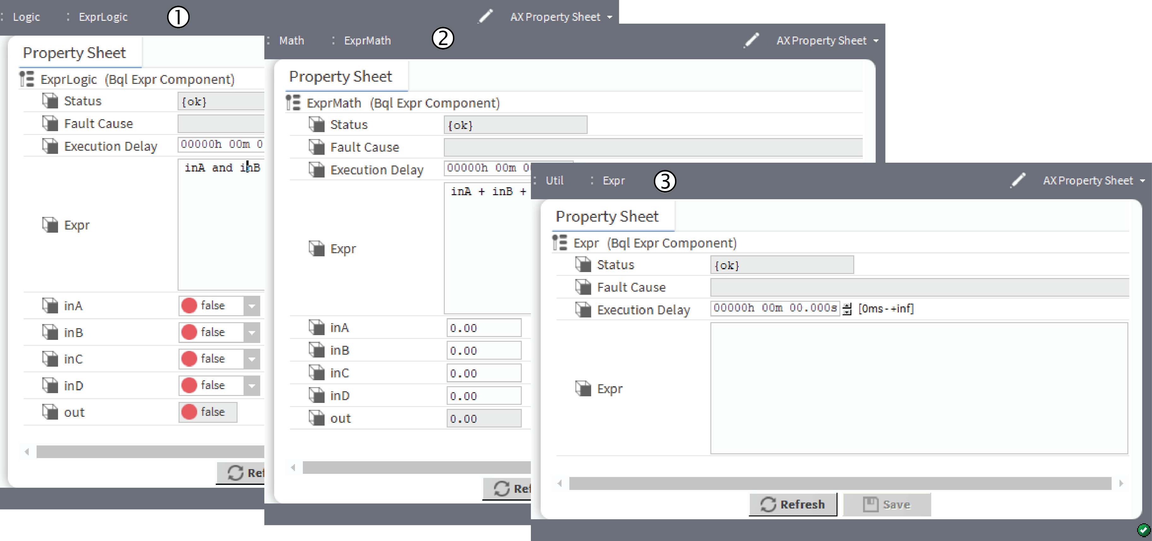
- (1) is for logic BQL expressions.
- (2) is for math BQL expressions.
- (3) is for general expressions.
The Logic and Math folders also contain expression components. ExprLogic provides a four-input logic AND gate. ExprMath provides a four-input math ADD component. The Util folder of the kitControl palette con- tains an empty expression component.
For complete information on BQL expressions, refer to Engineering Notes,BQL Expression component.

Property | Value | Description
Status | read only | Indicates the condition of the component at the last check  {ok} indicates that the component is licensed and polling successfully.  {down} indicates that the last check was unsucessful, perhaps because of an incorrect property, or possibly loss of network connection.  {disabled} indicates that the Enable property is set to  false.  false indicates another problem . Refer to Fault Cause for more information.
Fault Cause | read only | Indicates a reason why a system object ( network, device, com- ponent, extension, etc.) is in fault. This property is empty unless a fault exists.
Execution Delay | hours minutes sec- onds (defaults to 0) | Configures an amount of time to delay before executing the expression.
Expr | BQL expression | The standard syntax for an expression is as follows: input op- erator ‘output’, where:  input is the name of one or more slots.

Property | Value | Description
operator is a word or symbol.
‘output’ is the slot that contains the result of the expression. (note apostrophes around slot name)
InA, In B, InC and InD | BooleanStatus (true or false for logic), number (for math) | Defines four input values.
out | read-only Boolean- Status (true or false for logic), number (for math) | Defines a single output value, which is the result of executing the expression.
The supported operators for the BQL expression are as follows:

Order of Operation | Operator | Description
1 | !, not, - | Logical not, numeric negation
2 | * , / | multiplication, division
3 | +, - | addition, subtraction
4 | =, !=, >, >=, < <=, like | Comparison
5 | and, or | Logical operators
6 | as | result operator
Operators are processed by their precedence, that is “order of operation”, from first (1) to last (6). Parentheses is used to override the normal precedence.
Comma is used as a delimiter to create Expr with multiple expression(output slots). For long statements in a Expr use CR/LF to wrap the text.

BQL Like Query
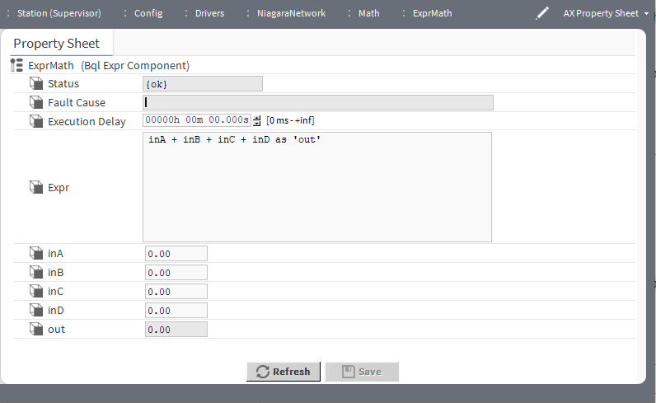

Following are some examples for Like expression:
- Multiply four Double properties inA * inB * inC * inD as ‘out’
- Multiply two BStatusNumeric properties to a Double output property inA.value * inB.value as ‘out’
- Negate a Double input property (if inA is 5, out becomes -5)
-inA as ‘out’

Chapter 10 Math components

Topics covered in this chapter
- kitControl-AbsValue
- kitControl-Add
- kitControl-ArcCosine
- kitControl-ArcSine
- kitControl-ArcTangent
- kitControl-Average
- kitControl-Cosine
- kitControl-Divide
- kitControl-Exponential
- kitControl-Factorial
- kitControl-LogBase10
- kitControl-LogicNatural
- kitControl-Maximum
- kitControl-Minimum
- kitControl-Modulus
- kitControl-Multiply
- kitControl-Negative
- kitControl-Power
- kitControl-Reset
- kitControl-Sine
- kitControl-SquareRoot
- kitControl-Subtract
- kitControl-Tangent
- kitControl-BqlExprComponent

Math components process one or more StatusNumeric input values and provide a StatusNumeric output value. Each component type provides a specific math function, such as Add, Average, Divide, Minimum, Maximum, Reset, AbsValue, and so on.
Figure 88 LogBase10, an example of a single-input math component
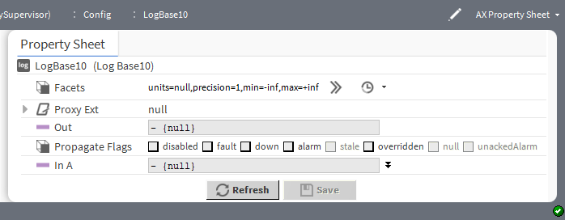
These components perform an operation on a single input:
- AbsValue
- ArcCosing
- ArcSine
- ArcTangent
- Cosine

- Exponential
- Factorial
- LogBase10
- LogNatural
- Negative
- Reset (uses four values of high and low limits, both input and output, also linkable as inputs)
- Sine
- SquareRoot
- Tangent
Figure 89 Modulus, an example of a math component with two inputs
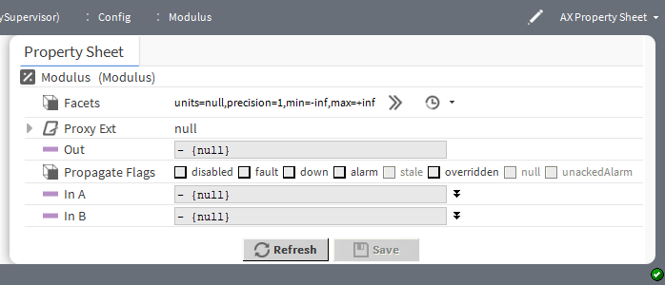
These components perform an operation using two inputs:
- Divide
- Modulus
- Power
- Subtract
Figure 90 Modulus, an example of a math component with two inputs
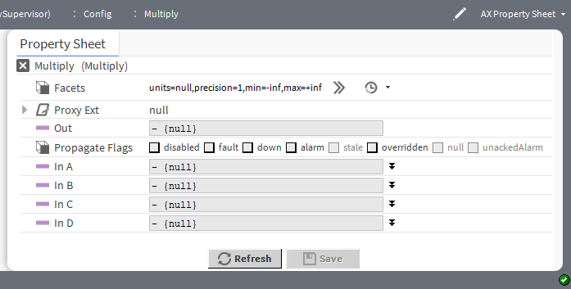
Math object types vary by number of inputs used, in addition to the math operation. These components perform an operation using one to four inputs:

  - Add
  - Average
  - Maximum
  - Minimum
  - Multiply
If needed, you can add alarm and history extensions to any math component, in addition to the control exten- sion NumericTotalizerExt.
As with logic components, you can individually configure math components to propagate status flags received on linked inputs (by default, status propagation does not occur). For more details refer to the Getting Started Guide.
The properties table summarizes the properties for all math components.

Property | Value | Description
Facets | Config Facets win- dow (defaults to null for units, one decimal place for precision, negative infinity for mini- mum, and positive infinity for maximum) | Selects units and configures how the value displays:  units defines the unit of measure from acceleration to  volumetric flow.  precision defines the number of decimal places.  min defines the lowest value allowed.  max defines the highest value allowed.  This definition applies to the In value for this component.
Out | read-only number (defaults to zero (0)) | Displays the result of the calculation.
In A  In A and In B  In A through In D (depends on the operation) | number (defaults to zero (0)) | Provides the input values for the calculation.

kitControl-AbsValue
This math component performs the operation: out = abs(inA), in other words, the absolute value of inA.
AbsValue is in the Math folder of the kitControl palette. It inputs a value to a widget that is the same as the value output from another widget.

kitControl-Add
This math component performs the operation: out = (inA + inB + inC + inD).
AbsValue is in the Math folder of the kitControl palette. It adds together up to four input values, generating a single output value.

Figure 91 Add properties
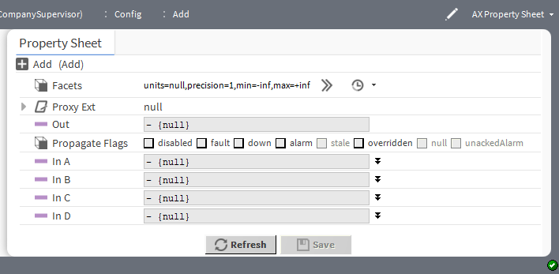

Property | Value | Description
Facets (Numeric) | Config Facets window | Selects units and configures how the value displays:  units defines the unit of measure from acceleration to  volumetric flow.  precision defines the number of decimal places.
Out | read-only number | Displays the sum of the four input values.
In A, In B, In C, In D | numbers (up to four values) | Defines the numbers to add.

kitControl-ArcCosine
This component performs the operation: out = acos(inA).
The ArcCosine is available in the Math folder of the kitControl palette.

kitControl-ArcSine
This component performs the operation: out = asin(inA).
The ArcSine is available in the Math folder of the kitControl palette.

kitControl-ArcTangent
This component performs the operation: out = atan(inA).
The ArcTangent is available in the Math folder of the kitControl palette.

kitControl-Average
This component determines the average value of valid inputs and writes that value to out: out = (inA + inB + inC + inD) / 4.
The Average is available in the Math folder of the kitControl palette.

kitControl-Cosine
This component performs the operation: out = cos(inA).
The Cosine is available in the Math folder of the kitControl palette.

kitControl-Divide
This component performs the operation: out = (inA / inB). If either input is Numeric.NaN, the output will be Numeric.NaN.
The Divide is available in the Math folder of the kitControl palette.

kitControl-Exponential
This component performs the operation: out = e ^ inA (e raised in the inA power). Exponential is available in the Math folder of the kitControl palette.

kitControl-Factorial
This component provides a factorial math output, based upon the value present at its statusNumeric input. Only the integer portion of the input value is evaluated—for example, either value of 1.03 or 1.9999 is evaluated as 1.
Factorial is available in the Math folder of the kitControl palette.

Behavior of Factorial object
This section describes the behavior of the factorial component. If the input value is set to 171 or greater, the out- put is set to infinite (+inf) with the fault status.
The output displays the message Input number too large to the user. Following are some examples where the inputs are varied:
- If the In A is set to 171, Out becomes +inf{fault}.
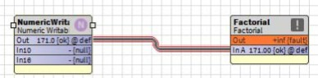
- If the In A is set to greater than 171, Out becomes +inf{fault}
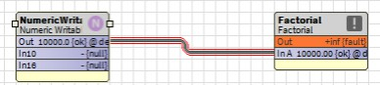
.
- If the In A is set to less than 171 (i.e 100), Out becomes 1.0 {ok}.
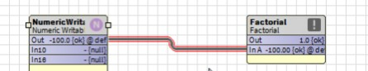

kitControl-LogBase10
This component performs the operation: A <= B with a Boolean result.

LogBase10 is available in the Logic folder of the kitControl palette.

kitControl-LogicNatural
This component performs the operation: out = ln(inA) (log base e of inA). LogNatural is available in the Math folder of the kitControl palette.

kitControl-Maximum
This component determines the maximum value of valid inputs and writes that value to the Out property. Out = max (inA, inB, inC, inD).
Maximum is available in the Math folder of the kitControl palette

kitControl-Minimum
This component determines the minimum value of valid inputs and writes that value to out. Out = min (inA, inB, inC, inD).
Minimum is available in the Math folder of the kitControl palette.

kitControl-Modulus
This component provides a modulus operation based on values at its two statusNumeric inputs. The output is the remainder of dividing the inA value by the inB value. If the inB value is 0, the output is NaN (not a number). Operation is intended for integer input values, such as from the output of a Counter component.
Modulus is available in the Math folder of the kitControl palette

kitControl-Multiply
This component performs the calculation: out = inA * inB * inC * inD. Multiply is available in the Math folder of the kitControl palette.

kitControl-Negative
This component converts any input status numeric to a negative output value. Negative is available in the Math folder of the kitControl palette.

kitControl-Power
This component performs the operation: out = (inA ^ inB) or a raised to the b power. Power is available in the Math folder of the kitControl palette.

kitControl-Reset
This component performs a linear reset on the In A property value. Reset is available in the Math folder of the kitControl palette.

Figure 92 Reset properties

Property | Value | Description
Facets | Config Facets win- dow (defaults to null for units, one decimal place for precision, negative infinity for mini- mum, and positive infinity for maximum) | Selects units and configures how the value displays:  units defines the unit of measure from acceleration to  volumetric flow.  precision defines the number of decimal places.  min defines the lowest value allowed.  max defines the highest value allowed.  This definition applies to the In value for this component.
Out | read-only number (defaults to zero (0)) | Displays the result of the calculation.
In A | degrees of temper- ature (defaults to null) | Contains one or more input values (degrees of temperature) for the calculation.
Input Low Limit | degrees of temper- ature (defaults to zero (0)) | Sets the lowest limit on outside air temperature. This value must be less than the Input High Limit.
Input High Limit | degrees of temper- ature (defaults to zero (0)) | Sets the highest limit on outside air temperature. This value must be greater than Input Low Limit.
Output Low Limit | degrees of temper- ature (defaults to zero (0)) | Sets the lowest limit on water temperature. This value may (or may not) be greater than the Output High Limit.
Output High Limit | degrees of temper- ature (defaults to zero (0)) | Sets the highest limit on water temperature. This value may (or may not) be greater than the Output Low Limit.

kitControl-Sine
This component performs the operation: out = sin(inA).

Sine is in the Math folder of the kitControl palette.

kitControl-SquareRoot
This component performs the operation: out = sqrt(inA) (square root of inA). The SquareRoot is available in the Math folder of the kitControl palette.

kitControl-Subtract
This component performs the operation: out = (inA - inB). If either input is Numeric.NaN, the output will be Numeric.NaN.
Subtract is available in the Math folder of the kitControl palette.

kitControl-Tangent
This component performs the operation: out = tan(inA). Tangent is available in the Math folder of the kitControl palette.

kitControl-BqlExprComponent
This component creates custom math and logic operations based upon manually-added slots and one or more BQL expression statements. Slots can be various baja types, such as primitives Double, Float, Integer, Boo- lean, or String, or status types: StatusBoolean, StatusNumeric, and so on. Slots are either inputs or one or more outputs. You enter BQL expressions in the component’s Expr (expression) property.
The ExprLogic and ExprMath components are not strictly speaking logic and math components. Instead, they are adaptations of the Expr component (BqlExprComponent), which provide four-input logic and math functions.
Figure 93 The three forms of the BqlExprComponent
- (1) is for logic BQL expressions.
- (2) is for math BQL expressions.

- (3) is for general expressions.
The Logic and Math folders also contain expression components. ExprLogic provides a four-input logic AND gate. ExprMath provides a four-input math ADD component. The Util folder of the kitControl palette con- tains an empty expression component.
For complete information on BQL expressions, refer to Engineering Notes,BQL Expression component.

Property | Value | Description
Status | read only | Indicates the condition of the component at the last check  {ok} indicates that the component is licensed and polling successfully.  {down} indicates that the last check was unsucessful, perhaps because of an incorrect property, or possibly loss of network connection.  {disabled} indicates that the Enable property is set to  false.  false indicates another problem . Refer to Fault Cause for more information.
Fault Cause | read only | Indicates a reason why a system object ( network, device, com- ponent, extension, etc.) is in fault. This property is empty unless a fault exists.
Execution Delay | hours minutes sec- onds (defaults to 0) | Configures an amount of time to delay before executing the expression.
Expr | BQL expression | The standard syntax for an expression is as follows: input op- erator ‘output’, where:  input is the name of one or more slots. operator is a word or symbol.  ‘output’ is the slot that contains the result of the expression. (note apostrophes around slot name)
InA, In B, InC and InD | BooleanStatus (true or false for logic), number (for math) | Defines four input values.
out | read-only Boolean- Status (true or false for logic), number (for math) | Defines a single output value, which is the result of executing the expression.
The supported operators for the BQL expression are as follows:

Order of Operation | Operator | Description
1 | !, not, - | Logical not, numeric negation
2 | * , / | multiplication, division
3 | +, - | addition, subtraction
4 | =, !=, >, >=, < <=, like | Comparison
5 | and, or | Logical operators
6 | as | result operator

Operators are processed by their precedence, that is “order of operation”, from first (1) to last (6). Parentheses is used to override the normal precedence.
Comma is used as a delimiter to create Expr with multiple expression(output slots). For long statements in a Expr use CR/LF to wrap the text.

BQL Like Query
Following are some examples for Like expression:
- Multiply four Double properties inA * inB * inC * inD as ‘out’
- Multiply two BStatusNumeric properties to a Double output property inA.value * inB.value as ‘out’
- Negate a Double input property (if inA is 5, out becomes -5)
-inA as ‘out’

Chapter 11 Select components

Topics covered in this chapter
  - kitControl-BooleanSelect
  - kitControl-EnumSelect
  - kitControl-NumericSelect
  - kitControl-StringSelect

Select objects pass one of multiple inputs to the output. You can select from three to 10 inputs for each action.
All select objects require an enumerated input to perform the selection. The four select object types differ only by the type of input data selected and passed to the Out property.

kitControl-BooleanSelect
This component passes one of multiple inputs to a component’s Out property. The component’s Select prop- erty chooses the input. From three to 10 inputs can be specified.
BooleanSelect is available in the Select folder of the kitControl palette.
All select objects require an enumerated input to perform the selection—the four select object types differ only by the type of input data selected and passed to the out slot.
Figure 94 BooleanSelect properties
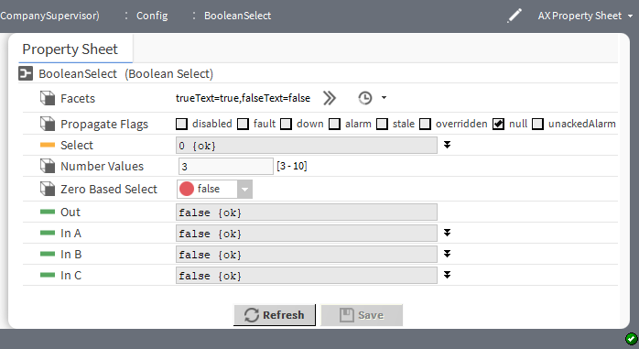

Property | Value | Description
Facets | Config Facets win- dow (defaults to true and false) | Defines the text to display for each Boolean value.  trueText configures the text to describe the state when the component returns true.  falseText configures the text to describe the state when the component returns false.  This configuration affects the Out property value.
Select | number (defaults to zero(0)) | Selects one of the 10 input values to be transferred to the output.

Property | Value | Description
Out | read-only Status- Boolean true or false (default) | Provides a Boolean output value for linking into a component.  false indicates no input values.  true indicates at least one input value.
In A through In J (10 inputs) | true or false  (default) | Define the selected Boolean input values and null definition.

kitControl-EnumSelect
This component passes one of multiple inputs to a component’s Out property. The component’s Select prop- erty chooses the input. From three to 10 inputs can be specified.
EnumSelect is available in the Select folder of the kitControl palette.
All select objects require an enumerated input to perform the selection—the four select object types differ only by the type of input data selected and passed to the out slot.
Figure 95 BooleanSelect properties
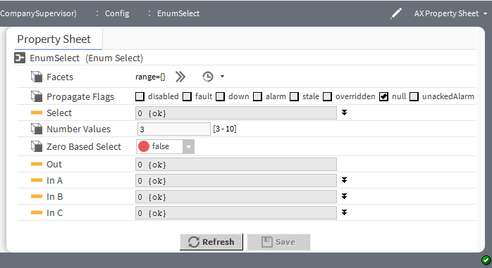

Property | Value | Description
Facets | Config Facets win- dow (defaults to blank) | Defines range of enumerated states (enum values). This config- uration affects the Out property value.
Select | number (defaults to zero (0)) | Selects one of the 10 input values to be transferred to the output.
Out | read-only enumer- ated value (defaults to zero (0)) | Provides a numeric output value for linking into a component.
In A through In J (10 inputs) | enumerated value (defaults to zero (0)) | Define the selected enum input values and null definition.

kitControl-NumericSelect
This component is a numeric select. The component’s Select property chooses the input. From three to 10 in- puts can be specified.
NumericSelect is available in the Selects folder of the kitControl palette.
All select objects require an enumerated input to perform the selection—the four select object types differ only by the type of input data selected and passed to the out slot.
Figure 96 NumericSelect example application
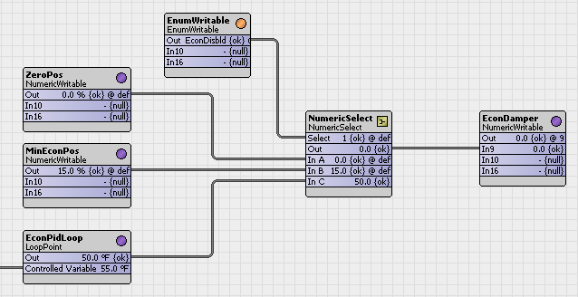
The wire sheet shows an EnumWritable linked to a NumericSelect’s select slot (where enumerated values are 1 = Econ Disabled, 2 = Min Oa Enabled, 3 = Econ Enabled). This sets the output value to one of the input val- ues depending on the select value.
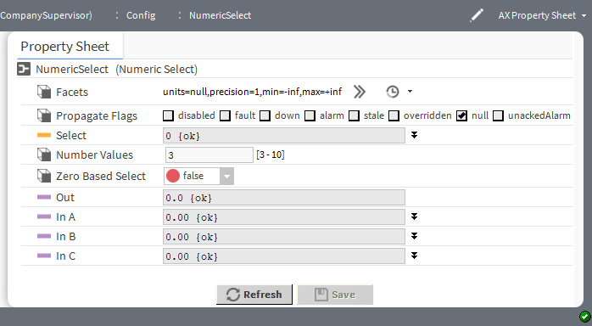

Property | Value | Description
Facets | Config Facets win- dow (defaults to null units, a single decimal place, mini- mum=negative in- finity, maximum= positive infinity) | Selects units and configures how the value displays:  units defines the unit of measure from acceleration to  volumetric flow.  precision defines the number of decimal places.  min defines the lowest value allowed.  max defines the highest value allowed.  This configuration affects the Out property value.
Select | number (defaults to zero(0)) | Selects one of the 10 input values to be transferred to the output.
Out | read-only number (defaults to zero (0)) | Provides a numeric output value for linking into a component.
In A through In J (10 inputs) | number (defaults to zero (0)) | Define the selected numeric input values and null definition.

kitControl-StringSelect
This component is a string select.
StringSelect is available in the String folder of the kitControl palette.
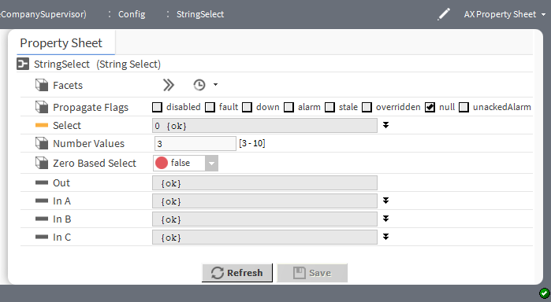

Property | Value | Description
Facets | Config Facets win- dow (defaults to blank) | Associates a key with one or more phrases. This configuration affects the Out property value.
Select | number (defaults to zero (0)) | Selects one of the 10 input values to be transferred to the output.

Property | Value | Description
Out | read-only text (de- faults to blank) | Provides a text string output value for linking into a component.
In A through In J (10 inputs) | text (defaults to blank) | Define the selected string input values and null definition.

Chapter 12 String components

Topics covered in this chapter
- kitControl-StringConcat
- kitControl-StringIndexOf
- kitControl-StringLen
- kitControl-StringSubstring
- kitControl-StringTest
- kitControl-StringTrim

These process one or more status string inputs, and produce some form of output.
String object types vary by type of output. Three string components perform a string function with a StatusString output:
- StringConcat
- StringSubstring
- StringTrim
Two string components provide a logic function with a StatusBoolean output:
- StringIndexOf
- StringTest
StringLen provides a StatusNumeric output equal to the number of non-null characters in the input string.

kitControl-StringConcat
This component concatenates (joins) up to four StatusString values present on inputs InA, InB, InC, and InD and outputs the concatenated string. String output order is A + B + C + D.
StringConcat is available in the String folder of the kitControl palette.
Figure 97 StringConcat properties
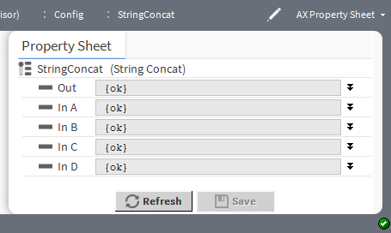

Property | Value | Description
Out | text (defaults to blank) and null definition | Contains the concatenated strings (up to four).
In A through In D | text (defaults to blank) and null definition | Define the strings to concatenate.

kitControl-StringIndexOf
This component compares two StatusString inputs (In A, In B), looking for an exact match of string In B within string In A. The object outputs a StatusBoolean result (true, false).
The StringIndexOf is available in the String folder of the kitControl palette.
Figure 98 StringIndexOf properties
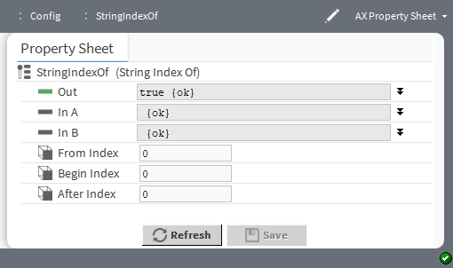

Property | Value | Description
Out | true (default) or false and null definition | Boolean output indicates the result of the comparison.
In A and In B | text (defaults to blank) and null definition | Define the two strings to compare.
From Index | integer (defaults to 0) | Defines the string from where to start the comparison.
Begin Index | integer (defaults to 0) | Defines which position in the string to start the comparison.
After Index | integer (defaults to 0) | Defines which position in the string to end the comparison.

kitControl-StringLen
This component outputs the total number of non-null characters in the In StatusString value. Out value is Sta- tusNumeric from 0 to n.
StringLen is available in the String folder of the kitControl palette.
Figure 99 StringLen properties
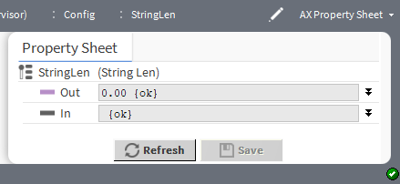

Property | Value | Description
Out | number and null definition | Outputs the length of the string.
In | text (defaults to blank) and null definition | Identifies the string for the length calculation.

kitControl-StringSubstring
This component outputs a portion of the In slot StatusString value, as specified by integer properties Begin Index and End Index.
StringSubstring is available in the String folder of the kitControl palette.
By default, Begin Index=0 and End Index=-1, which means the component passes the entire In string.
Figure 100 StringSubstring properties
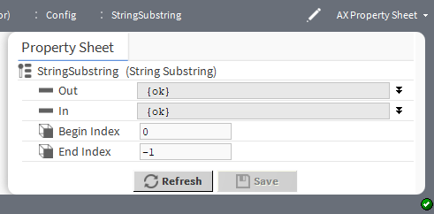

Property | Value | Description
Out | text (defaults to blank) and null definition | Displays the substring.
In | text (defaults to blank) and null definition | Displays the string from which to extract the substring.
Begin Index | number (defaults to zero (0)) | Defines where in the In string the substring starts.
End Index | number (defaults to  -1) | Defines where in the In string the substring ends.

kitControl-StringTest
This component compares two StatusString values (In A and In B) and outputs a StatusBoolean Out (true/ false) result.
StringTest is available in the String folder of the kitControl palette Test Selection property choices are:
- aEqualsB
- aEqualsBIgnoreCase
- aStartsWithB

- aEndsWithB
- aContainsB
Figure 101 StringTest properties
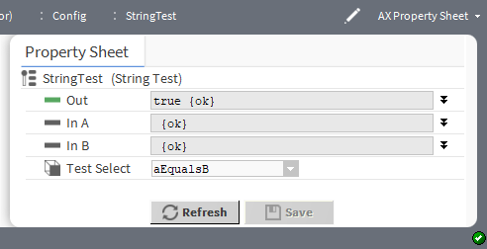

Property | Value | Description
Out | true (default) or false and null definition | Boolean output indicates the result of the comparison.
In A and In B | text (defaults to blank) and null definition | Define the two strings to compare.
Test Select | drop-down list | Identifies the test to perform on In A:  aEqualsB compares In A with In B taking case into consideration.  AEqualsBIgnoreCase compares with In B ignoring case.  aStartsWithB tests to see if In A includes In B beginning at the first position.  aEndsWithB tests to see if In A includes In B beginning at the last position.  aContainsB tests to see if In A includes In B anywhere within  In A.

kitControl-StringTrim
This component trims white space from both ends of the StatusString In property value. White space is typi- cally leading or trailing space characters, but may also include control characters.
StringTrim is available in the String folder of the kitControl palette.
Figure 102 StringTrim properties
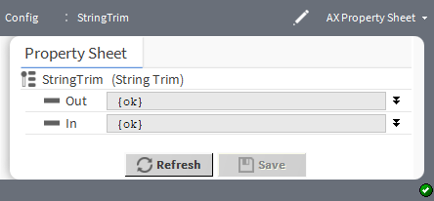

Property | Value | Description
Out | text (defaults to blank) and null definition | Outputs the trimmed string.
In | text (defaults to blank) and null definition | Identifies the string from which to strip white space.

Chapter 13 Timer components

Topics covered in this chapter
  - kitControl-BooleanDelay
  - kitControl-CurrentTime
  - kitControl-NumericDelay
  - kitControl-OneShot
  - kitControl-TimeDifference

These components include three types of timers, and two components for working with Baja absolute time (AbsTime).
Two of the timers are Boolean-types:
- BooleanDelay
- OneShot
A third dimer is a Numeric-type: NumericDelay.
To work with absolute time, kitControl provides two components:
- CurrentTime
- TimeDifference

kitControl-BooleanDelay
This component delays the status change of a Boolean status Out property value by the amount of time config- ured in the associated Delay property.
BooleanDelay is available in the Timer folder of the kitControl palette.
Delays relate to on (true) and off (false) statuses and are labeled On Delay and Off Delay respectively. The delay applies to any transition (status change from on to off or off to on) at the component’s status Boolean in- put. You configure both delay times in terms of hours, minutes and seconds.
Figure 103 BooleanDelay property sheet
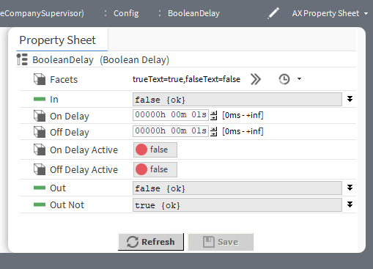

Property | Value | Description
Facets | Config Facets win- dow (defaults to true and false) | Defines the text to display for each Boolean value.  trueText configures the text to describe the state when the component returns true.  falseText configures the text to describe the state when the component returns false.  For example, trueText might display ON or Enabled, and  falseText OFF or Disabled.
In | true and false (default) and null definition | Configures the default input value when no Boolean out value is linked to it.  Typically, you link a Boolean Out to this property, in which case, you do not need to manually configure it. You would set this property to true, false or null if no out is linked to it.  When this property’s status changes, the framework passes this value to the Out and Out Not properties after any On Delay or Off Delay.  When null is checked, the value displayed defaults to the incom- ing value from the device. If you remove the check mark you can configure theIn value.
On Delay | hours, minutes, seconds (defaults to one second) | Sets the amount of time to wait before sending a true value to the Out property. Time begins to expire the moment the In property changes from false or null to true.
Off Delay | hours, minutes, seconds (defaults to one second) | Sets the amount of time to wait before sending a false value to the Out property. Time begins to expire at the moment the In property changes from true to false or from false to true .
On Delay Active | read-only (normally  false) | Shows if the On Delay time is actively counting down. This val- ue changes to true when the In property transitions from false to true and stays unchanged until any Off Delay time expires. If On Delay is set to zero (0), this value does not change to true.
Off Delay Active | read-only (normally  false) | Shows if the Off Delay time is actively counting down. This val- ue changes to true when the In property transitions from true to false and stays unchanged until any Off Delay time ex- pires. If On Delay is set to zero (0), this value does not change to true.
Out | true , false and null definition | Reflects the In property value at the end of any On Delay or  Off Delay.  When null is checked, the value displayed defaults to the incom- ing value from the device. If you remove the check mark you can configure theIn value.
Out Not | true , false and null definition | Reflects the inverse of the In property value at the end of any On Delay or Off Delay. For example, when the In value is true, the Out Not value is set to false after any delay expires.  When null is checked, the value displayed defaults to the incom- ing value from the device. If you remove the check mark you can configure theIn value.

kitControl-CurrentTime
This component references or displays the current system time formatted in Baja absolute time (AbsTime). You use it directly for graphics display, or with a TimeDifference object for other applications.
CurrentTime is in the Timer folder of the kitControl palette.
Figure 104 CurrentTime properties
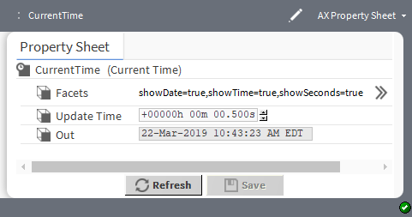

Property | Value | Description
Facets | Config Facets win- dow (defaults to show the date, time and seconds) | Configures how much of the current time to show.  For example, some applications may not require time in seconds.
Update Time | hours minutes seconds | Selects the time to output.
Out | read-only current time | Displays the result of the selected time and facets.

kitControl-NumericDelay
This component provides a so called “soft ramp” or “stepped ramp” delay from StatusNumeric In to Out. It uses values of Max Step Size and Update Time to provide a “stepped” output value. The combination of these two property values determines how quickly and how smoothly the current Out value changes as it ap- proaches the In value.
NumericDelay component is located in the Timer folder of the kitControl palette.
Figure 105 NumericDelay properties
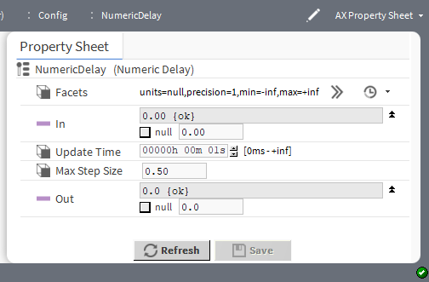

Property | Value | Description
Facets | Config Facets win- dow (defaults to null units, a single decimal place, mini- mum=negative in- finity, maximum= positive infinity) | Selects units and configures how the value displays:  units defines the unit of measure fromacceleration to  volumetric flow.  precision defines the number of decimal places.  min defines the lowest value allowed.  max defines the highest value allowed.  This definition applies to the Out value for this component.
In | number (defaults to 0.00) and null definition | Defines the input value. Typically, you set this value by linking a numeric out value into it. You can manually configure the default state to a numeric value or set it to null, so that when no value is linked into this property, the component uses the default value.  The component passes this numeric value to the component’s Out property in stages or steps according to the property values in the Update Time and Max Step Size properties.  When null value is checked, the value displayed defaults to the incoming value from the device. If you remove the check mark you can configure the In value.
Update Time | hours minutes sec- onds (defaults to one second) | Determines how often to add the Max Step Value to the current Out value. The greater the Update Time value, the longer it takes for the Out value to match the In value.  NOTE: An Update Time value that is equal to or less than zero  (0) disables updating. In this case, the component sets In , but passes no value to the Out property.
Max Step Size | number to two deci- mal places (de- faults to 0.50) | Limits the amount that may be added with each step that occurs at Update Time. If Update Time occurs every second, the Max Step Size value (or a lesser value) may be added to the cur- rent Out value every one second until the Out value equals the In value.
Out | number (defaults to 0.00) and null definition | Displays the current output value as it approaches and equals the In property value. The numeric in this property changes at a rate defined by the Update Time and Max Step Size proper- ties until the value equals the In property value.

kitControl-OneShot
This component provides a single, temporary, status Boolean output for a specified duration (as set in the Time property). A OneShot action occurs with a false-to-true value transition at the In property, or with an invoked Fire action. When either of these conditions occurs, the component sets the Out property value to true and the Out Not property value to false for a time that is equal to the value of the Time property. When the time expires, these values revert to the previous default values.
OneShot is available in the Timer folder of the kitControl palette.

Figure 106 OneShot properties
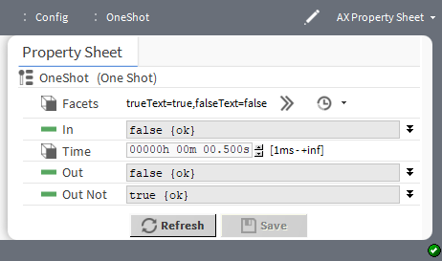

Property | Value | Description
Facets | Config Facets window | Defines the text to display for each Boolean value.  trueText configures the text to describe the state when the component returns true.  falseText configures the text to describe the state when the component returns false.  This definition applies to the Out value for this component.
In | true or false (default) and null definition | Defines the input value. You set this property by linking a Boo- lean Out value to it. You can manually configure the default state to a numeric value or set it to null, so that when no value is linked into this property, the component uses the default val- ue. The component passes this property value to its Out prop- erty for the amount of time set in the Time property.  When null value is checked, the value displayed defaults to the incoming value from the device. If you remove the check mark you can configure the In value.
Time | hours minutes sec- onds (defaults to .5 second) | Determines how long the Out and Out Not properties hold their one-shot values.  For example, a Time property value of 2 holds the Out property at true and the Out Not property value at false for two seconds.

Property | Value | Description
Out | true or false (default) and null definition | Displays the current value (display text) that changes with afalse to true transition at the In property value or a Fire ac- tion. Using the Facets property, you configure the Out value display text as desired.  After a OneShot is triggered and the Time value period expires, this value returns to the default (false) value. null does not change the value with a OneShot Fire action or false to true transition at the In property value.  When null value is checked, the value displayed defaults to the incoming value from the device. If you remove the check mark you can configure the In value.
Out Not | true (default) or false and null definition | Displays the opposite of the Out property. This value changes with a false to true transition at the In property value or a Fire action.  After a OneShot is triggered and the Time value period expires, this value returns to the default (true) value. null does not change with a OneShot Fire action or false to true transition of the In property value.  When null value is checked, the value displayed defaults to the incoming value from the device. If you remove the check mark you can configure the In value.

kitControl-TimeDifference
This component subtracts In2 from In1, and outputs it as a StatusNumeric in milliseconds. You may link a CurrentTime object to one of the inputs for a countdown or count-up type of output.
TimeDifference is in the Timer folder of the kitControl palette
Figure 107 TimeDifference properties
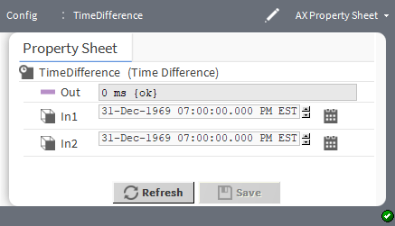

Property | Value | Description
Out | read-only milliseconds | Displays the numeric value that represents the time difference between In1 property value and In2 property value.
In1 | date hour:minute: second AM/PM Time zone | Defines a value from which to subtract In2.
In2 | date hour:minute: second AM/PM Time zone | Defines the value to subtract from In1.

Chapter 14 Util components

Topics covered in this chapter
- kitControl-BooleanSwitch
- kitControl-Counter
- kitControl-DigitalInputDemux
- kitControl-EnumSwitch
- kitControl-MinMaxAvg
- kitControl-MultiVibrator
- kitControl-NumericBitAnd
- kitControl-NumericBitOr
- kitControl-NumericBitXor
- kitControl-NumericSwitch
- kitControl-NumericToBitsDemux
- kitControl-Ramp
- kitControl-Random
- kitControl-SineWave
- kitControl-StatusDemux
- kitControl-BqlExprComponent

These components range from a Counter object with Boolean input and a numeric output (counts active transi- tions) to a Boolean-controlled NumericSwitch that selects one of two numeric values. A StatusDemux provides a method to logic test (true/false) a linked object for the presence of one or more status flags.
Util components also include generator components for simulation/logic testing, such as the SineWave and Ramp (each with a numeric output) and MultiVibrator (Boolean output).
The Expr (BqlExprComponent) component creates custom math and logic functions based upon one or more BQL expression statements.

kitControl-BooleanSwitch
This component selects one of two StatusBoolean inputs based upon the Boolean value at the StatusBoolean input In Switch.
BooleanSwitch is available in the Util folder of the kitControl palette.
Figure 108 BooleanSwitch properties
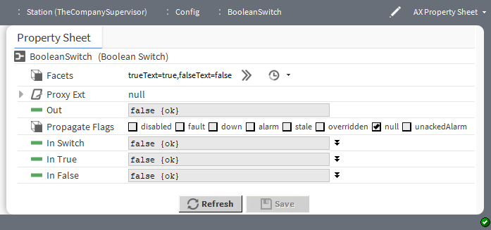

Property | Value | Description
Facets | Config Facets win- dow (defaults to true and false) | Defines the text to display for each Boolean value.  trueText configures the text to describe the state when the component returns true.  falseText configures the text to describe the state when the component returns false.
Out | read-only Status- Boolean true or false (default) | Displays the result of the selection.
In Switch | true or false (default) and null definition | Indicates which input value to select.
In True | true or false (default) and null definition | Returns true.
In False | true or false (default) and null definition | Returns false.

kitControl-Counter
This component counts Boolean inactive to active transitions. It supports counting up, counting down, preset- ting, and clearing.
The Counter is available in the Util folder of the kitControl palette.
Figure 109 Counter properties
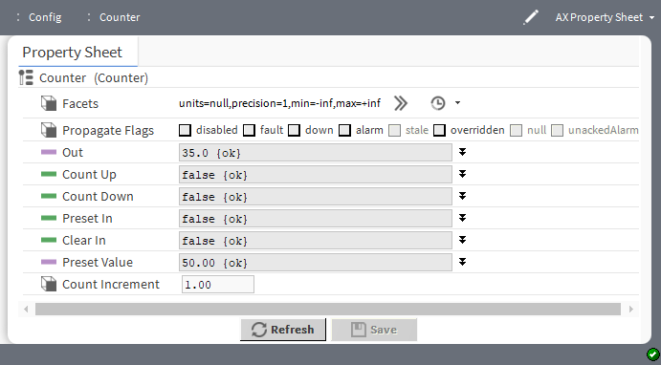
The screen capture shows a counter component property sheet.

Property | Value | Description
Facets | Config Facets win- dow (defaults to null units, a single decimal place, mini- mum to negative in- finity, maximum to positive infinity) | Selects units and configures how the value displays:  units defines the unit of measure fromacceleration to  volumetric flow.  precision defines the number of decimal places.  min defines the lowest value allowed.  max defines the highest value allowed.  This definition applies to the Out value for this component.
Out | number (defaults to 0.0) and null definition | Reports the current count.  When null value is checked, the value displayed defaults to the incoming value from the device. If you remove the check mark you can configure the In value.
Count Up | true or false (default) and null definition | Defines a StatusBoolean input. When this input transitions from inactive to active, the value of the Out property increments by the Count Increment value.  When null value is checked, the value displayed defaults to the incoming value from the device. If you remove the check mark you can configure the In value.
Count Down | true or false (default) and null definition | Defines a StatusBoolean input. When this input transitions from inactive to active, the Out property decrements by the Count Increment.  When null value is checked, the value displayed defaults to the incoming value from the device. If you remove the check mark you can configure the In value.
Preset In | true or false (default) and null definition | Defines a StatusBoolean input. When this input transitions from inactive to active, the Out property decrements by the Count Increment.  When null value is checked, the value displayed defaults to the incoming value from the device. If you remove the check mark you can configure the In value.
Clear In | true or false (default) and null definition | Defines a StatusBoolean input. When this input transitions from inactive to active, the framework sets the Out property to 0.0.  When null value is checked, the value displayed defaults to the incoming value from the device. If you remove the check mark you can configure the In value.
Preset Value | number (defaults to 0.00) and null definition | Defines the value of the Out property when Preset In changes to active, or when a user invokes the Preset action.  When null value is checked, the value displayed defaults to the incoming value from the device. If you remove the check mark you can configure the In value.
Count Increment | number (defaults to 1.00) and null definition | Defines how much the Out property increases or decreases when a StatusBoolean transitions from inactive to active.  When null value is checked, the value displayed defaults to the incoming value from the device. If you remove the check mark you can configure the In value.

Actions
These actions are available when you right-click.

Action | Description
Preset | Sets the Out property value to the Preset Value.
Clear | Sets the Out property value to 0.00.

Examples
This wire sheet shows an application that ramps between the RampMaxValue and the RampMinValue. The pe- riod of the Multi Vibrator object sets how fast the ramp counts. The Clock input of the BooleanLatch object con- fig flags is set to allow fan-in.
Figure 110 Counter component ramp up and down
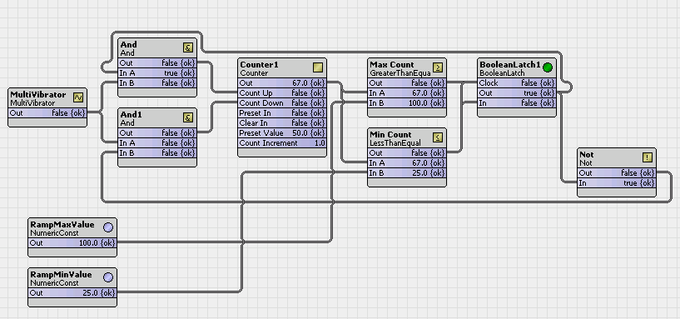
The next wire sheet shows a count from the RampMaxValue down to zero (0), which is then reset back to the RampMaxValue and repeated.
Figure 111 Counter component ramp down, reset and repeat
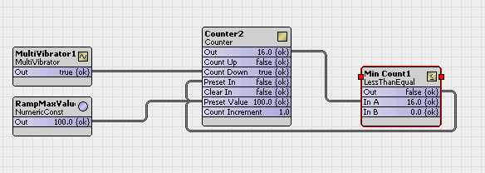

kitControl-DigitalInputDemux
This component provides four StatusBoolean outputs from one StatusNumeric input. DigitalInputDemux is available in the Util folder of the kitControl palette.

A typical application for this demultiplexer object is in association with a multiplexer module to expand the IO capacity of a system. The multiplexer creates a single analog voltage output to represent the state of up to four digital inputs. The DigitalInputDemux component then de-multiplexes the analog voltage into four StatusBoo- lean outputs.
Figure 112 DigitalInputDemux object application
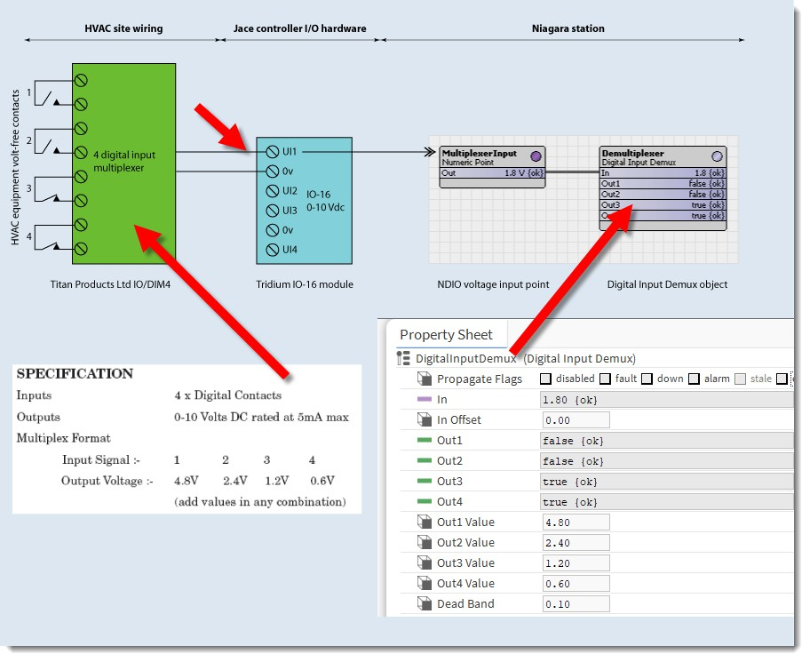

The illustration shows four volt-free contacts, such as door status, connected to a four-channel digital input mul- tiplexer. The IO/DIM4 multiplexer device is manufactured by Titan Products Ltd., although similar suitable devi- ces are available from other equipment suppliers. The IO/DIM4 multiplexer is microprocessor-based and designed to convert four separate digital input signals into a single analog voltage output. Each combination of digital input signal is converted to an output voltage level, which is then connected to one universal input of an NDIO IO-16 module. The NDIO universal input is configured as a voltage input point. Its output feeds the Digi- talInputDemux object. Finally, the DigitalInputDemux object provides four status Boolean outputs, which repre- sent the status of the original four contacts.

Property | Value | Description
In | number (defaults to 0.00) and null definition | Provides a StatusNumeric value for this object to serve as the in- put analog value from the multiplexer, which represents the state of the four digital inputs. This input must be valid for the object to function.  When null is checked, the value displayed defaults to the incom- ing value from the device. If you remove the check mark you can configure theIn value.
In Offset | positive or negative number to two deci- mal places | Defines an offset for the input.
Out1 | read-only true or  false (default) | Provides a status Boolean value, which the component sets to true if the In property contains a value equivalent to the value set as the Out1 Value property.
Out2 | read-only true or  false (default) | Provides a status Boolean value, which the component sets to true if the In property contains a value equivalent to the value set as the Out2 Value property.
Out3 | read-only true or  false (default) | Provides a status Boolean value, which the component sets to true if the In property contains a value equivalent to the value set as the Out3 Value property.
Out4 | read-only true or  false (default) | Provides a status Boolean value, which the component sets to true if the In property contains a value equivalent to the value set as the Out4 Value property.
Out1 Value | number to two deci- mal places (de- faults to 4.80) | Sets a value, which corresponds with the equivalent setting in the multiplexer device to represent the status of the digital input 1.
Out2 Value | number to two deci- mal places (de- faults to 2.40) | Sets a value, which corresponds with the equivalent setting in the multiplexer device to represent the status of the digital input 2.
Out3 Value | number to two deci- mal places (de- faults to 1.20) | Sets a value, which corresponds with the equivalent setting in the multiplexer device to represent the status of the digital input 3.
Out4 Value | number to two deci- mal places (de- faults to 0.60) | Sets a value, which corresponds with the equivalent setting in the multiplexer device to represent the status of the digital input 4.
Dead Band | number to two deci- mal places (de- faults to 0.10) | Sets a tolerance value to prevent output ‘chatter’ due to a fluctu- ating input value. This property operates purely on the input In value.

Dead band example
An on-site multiplexer device with four digital inputs (DI) feeds the DigitalInputDemux component. DI1 and DI2 are open (off) and DI3 and DI4 are closed (on). The combined voltage weighting of DI3 and DI4 is 1.8v. An NDIO universal input transmits the combined voltage weighting of DI3 and DI4 (1.8v) to the DigitalInputDemux component. The DigitalInputDemux object then faithfully de-multiplexes this signal, setting Out3 and Out4 to true. In practice, a voltage drop occurs on the received signal and the Dead Band property allows you to engi- neer in some protection for this fluctuation to prevent it from adversely upsetting your control strategy.

Figure 113 Operation of the Dead Band property
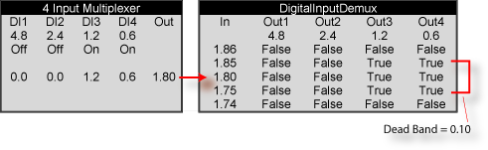

The Dead Band property in this example is set to 0.10, which is applied to the In value. The dead band function operates equally in both positive and negative sense on the In value. In this example therefore, all values from
1.75 through to 1.85 are valid.

kitControl-EnumSwitch
This component selects one of two StatusEnum inputs based upon the Boolean value at the StatusBoolean in- put In Switch.
EnumSwitch is available in the Util folder of the kitControl palette.
Figure 114 EnumSwitch properties
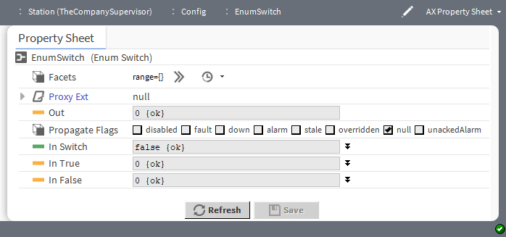

Property | Value | Description
Facets | Config Facets win- dow (defaults to blank) | Defines a range of enumerated states (enum values).
Out | read-only Status- Boolean true or false (default) | Displays the result of the selection.
In Switch | true or false (default) and null definition | Indicates which input value to select.

Property | Value | Description
In True | true or false (default) and null definition | Returns true.
In False | true or false (default) and null definition | Returns false.

kitControl-MinMaxAvg
This component has three StatusNumeric output slots that provide the current minimum, maximum, and aver- age values of from 2 to 10 linked StatusNumeric inputs.
It is available in the Util folder of the kitControl palette.
Figure 115 MinMaxAvg properties
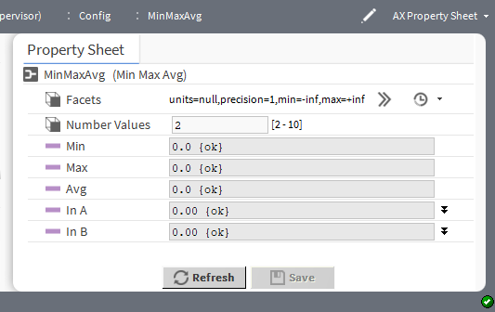

Property | Value | Description
Facets | Config Facets win- dow (defaults to null units, a single decimal place, mini- mum=negative in- finity, maximum= positive infinity) | Selects units and configures how the value displays:  units defines the unit of measure fromacceleration to  volumetric flow.  precision defines the number of decimal places.  min defines the lowest value allowed.  max defines the highest value allowed.  This definition applies to the Out value for this component.
Number Values | number (defaults to 2–10) | Select the number of inputs which need to be calculated.
Min | read-only number | Reports the lowest number in the set.
Max | read-only number | Reports the highest number in the set.
Avg | read-only number | Reports the average.
In A through In J | number (defaults to 0) and null definition | Defines the set of number upon which to calculate the average.

kitControl-MultiVibrator
This component provides an oscillating binary pulse output (StatusBoolean) with a period to configure between 200ms to infinity and a duty cycle from 0 to 100%.
MultiVibrator is available in the Util folder of the kitControl palette.
Figure 116 MultiVibrator properties
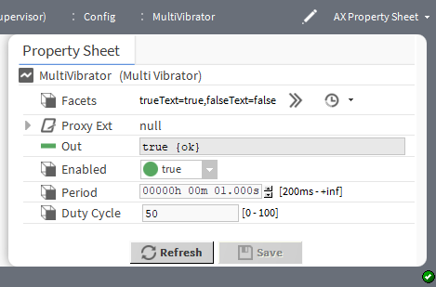

Property | Value | Description
Facets | Config Facets win- dow (defaults to true and false) | Defines the text to display for each Boolean value.  trueText configures the text to describe the state when the component returns true.  falseText configures the text to describe the state when the component returns false.
Out | read-only Status- Boolean true (de- fault) or false | Reports the result of the calculation.
Period | hours minute sec- onds (defaults to one minute) | Defines (from 200ms to infinity) how long it takes for an oscilla- tion to complete an on-off cycle.
Duty Cycle | percentage | Defines the percentage of the Period in which the oscillation signal is active. This is the total period of the signal. A 40% duty cycle means the signal is on 40% of the time and off 60% of the time.

kitControl-NumericBitAnd
This component performs a logical AND on the bit equivalent of the StatusNumeric In value against the bit equivalent of its StatusNumeric mask slot value. It may be useful in cases where Boolean information is mapped into integer values.
NumericBitAnd is available in the Util folder of the kitControl palette, along with the closely-related Numer- icBitOr and NumericBitXor components.
As an example, some manufacturers multiplex binary data into a single numerical point by converting the bits from hexadecimal to decimal format. To obtain the status of the individual binary data, the number must be con- verted back from decimal to hex format. Each digit of the hex number represents a particular binary state (0 = false, 1 = true). The NumericBitAnd object converts a StatusNumeric input to its hex value and compares it

against the mask value. Any digits with a value of 1 in the mask and the input result in a corresponding value of 1 in the same digit of the output.
Figure 117 NumericBitAnd example
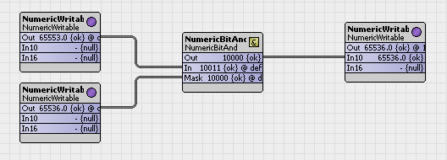
In this example:
- Input decimal 65553 converts to a hex value of 10011.
- Mask decimal 65536 converts to a hex value of 10000.
- The resulting hex value is 10000.
Figure 118 NumericBitAnd properties
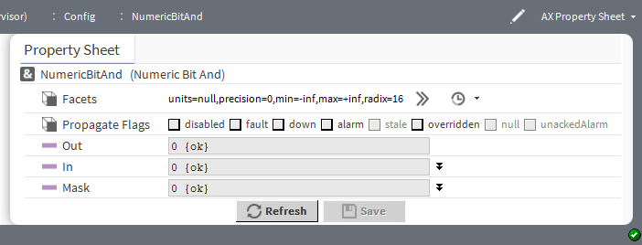

Property | Value | Description
Facets | Config Facets win- dow (defaults to null units, a single decimal place, mini- mum=negative in- finity, maximum= positive infinity, and radix=16) | Selects units and configures how the value displays:  units defines the unit of measure fromacceleration to  volumetric flow.  precision defines the number of decimal places.  min defines the lowest value allowed.  max defines the highest value allowed.  radix defines the base of the numeration system. Radix 16 is hexidecimal.  This definition applies to the Out property value for this component.
Out | read-only number (defaults to zero (0)) | Displays the result of the comparison.

Property | Value | Description
In | number (defaults to zero (0)) and null | Defines the bit to compare with the Mask.
Mask | number (defaults to zero (0)) and null | Defines what to compare with the In property.

kitControl-NumericBitOr
This component performs a logical OR on the bit equivalent of the StatusNumeric In value against the bit equivalent of its StatusNumeric mask slot value. It may be useful in cases where boolean information is mapped into integer values.
NumericBitOr is available in the Util folder of the kitControl palette, along with the closely-related Numeric- BitAnd and NumericBitXor.
As an example, some manufacturers multiplex binary data into a single numerical point by converting the bits from hexadecimal to decimal format. To obtain the status of the individual binary data, the number must be con- verted back from decimal to hex format. Each digit of the hex number represents a particular binary state (0 = false, 1 = true). The NumericBitOr object converts a StatusNumeric input to a hex value, and compares it against the mask value. Any digits with a value of 1 in the mask or the input results in a corresponding value of 1 in the same digit of the output. Any value on the output slot greater than 1 indicates that at least one of the bi- nary parameters is true.
Figure 119 NumericBitOr example
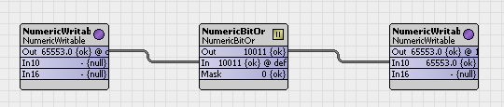
In this example:
- Input decimal 65553 converts to a hex value of 10011.
- Mask decimal 0 converts to a hex value of 00000.
- The resulting hex value is 10011.
Figure 120 NumericBitOr properties
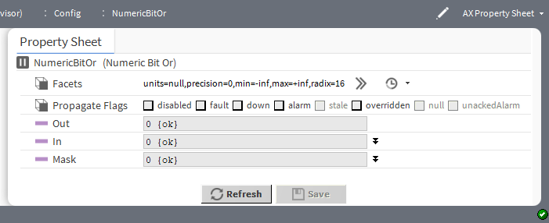

Property | Value | Description
Facets | Config Facets win- dow (defaults to null units, a single decimal place, mini- mum=negative in- finity, maximum= positive infinity, and radix=16) | Selects units and configures how the value displays:  units defines the unit of measure fromacceleration to  volumetric flow.  precision defines the number of decimal places.  min defines the lowest value allowed.  max defines the highest value allowed.  radix defines the base of the numeration system. Radix 16 is hexidecimal.  This definition applies to the Out property value for this component.
Out | read-only number (defaults to zero (0)) | Displays the result of the comparison.
In | number (defaults to zero (0)) and null definition | Defines the bit to compare with the Mask.
Mask | number (defaults to zero (0)) and null definition | Defines what to compare with the In property.

kitControl-NumericBitXor
This component performs a logical XOR on the bit equivalent of the StatusNumeric In value against the bit equivalent of its StatusNumeric mask slot value. It may be useful in cases where boolean information is mapped into integer values.
NumericBitXor is available in the Util folder of the kitControl palette, along with the closely-related Numeric- BitAnd and NumericBitOr.
As an example, some manufacturers multiplex binary data into a single numerical point by converting the bits from hexadecimal to decimal format. To obtain the status of the individual binary data, the number must be con- verted back from decimal to hex format. Each digit of the hex number represents a particular binary state (0 = false, 1 = true). The NumericBitXor object converts a StatusNumeric input to hex value and compares it against the mask value. Each digit is analyzed using exclusive OR (XOR) logic, setting the corresponding digit value to either a 1 or 0.
Figure 121 NumericBitXor example
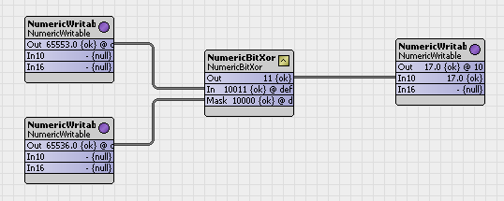

In this example:
- Input decimal 65553 converts to a hex value of 10011.
- Mask decimal 65536 converts to a hex value of 10000.
- The resulting hex value is 00011.
Figure 122 NumericBitOr properties
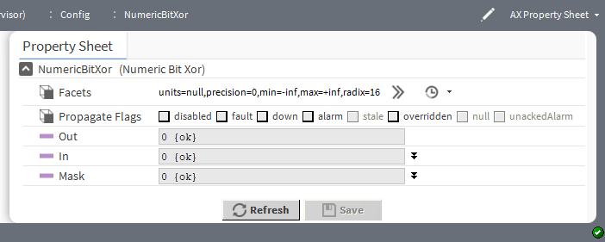

Property | Value | Description
Facets | Config Facets win- dow (defaults to null units, a single decimal place, mini- mum=negative in- finity, maximum= positive infinity, and radix=16) | Selects units and configures how the value displays:  units defines the unit of measure fromacceleration to  volumetric flow.  precision defines the number of decimal places.  min defines the lowest value allowed.  max defines the highest value allowed.  radix defines the base of the numeration system. Radix 16 is hexidecimal.  This definition applies to the Out property value for this component.
Out | read-only number (defaults to zero (0)) | Displays the result of the comparison.
In | number (defaults to zero (0)) and null definition | Defines the bit to compare with the Mask.
Mask | number (defaults to zero (0)) and null definition | Defines what to compare with the In property.

kitControl-NumericSwitch
This component selects one of two StatusNumeric inputs based upon the Boolean value at the StatusBoolean input In Switch.
NumericSwitch is available in the Util folder of the kitControl palette.

Figure 123 BooleanSwitch properties
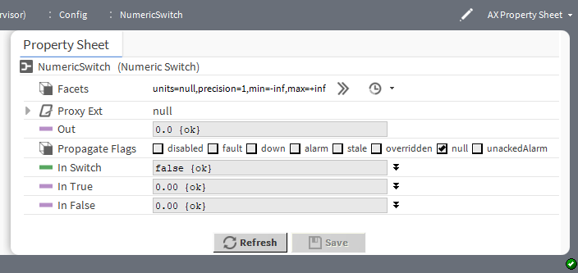

Property | Value | Description
Facets | Config Facets win- dow (defaults to null units, a single decimal place, mini- mum=negative in- finity, and maximum=positive infinity) | Selects units and configures how the value displays:  units defines the unit of measure fromacceleration to  volumetric flow.  precision defines the number of decimal places.  min defines the lowest value allowed.  max defines the highest value allowed.  This definition applies to the Out property value for this component.
Out | number (defaults to zero (0)) and null definition | Displays the result of the selection.
In Switch | true or false (default) and null definition | Indicates which input value to select.
In True | true or false (default) and null definition | Returns true.
In False | true or false (default) and null definition | Returns false.

kitControl-NumericToBitsDemux
This component converts a numeric value into the binary equivalent. Each bit in the component represents the binary bit position of the numeric integer (the component truncates numerics to whole numbers for the conver- sion). This component can express numeric values in bits (up to 32) as well as bytes (up to 4).
NOTE: This component is not designed to convert negative numbers. NumericToBitsDemux component is located in the Util folder of the kitControl palette.

Figure 124 NumericToBitsDemux properties
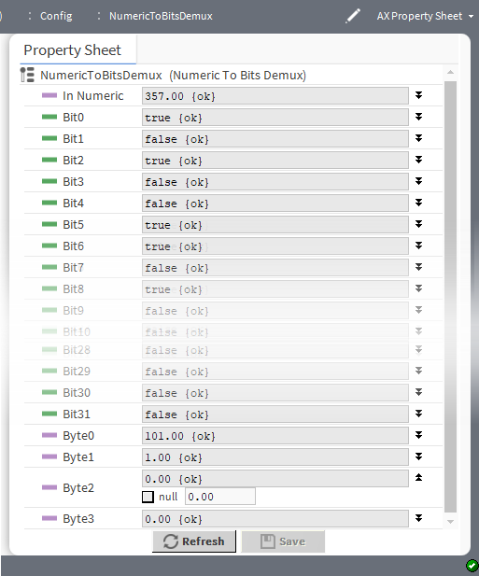

Property | Value | Description
In Numeric | number (defaults to 0.00) and null definition | Displays the numeric input value. Typically, you would link a Sta- tusNumeric output to the In Numeric property of this compo- nent. The component propagates the Status portion of the input to all StatusBoolean and StatusNumeric (byte) outputs.  When null is checked, the corresponding value defines the de- fault when a calculation returns null.
Bit0 through Bit31 | true or false (default) and null definition | Represent the converted numeric as binaries.  When null is checked, the corresponding value defines the de- fault when a calculation returns null.
Byte0 through Byte3 | number (defaults to 0.00) and null definition | Express the converted numeric input as bytes.  When null is checked, the corresponding value defines the de- fault when a calculation returns null.

kitControl-Ramp
This component provides a StatusNumeric Out with a linear ramping output. Properties define the Period, Am- plitude, Offset, and Update Interval.
Ramp is available in the Util folder of the kitControl palette.

Figure 125 Ramp properties
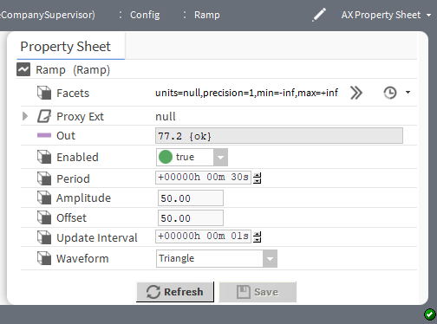

Property | Value | Description
Facets | Config Facets win- dow (defaults to null units, a single decimal place, mini- mum=negative in- finity, and maximum=positive infinity) | Selects units and configures how the value displays:  units defines the unit of measure fromacceleration to  volumetric flow.  precision defines the number of decimal places.  min defines the lowest value allowed.  max defines the highest value allowed.  This definition applies to the Out property value for this component.
Out | read-only number | Reports the result of the calculation.
Period | hours minutes sec- onds (defaults to 30 seconds) | Defines the duration of the ramp.
Amplitude | number of decibels (defaults to 50.00) | Amplitude is height of the ramp from its lowest to highest point.
Offset | positive or negative number to two deci- mal places (de- faults to 50.00) | Adjusts the amplitude.
Update Interval | hours minutes sec- onds (defaults to one second) | Specifies the time between output changes. A smaller value re- sults in a more accurate ramp with more changes per second, while a larger value results in less precision but with less overhead.
Waveform | drop-down list | Selects the type of waveform:  Triangle Saw Tooth  Inverted Saw Tooth

kitControl-Random
This component generates random numbers. The output is derived by multiplying a random number (that is greater than 0 but less than 1) times a variable multiplier plus an offset.
Random is available in the Util folder of the kitControl palette.
Figure 126 Random properties
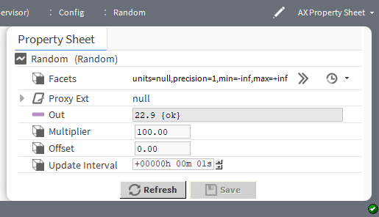

Property | Value | Description
Facets | Config Facets win- dow (defaults to null units, a single decimal place, mini- mum=negative in- finity, and maximum=positive infinity) | Selects units and configures how the value displays:  units defines the unit of measure fromacceleration to  volumetric flow.  precision defines the number of decimal places.  min defines the lowest value allowed.  max defines the highest value allowed.  This definition applies to the Out property value for this component.
Out | read-only number to a single decimal place | Displays the random number.
Multiplier | number to two deci- mal places (de- faults to 1.0) | Defines a double value used to multiply by the random number (the random number is: >=0.0 but <1.0).
Offset | number to two deci- mal places (de- faults to 50) | Defines a positive or negative distance from zero that the wave's amplitude is centered on.
Update Interval | hours minutes sec- onds (defaults to one second) | Defines the amount of time between output changes.

kitControl-SineWave
This component generates a sine wave as a StatusNumeric out. SineWave is available in the Util folder of the kitControl palette.

Figure 127 SineWave properties
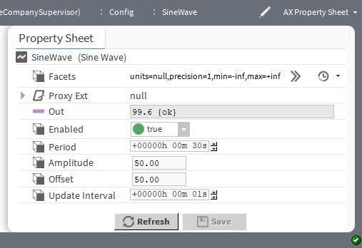

Property | Value | Description
Facets | Config Facets win- dow (defaults to null units, a single decimal place, mini- mum=negative in- finity, and maximum=positive infinity) | Selects units and configures how the value displays:  units defines the unit of measure fromacceleration to  volumetric flow.  precision defines the number of decimal places.  min defines the lowest value allowed.  max defines the highest value allowed.  This definition applies to the Out property value for this component.
Out | read-only number | Displays the calculated value
Period | hours minutes sec- onds (defaults to 30 seconds) | Defines the duration of the ramp.
Amplitude | number of decibels (defaults to 50.00) | Amplitude is the height of sine wave from its lowest to highest point.
Offset | positive or negative number to two deci- mal places (de- faults to 50.00) | Adjusts the amplitude.
Update Interval | hours minutes sec- onds (defaults to one second) | Defines how often to restart the ramp.
Offset | number to two deci- mal places (de- faults to 50) | Defines a positive or negative distance from zero that the wave's amplitude is centered on.
Update Interval | hours minutes sec- onds (defaults to one second) | Defines the interval.

kitControl-StatusDemux
This component provides a method to check for individual status flags of the In-linked object, and sets corre- sponding (demuxed) StatusBoolean out slots active (true) if that status as found.
StatusDemux is available in the Util folder of the kitControl palette.
Figure 128 StatusDemux properties
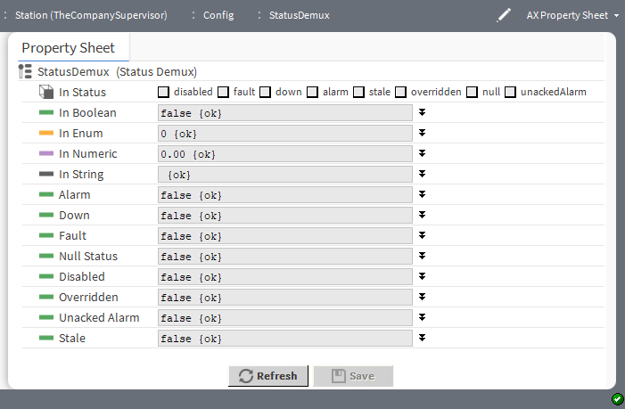

Property | Value | Description
In Status | check boxes | Identifies the possible conditions of the In-linked object: dis- abled, fault, down, alarm, stale, overridden, null and unackedAlarm.
In Boolean | true or false (default) and null definition | Receives input from a connected Boolean object.
In Enum | enumerated value (defaults to zero) and null definition | Receives input from a connected Enum object.
In Numeric | number (defaults to zero) and null definition | Receives input from a connected Numeric object.
In String | text (defaults to blank) and null definition | Receives input from a connected String object.
Alarm | out property: true or false (default) and null definition | Activates (true) if the In-linked object is in alarm.
Down | out property: true or false (default) and null definition | Activates (true) if the In-linked object is down.
Fault | out property: true or false (default) and null definition | Activates (true) if the In-linked object is in fault.

Property | Value | Description
Null Status | out property: true or false (default) and null definition | Activates (true) if the In-linked object is in null status.
Disabled | out property: true or false (default) and null definition | Activates (true) if the In-linked object reports a disabled.
Overridden | out property: true or false (default) and null definition | Activates (true) if the In-linked object has been overridden.
Unacked Alarm | out property: true or false (default) and null definition | Activates (true) if the In-linked object has an unacknowledged alarm
Stale | out property: true or false (default) and null definition | Activates (true) if the In-linked object is stale (has not been updated in a timely manner).

kitControl-BqlExprComponent
This component creates custom math and logic operations based upon manually-added slots and one or more BQL expression statements. Slots can be various baja types, such as primitives Double, Float, Integer, Boo- lean, or String, or status types: StatusBoolean, StatusNumeric, and so on. Slots are either inputs or one or more outputs. You enter BQL expressions in the component’s Expr (expression) property.
The ExprLogic and ExprMath components are not strictly speaking logic and math components. Instead, they are adaptations of the Expr component (BqlExprComponent), which provide four-input logic and math functions.
Figure 129 The three forms of the BqlExprComponent
- (1) is for logic BQL expressions.
- (2) is for math BQL expressions.
- (3) is for general expressions.

The Logic and Math folders also contain expression components. ExprLogic provides a four-input logic AND gate. ExprMath provides a four-input math ADD component. The Util folder of the kitControl palette con- tains an empty expression component.
For complete information on BQL expressions, refer to Engineering Notes,BQL Expression component.

Property | Value | Description
Status | read only | Indicates the condition of the component at the last check  {ok} indicates that the component is licensed and polling successfully.  {down} indicates that the last check was unsucessful, perhaps because of an incorrect property, or possibly loss of network connection.  {disabled} indicates that the Enable property is set to  false.  false indicates another problem . Refer to Fault Cause for more information.
Fault Cause | read only | Indicates a reason why a system object ( network, device, com- ponent, extension, etc.) is in fault. This property is empty unless a fault exists.
Execution Delay | hours minutes sec- onds (defaults to 0) | Configures an amount of time to delay before executing the expression.
Expr | BQL expression | The standard syntax for an expression is as follows: input op- erator ‘output’, where:  input is the name of one or more slots. operator is a word or symbol.  ‘output’ is the slot that contains the result of the expression. (note apostrophes around slot name)
InA, In B, InC and InD | BooleanStatus (true or false for logic), number (for math) | Defines four input values.
out | read-only Boolean- Status (true or false for logic), number (for math) | Defines a single output value, which is the result of executing the expression.
The supported operators for the BQL expression are as follows:

Order of Operation | Operator | Description
1 | !, not, - | Logical not, numeric negation
2 | * , / | multiplication, division
3 | +, - | addition, subtraction
4 | =, !=, >, >=, < <=, like | Comparison
5 | and, or | Logical operators
6 | as | result operator

Operators are processed by their precedence, that is “order of operation”, from first (1) to last (6). Parentheses is used to override the normal precedence.
Comma is used as a delimiter to create Expr with multiple expression(output slots). For long statements in a Expr use CR/LF to wrap the text.

BQL Like Query
Following are some examples for Like expression:
- Multiply four Double properties inA * inB * inC * inD as ‘out’
- Multiply two BStatusNumeric properties to a Double output property inA.value * inB.value as ‘out’
- Negate a Double input property (if inA is 5, out becomes -5)
-inA as ‘out’

EC-Net4 KitControl_UG_13_EN

